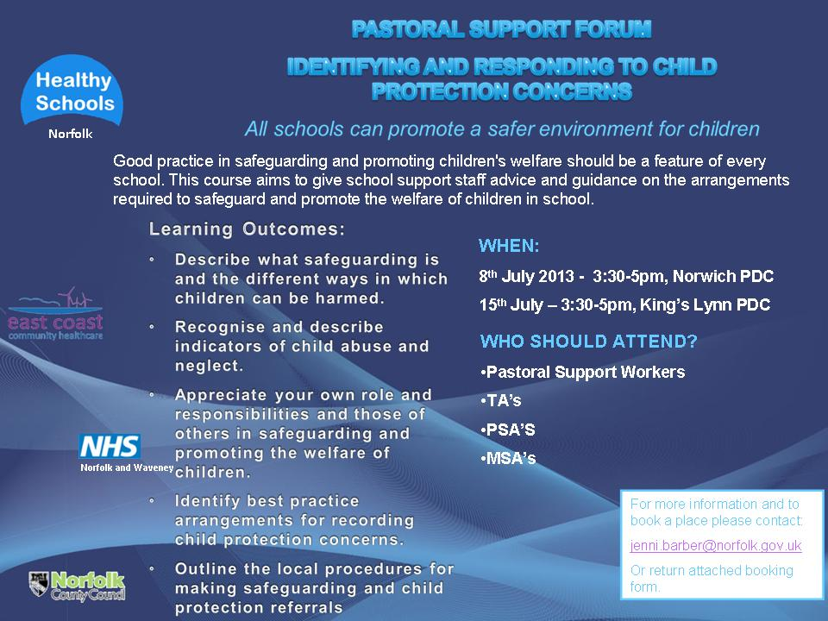
 |  |  |  |  |  |  | Professional Learning  and Development  Booking Form
Return to:  Jenni Barber  Healthy Norfolk Schools  Professional Development Centre  144 Woodside Road  Norwich NR7 9QL  Tel: 01603 307756  Fax: 01603 700236 |  |  |  | From:  Name ………………………………………………………………..  School/Organisation ……………………………………………..  Address …………………………………………….………………  ………………………………………………………………….. …..  Date:…………………………….Tel:………………………………  School Dfes No. (926) ……………………………………………
Course Titles: |  | Pastoral Support Forum – Identifying and responding to child protection concerns  …………………………………………………………………………………….
Workshop choice(s):  If applicable |  | …………………………………………………………………………………….
Venue: |  | ……………………………………………………………………………………..
Date: |  | …………………… |  |  |  | Course Ref No’s.
Title | Forename |  |  |  | Surname (block capitals please) |  |  |  |  | Cost £0.00
Please do not send a cheque with this booking form. |  |  |  |  |  |  |  | TOTAL |  | £0.00
It is our policy to ensure that we provide access for all people. Meat and vegetarian meals come as standard. If you have any other special requirements of any kind, please state here so that we can try to help you.

Booking(s) authorised by: |  |  | ………………………………………………………………. Signature  ………………………………………………………………. Title
Cancellation Policy: For cancellations made by the school/establishment more than 28 working days prior to the course date, a £15 administration fee will be levied per person. The full fee will be charged for cancellations made within 28 working days of the course date. Free courses will incur a £15 administration fee for non-attendance or if cancelled within 5 working days of the course date.
In exceptional circumstances, and at the discretion of Children's Services or should Children's Services cancel the course, either the fee paid will be refunded in total, or the course will be rescheduled for a mutually convenient date.

