SIMS demonstration at Norfolk Roadshows
In our SIMS Demonstration Ruth Walker showed you how SIMS:
- Allows you to customise your home page to give you the information you need at your fingertips including alerts, favourites, school diary, bulletins as well as Attendance and Assessment data for groups that are relevant to the user
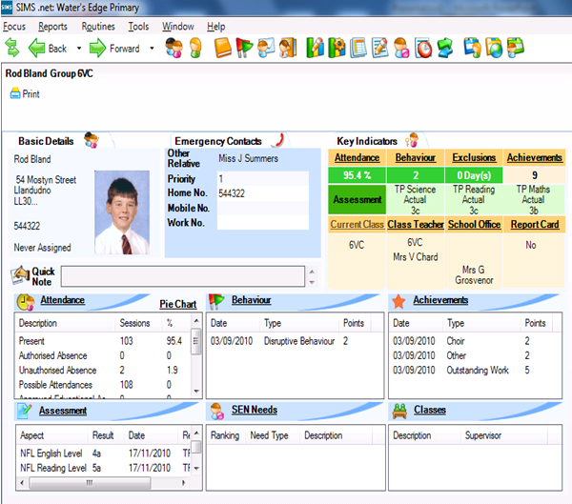
- The separate views for looking at a pupil record either as a summary or a more traditional view for data input. All in a single canvas with links to other relevant parts of the software
- Allows you to change attendance years easily to look at attendance patterns across more than one academic year, the same functionality exists in Assessment
- The flexibility of reports using word templates and a library of over 200 standard reports. The project team are working to review Norfolk reports that can be added to this library if you have any suggestions please let us know.
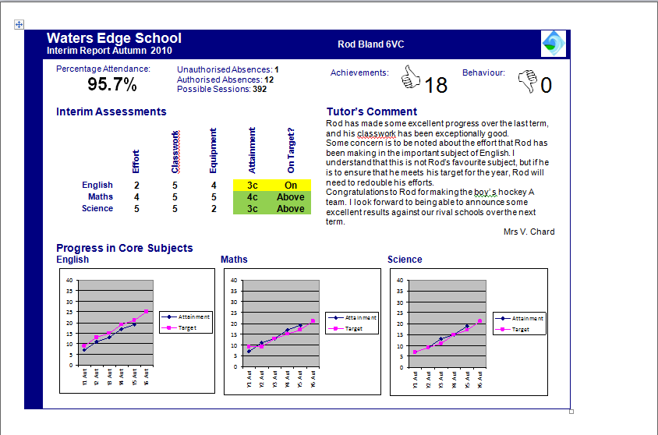
- The mantra of enter data once and use many times to ensure staff are not duplicating data entry
- Uses Quick letter for those letters that need to be sent to Parents quickly usually at the end of the school day
- Document Management stores relevant information against the pupil making it accessible to those staff across the school who may need access
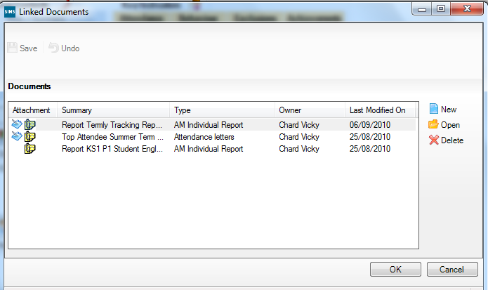
- The ease with which Dinner Money is automatically populated form the attendance record yet allows you to change the information to fit in with the circumstances on the day
- The Norfolk Tracker and One 2One Marksheets are being built into SIMS Assessment for you to use from day one
- Tracking Grids based on the National Strategies ISP Project
- Assessment using the Raise on line filters and allowing you to create different filters that are relevant and important to your school
- IEP writer embedded within the SIMS Software again making access to IEP across the school simpler

In summary who Capita are/what they do:
- 6 million student records are entrusted to SIMS
- SIMS Attendance module records over 2.5 million attendance marks every single school day
- 22,000 schools use and rely on SIMS every day
- 147 local authorities recommend SIMS as the preferred MIS supplier
- Over 23 years experience in developing MIS
- 70% of academies work in partnership with Capita
- No other MIS provider spends more on development - £10m in 2010 alone
- Over 400 schools came to SIMS in 2010 after trying another MIS provider
- Backed up with training from experienced SIMS consultants, most of whom are ex teachers/school employees with firsthand knowledge of using SIMS in school.
- Users are kept up-to-date with roadmap of product improvements every term.
- Premier partner with ASCL
- SIMS partners with over 200 companies whose products enrich SIMS functionality
- Part of the Capita group plc a FTSE 100 company

