Dinner Monies Database Upgrade v2011:
Please Note: You must only complete this upgrade if you are currently using Version 2010 of the Dinner Monies Database.

To complete the Upgrade please take the following steps:

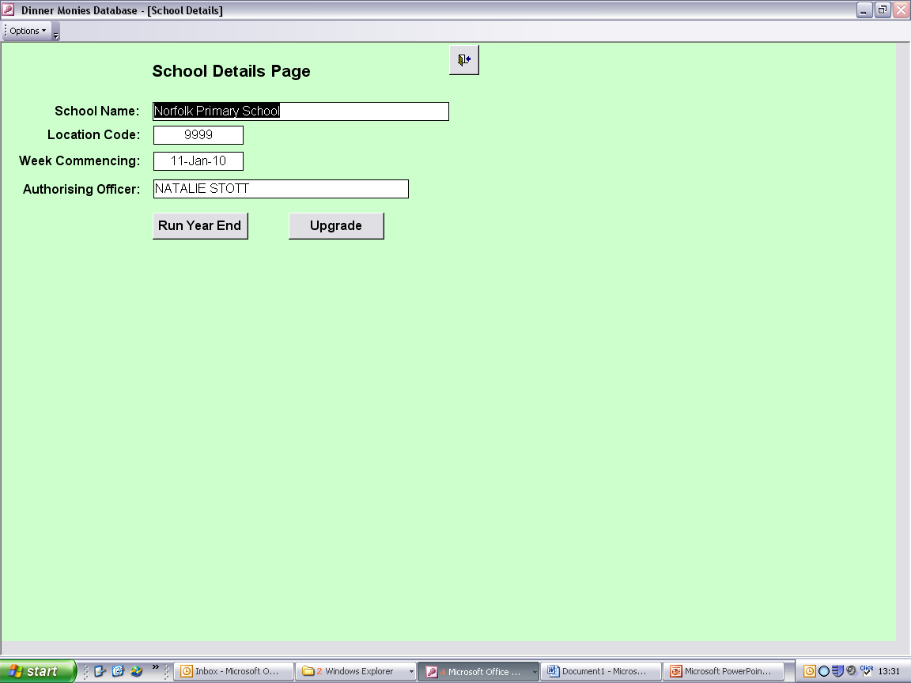
Within the “School Details” screen click the ‘Upgrade’ button.
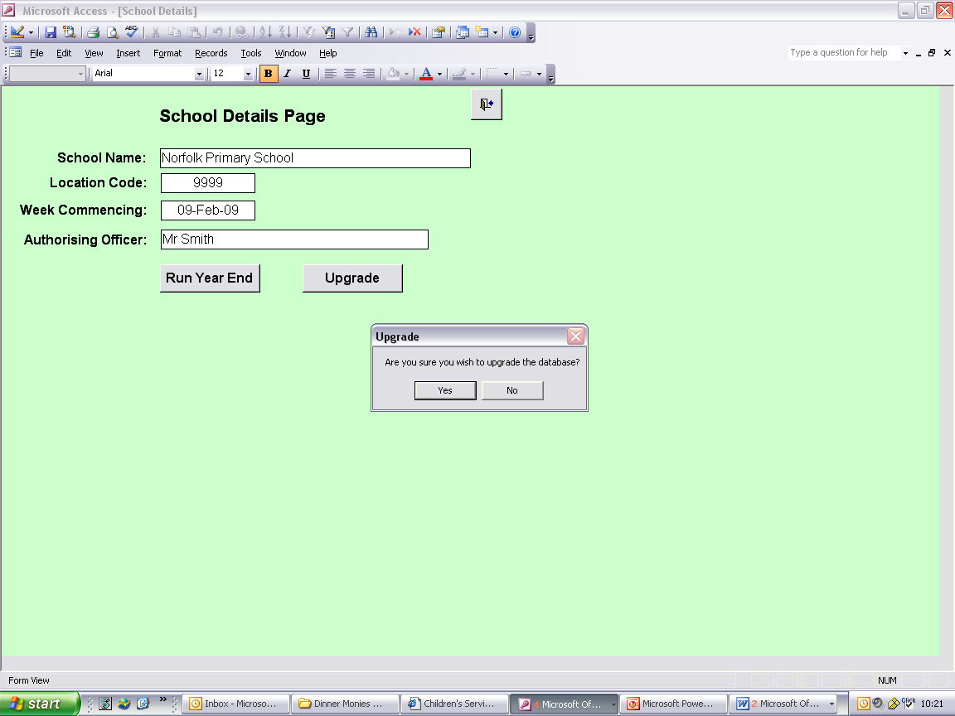

Click ‘Yes’ to continue with the upgrade process, or ‘No’ to cancel.

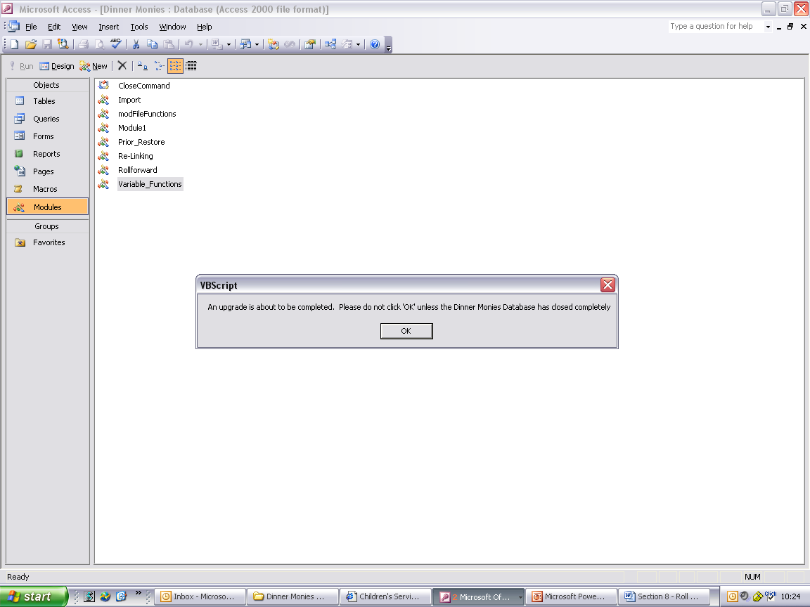
Click ‘OK’ to the above message once the Dinner Monies Database has closed completely.

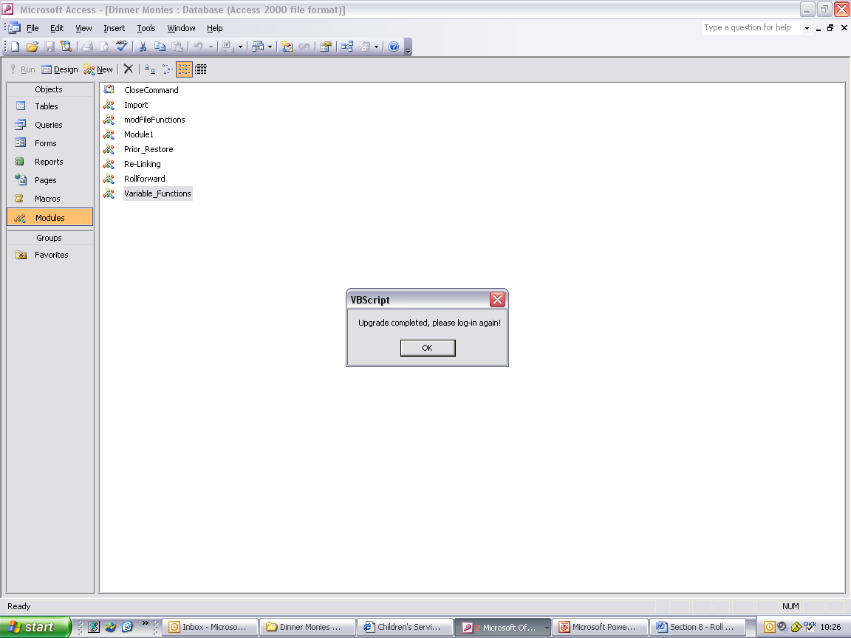

You must wait for this message before logging back into the database. This process may take a few minutes depending on the speed of your computer.

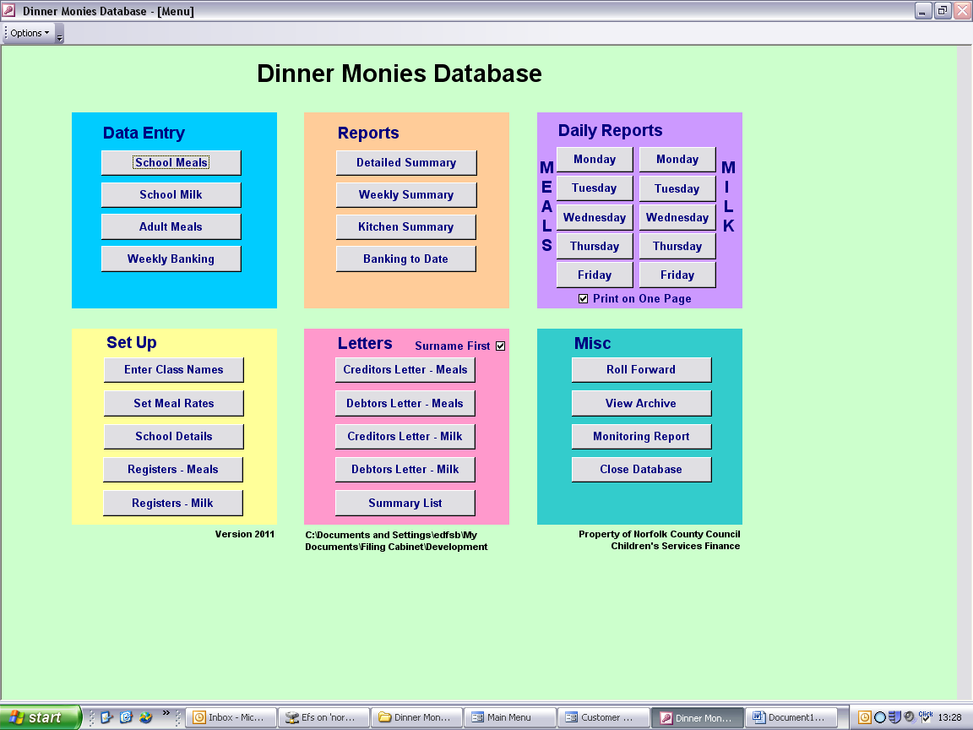
Once the upgrade is complete please ensure that the version stated on the Main Menu is 2011. If it is not please contact Computer Accounts for further assistance.

After completing the upgrade you will be required to make amendments to your Meal Rates screen to accommodate the changes outlined below. Please refer to Section 1, Page 2, of the User Guide.

Changes Made within Upgrade Version 2011:

To accommodate the changes required for banking Dinner Monies income within Star Accounts the procedure for entering meal rates has been amended. Please refer to Section 1 Page 2 of the User Guide.

Procedures have been created to allow users to set up their own Meal Types for registering school specific meals (for example, Christmas Meals, Party Meals etc). A price can be entered for the Meal Types which will be reflected in the Bfwd / Cfwd figures within the Pupil Meals screen. Please refer to Section 1 Page 2 of the User Guide.

The Weekly Banking screen has been altered to allow users to separate all types of Banking – Pupil Meals, Pupil Milk, Adult Non-VATable Meals, Adult VATable Meals and Snack Monies. The way in which Brought Forward unpresented income is calculated and shown has also been altered. Please refer to Section 5 of the User Guide.

A summary of the current weeks’ transactions has been included within the Weekly Summary Report. This summary includes the coding details that should be entered into Star Accounts. Please refer to Section 5 Page 3 of the User Guide.

The Monitoring Report has been altered to the format required by Jayne Dyndal for County Hall’s reconciliation process. This report will not be emailed as part of the roll forward process. Please see Section 6 Page 9 of the User Guide.

