To download the 2011-12 Budget Planner Spreadsheet update please take the following steps.

1. Download the Installation File

Start a call in AVCO AnyComms. Once the call is completed open the Finance folder within the AVCO Inbox Folder. Ensure the file ‘Upgrade_Budget_Planner_Data.2.exe’ has been downloaded.
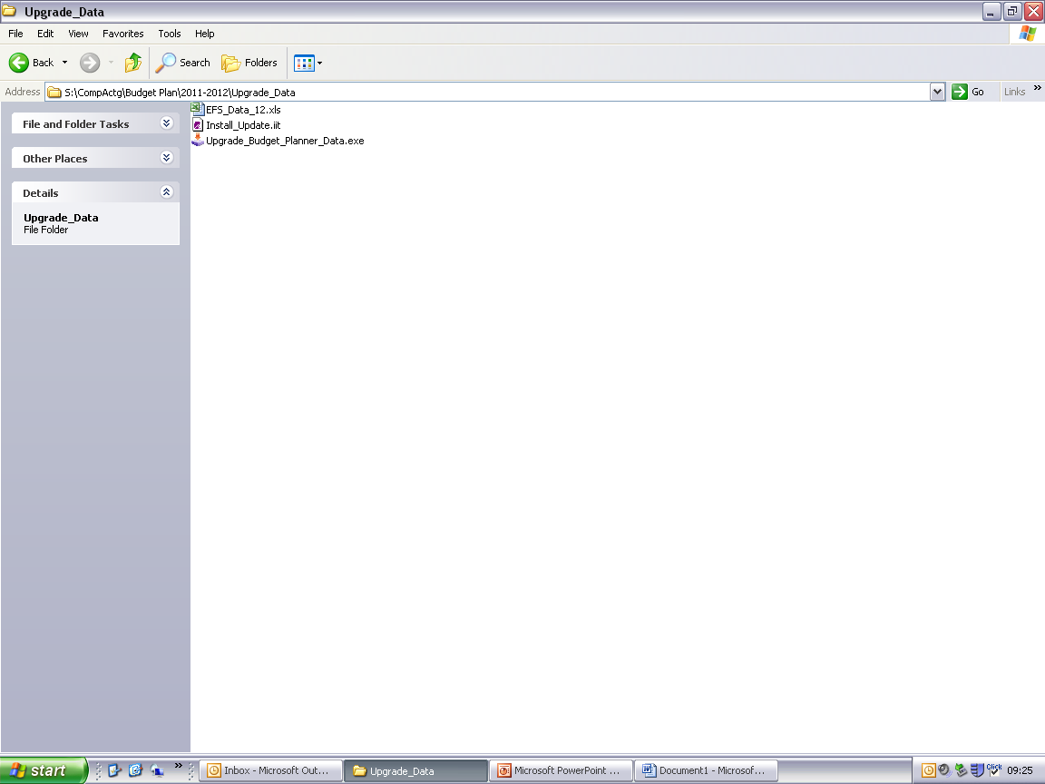

If you have any issues receiving this file via AVCO please contact ICT Solutions (0845 303 3003).

If you wish to install the update onto a different computer, copy the ‘Upgrade_Budget_Planner_Data.2.exe’ file to a memory stick and follow the instructions below on the other machine.

2. Run the Installation File

Double click the ‘Upgrade_Budget_Planner_Data.2.exe’ file.

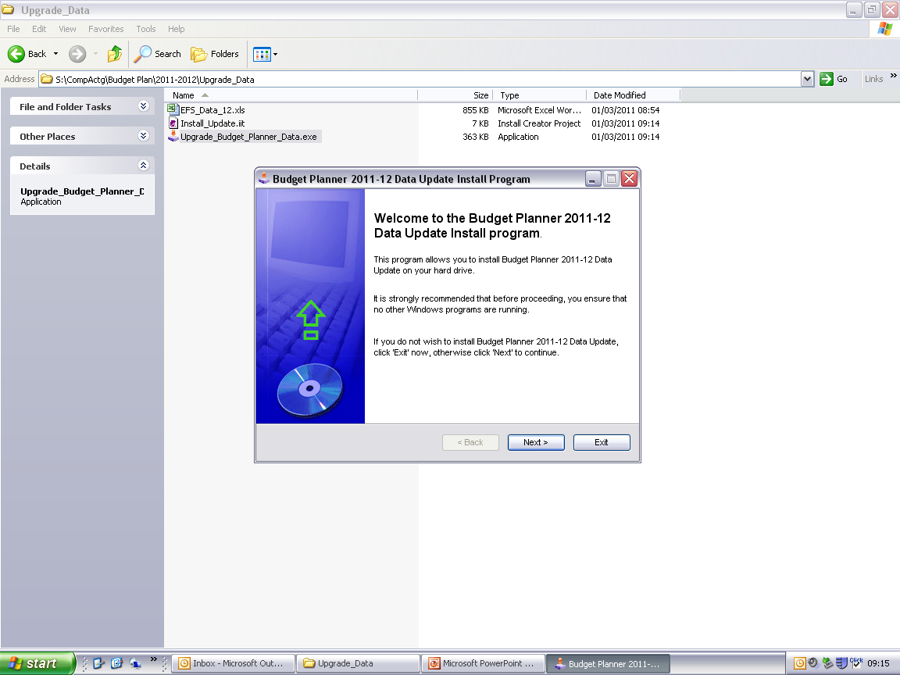
Click ‘Next’.

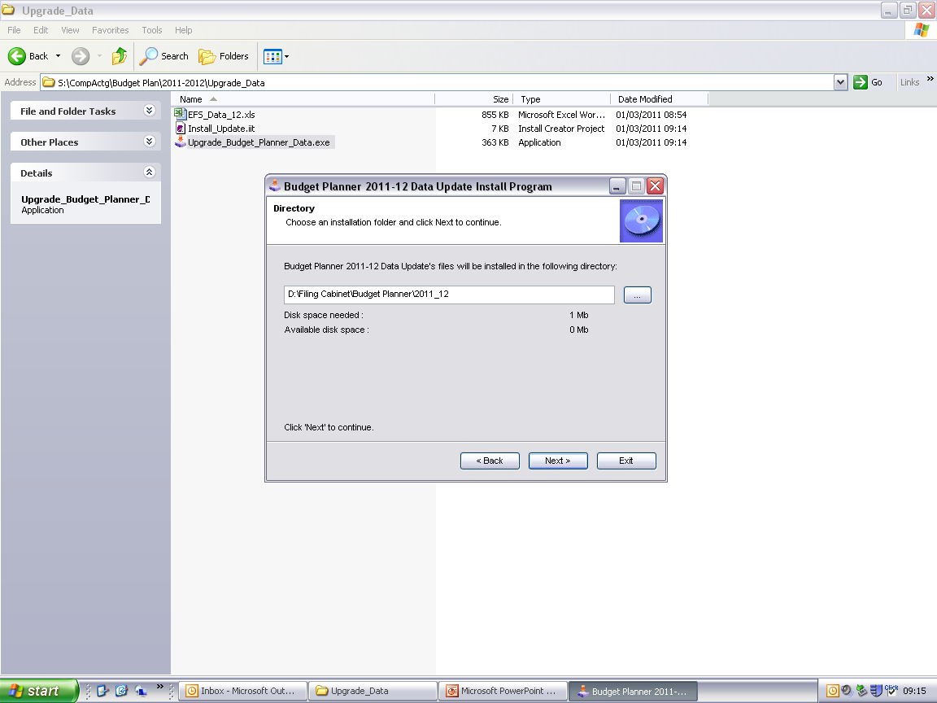
The Budget Plan will default to installing in the directory shown. You must browse in the location of the Budget Planner 2011-12 folder by clicking here.

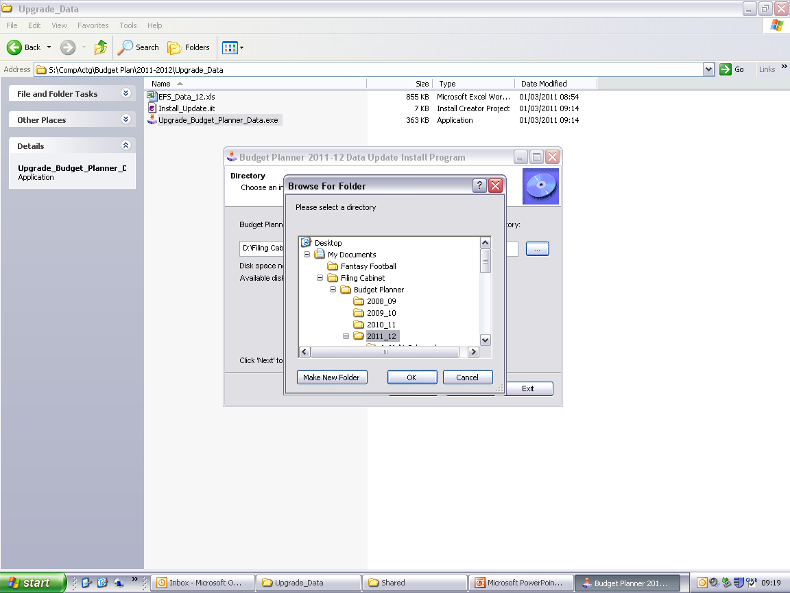
Browse in the location of the 2011-12 Budget Planner folder, and click ‘OK’.

Click ‘Next’.

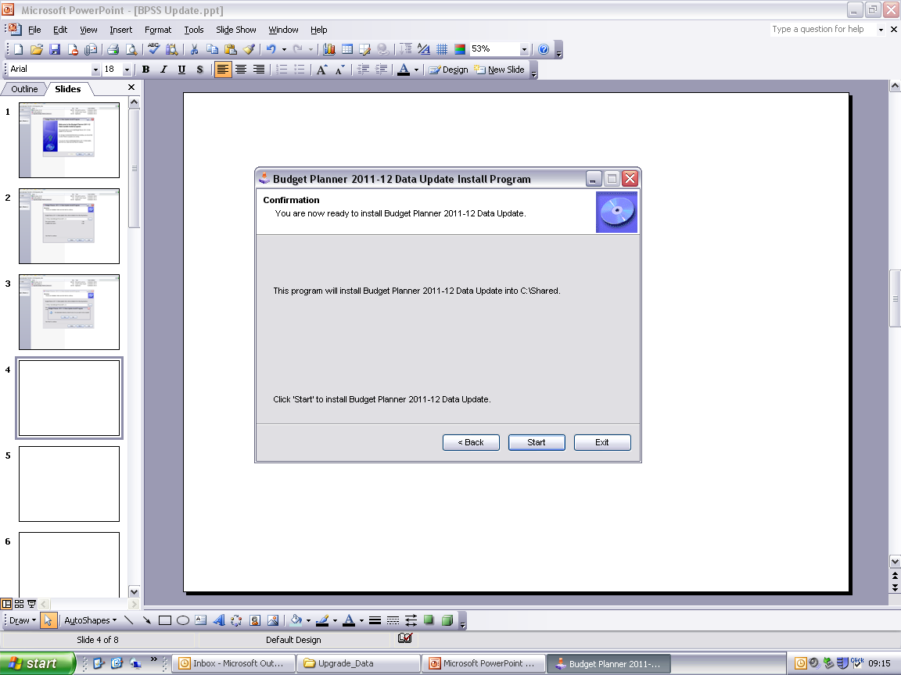
Click ‘Start’.

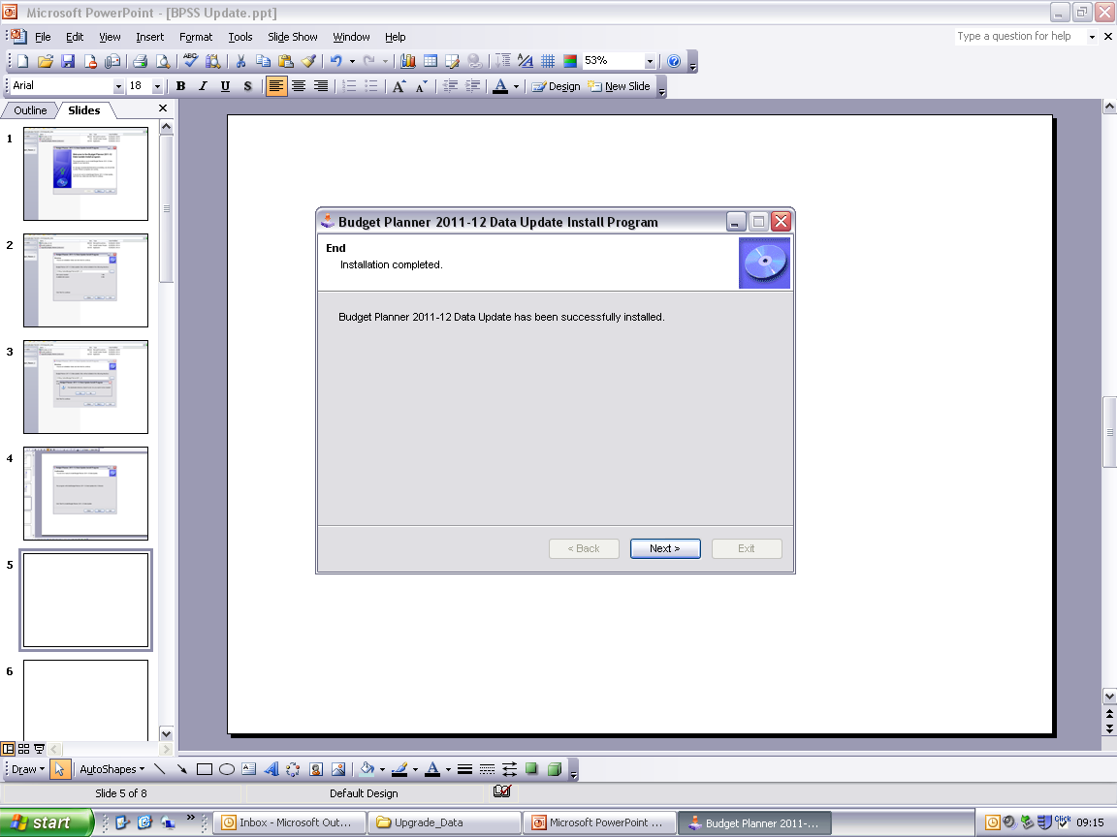
Click ‘Next’.

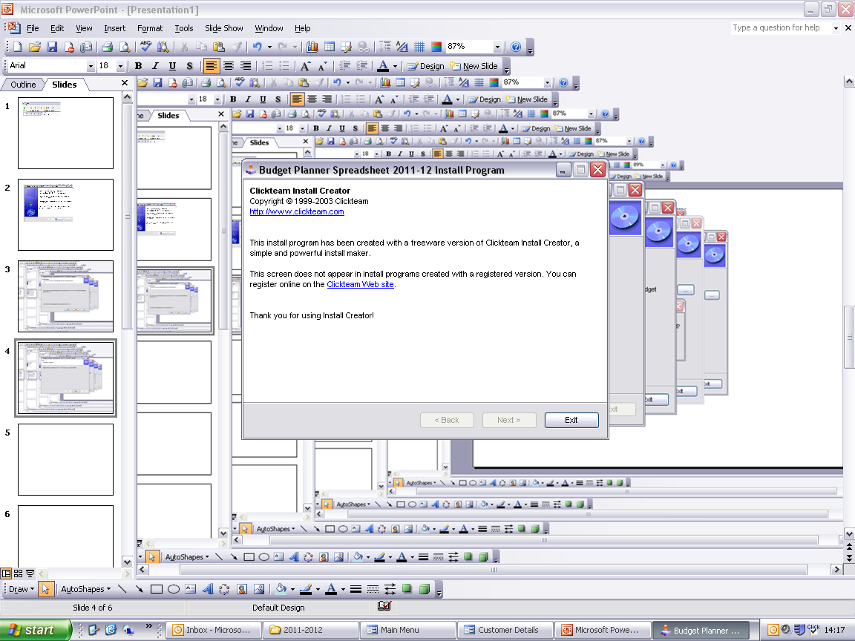
Click ‘Exit’.

3. Open the Spreadsheet

If the update has been successfully saved to the correct folder when the Budget Planner Spreadsheet is opened the version stated on the Main Menu will state Version 1.2:

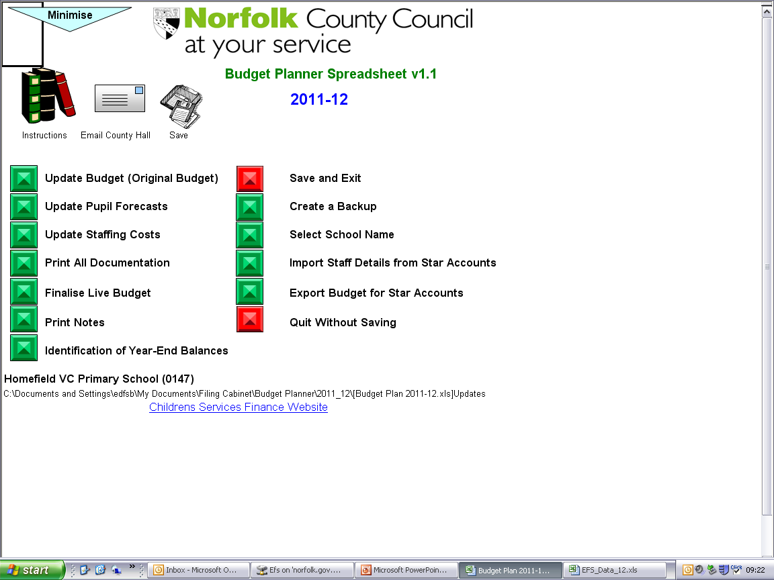

Please Note: This update will not delete any data entered into the budget planner spreadsheet (i.e. staffing forecasts, pupil forecasts etc). This update is only required to ensure the “Export Budget for Star Accounts” function will work correctly.

