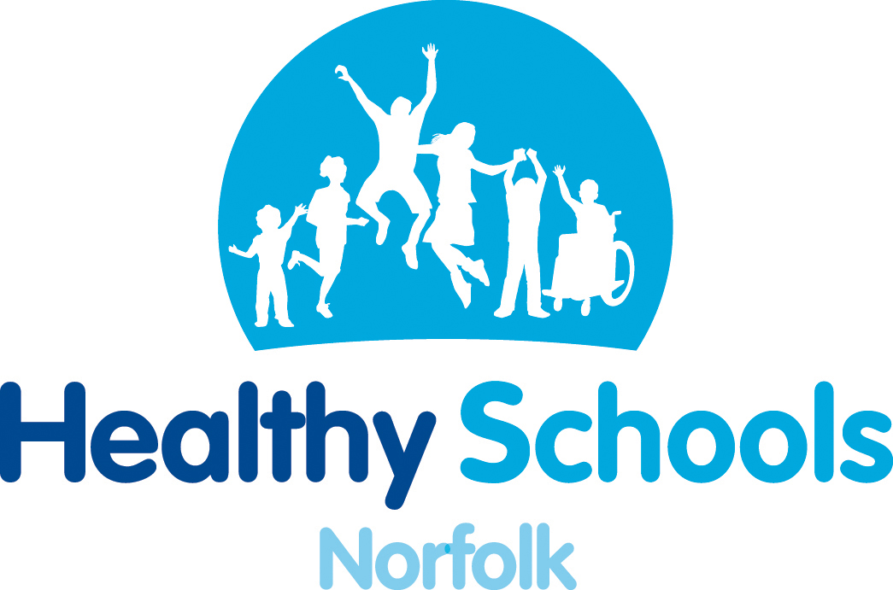
Improve the health and wellbeing of your pupils through the
Healthy Schools’ Enhancement Model

The Healthy Schools’ Enhancement Model is a robust model for implementing health improving change in schools. Engaged schools will focus on a priority such as healthy weight or emotional health and well being, in order to demonstrate an impact on the health and well-being of children and young people.
The enhancement model will:

- equip schools to promote health improvement effectively for all pupils
- target support specifically to those pupils in challenging circumstances
- help embed healthier behaviours and well-being outcomes into the everyday activities of school life
- continue to support schools in achieving the Every Child Matters outcomes
- provide schools with rigorous health and well-being evidence for School Improvement Plans, the Ofsted Self Evaluation (SEF)

Schools will be supported throughout this process by the Healthy Norfolk Schools’ Team. A member of staff will need to attend a half-day training session and then be available for a follow up session in school in order to finalise the planning stage.
Introduction to the Healthy Norfolk Schools’ Enhancement Model

- Phase Four 4th October 2011 2.30 – 4.00

The Enhancement Model is open to schools who have already achieved National Healthy Schools Status.
- To find out if the Enhancement Model is for you contact: Marian Fox 01603 221810 marian.fox@norfolk.nhs.uk

- To book a place contact Jenni Barber 01603 307756 jenni.barber@norfolk.gov.uk



