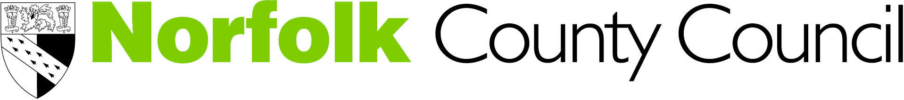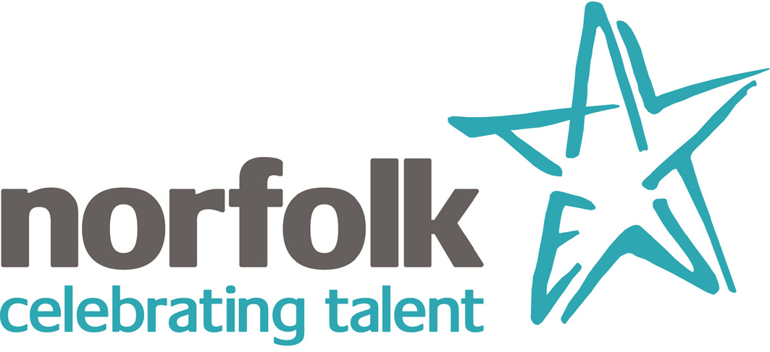

2012 Cultural Offer for Schools

Plan ahead for 2012 -find out what’s available for your school to take part in at our
FREE 2012 Cultural Offer twilight at the

Norwich Castle Museum on 18 October 2011 from 2- 5pm

Some of the opportunities available:

- London 2012 Education Team- support for schools to gain London 2012 Get Set Network status
- Norfolk County Council’s Children and Young People’s 2012 Art competition
- Norfolk Museum and Archaeology Services’ Stories of the World
- Dr Ken Farquar from the Inspirational Science Theatre with ‘Dr Ken's Olympic Dream’
- Grassroots Theatre Company and the One World programme
- Whitlingham Outdoor Education Centre
- Libraries - Reading Relays and 2012 Loan Boxes
- Take your children and young people to the Olympics- experience our virtual Olympic Stadium
- Norfolk Museum and Archaeology Services’ Stories of the World
- The award winning Artists for Climate Change project with AFCC artists on hand
- Norwich City Council - the Olympic Torch Relay and opportunities for schools
- Dance and Physical Theatre artist Neil Paris from Dance Aloud
- Capoeira Communities 2012 Legacy Programme
For further details and to book a place contact:
Anna McCarthy, Creative Projects Officer
E:anna.mccarthy@norfolk.gov.uk.
T: 01603 638099

