The file “Upgrade_Star.exe” will be available from 27th February 2012.

DO NOT OPEN THE FILE UPGRADE_STAR.EXE.
TO COMPLETE THE UPGRADE YOU MUST FOLLOW THE INSTRUCTIONS BELOW!

1. AVCO Automatic Upgrade

Please Note: The Automatic Upgrade will only work if AVCO is accessible on the same PC that operates Star Accounts.

If AVCO is not accessible, copy the file Upgrade_Star.exe from your AVCO Finance Inbox into the folder designated as your Inputs Path (see Records, School Details). If the file does not exist please copy it from the AVCO Archive folder.

Start a call in AVCO. Once the call has completed you should see a file called

Upgrade_Star.exe in the Finance folder within the Inbox.

Log into Star Accounts from your desktop as you would normally. If you were logged into Star Accounts whilst the AVCO call was being made you will need to log out completely, and then log-in again for the upgrade to take place.

Please Note: If you get the following message click ‘Open’ to continue.
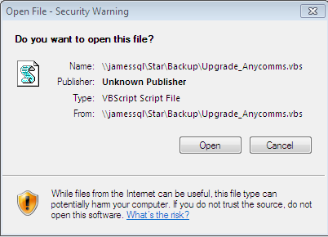

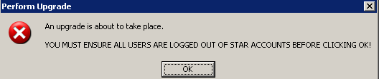

Star Accounts will close and the following screen will be displayed. Follow the directions on the screen.
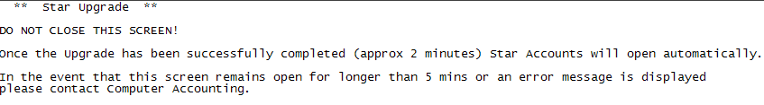

Access 2010 only!
Schools using Access Version 2010 will see the additional prompt

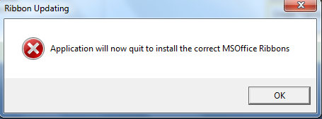
Click ‘OK’ to close Star Accounts

Once Star Accounts has closed you can log back into Star Accounts.

The first time you login the upgrade will update all data files (including prior year data files). This will take a while but you must wait for the following message to appear:

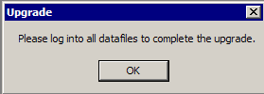
The Main Menu should say 5.4. Remember to log into all other data files to complete the upgrade. If the upgrade is unsuccessful please contact Computer Accounting.

2. Upgrade Release Notes and Current Version Number
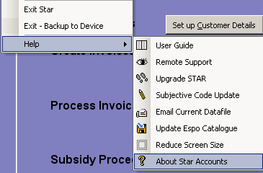

The ‘Current Upgrade Release Notes’ can be viewed within “About Star Accounts”.

(From the keyboard hold keys Ctrl & A)

3. Debtors Changes

To improve performance the Debtors system has been rewritten. There is no change to the user but rounding issues may affect some invoices since the upgrade. Reprint the ‘Outstanding Invoices’ and compare this report with the report printed prior to the upgrade. This will highlight any invoices that have changed.

For any invoices that have changed please note the following:

- If an invoice that did not previously appear on the Outstanding List has now appeared with a small balance, check to see if it also appears on the Edit/Print List of invoices with an outstanding balance. If it does, clear the remaining balance as per the User guide Section 18 page26. If the invoice does not appear on the Edit/Print Invoices screen with an outstanding balance, the balance will be cleared as part of the Year End Rollover process.
- If an invoice total has increased and the invoice has not yet been sent, reprint the invoice and send the revised invoice.
- If an invoice total has increased and the invoice has been sent, once paid clear the remaining balance as per the User guide Section 18 page26.

