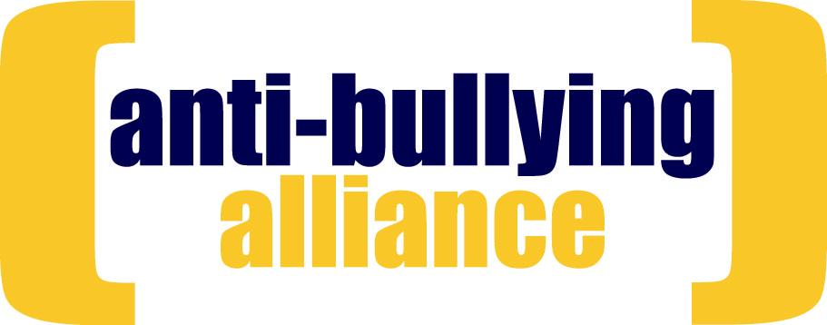

NOMINATION FORM

Elections 2012

If you wish to stand for the position of Chair of the Anti-Bullying Alliance and/or to be a member of the Advisory Group you must complete both pages of the form below and return by Monday 16 April 2012 by post or e-mail to:

Hanneke Koekkoek, HR/ABA, 8 Wakley Street, London EC1V 7QE hr@ncb.org.uk

Name:

Organisation:

Email:

Direct Number:

I wish to stand for: Chair [ ] Advisory Group [ ] Both [ ]

Signature: Title:

Date:

I have my Organisation’s consent to stand in this election

Signature: Title:
(Senior manager or Trustee)
Date:

Please provide a short biography to support your nomination. (c75 words)

If elected, what would you contribute to the Advisory Group and/or the work of the Alliance? (c125 words)

Which other Alliance Member supports your application?

Name:

Organisation:

return by Monday 16 April 2012 by post or e-mail to:
Hanneke Koekkoek, HR/ABA, 8 Wakley Street, London EC1V 7QE hr@ncb.org.uk

