Calling all Norfolk Primary Schools!

The Reuse Shop Bookmark Competition is open for Key Stage 1 and 2 pupils

We are looking for young artists to help us encourage Norfolk residents to reduce, reuse and recycle their waste by using Norfolk’s Reuse Shops.

We are running a competition to design a bookmark promoting the three R’s (reduce, reuse and recycle) and The Reuse Shops. Designs may include pictures of one of our shops, drawings of some of the items that you could buy and donate to the shop, or anything relating to the three R’s.

The winning design will be printed on 2500 bookmarks, which will be distributed throughout the County at the Reuse Shops and at Libraries.

Fun and funky recycled goodies will be awarded to the winner, (including a batch of their bookmarks) as well as prizes for the runner-ups of each entry category (Key Stage 1 and Key Stage 2).

Please find below an entry form that can be photocopied. The closing date for this competition has now been extended to 1 June 2012

We know that this is a busy time of the year, but we hope your pupils will find the time in science, citizenship, art classes or after school groups to enter. Alternatively, pupils could be encouraged to enter in their free time.

Please send your entries to Reuse Shop Bookmark Competition, Marketing Assistant, Room 501, Norfolk County Council, County Hall, Martineau Lane, Norwich, NR1 2DL.

Kind Regards

The Reuse Shop Team.

Have you been to a Reuse Shop? They are full of unwanted treasures that people donate for others to buy, rather than throwing it away. There are Reuse Shops at six of Norfolk’s Recycling Centres, to find out more please go to www.norfolk.gov.uk/reuseshop.

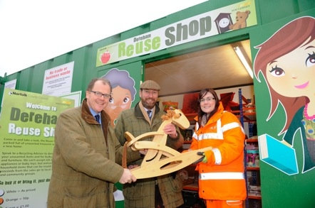
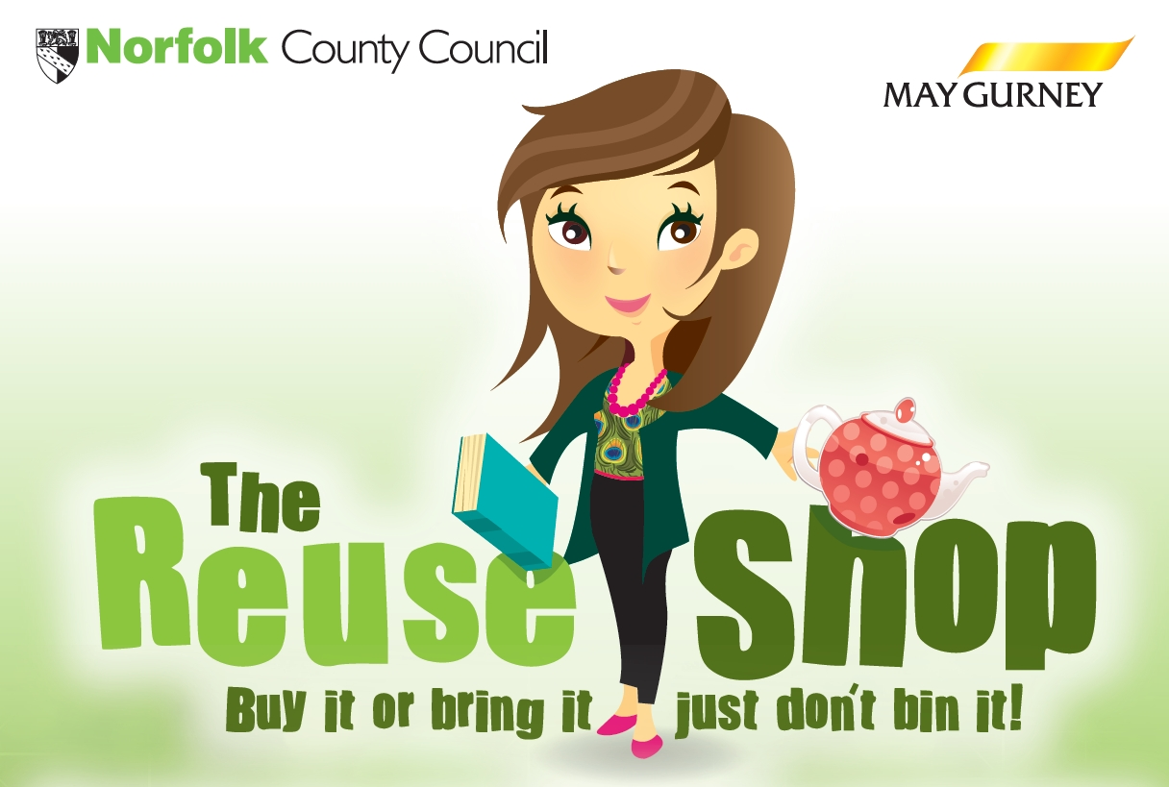

Please draw or paint your bookmark design in the rectangle box.
⬅
Remember, we want to tell people about waste reduction, reuse and recycling as well as the Reuse Shops.

Have you been to your local Reuse Shop? It’s full of unwanted treasures that people donate for others to buy, rather than throwing it away…

GOOD LUCK!
Don’t forget to send your entries by 1 June 2012, to be in with the chance of getting your bookmark design printed!

Name: ……………………………………………………. Age: ………………………..
Name of parent or Teacher……………………………… Class: ………………………..

Name of School and Telephone number: …………………………

Please give this to your teacher or return to Reuse Shop Bookmark Competition, Marketing Assistant, Room 501, Norfolk County Council, County Hall, Martineau Lane, Norwich, NR1 2DL

