STAR UPGRADE 5.44 (INTERIM UPGRADE)

The following problems have been identified since Star upgrade 5.41 was released.
- Error clicking on the ‘View Remaining Budget’ when entering an order.
- When printing a Non-Subsidised Letting the form remained open in the background and caused subsequent errors when creating new invoices.
- The Advanced report from the Review Commitments screen, Debtors option, listed all invoices not just the outstanding invoices.
- Entering Transactions in SchoolFund year 2012/13
- Printing a receipt when entering an Income Transaction did not print the receipt amount.
- Problems printing Department reports in the Prior Year.
- Reconciliation errors reported after completing the March 31st Bank Reconciliation.

Enhancements
- The ability to reverse a transaction from the ‘Find’ button or when drilling down from the Transaction menu.
- Download file version control amended to compensate for slower PC’s.

In view of the problems we have issued a further upgrade, Version 5.44. If you are already using version 5.44 no further action is required. If you are experiencing any of the issues above perform an Upgrade, follow the instructions from within Star Accounts as shown below. (Also in the UserGuide Section 1 page 5/6)

Access 2003 Star Accounts Drop-Down
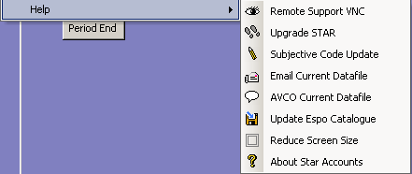

Select Upgrade STAR to manually upgrade your accounts.

Access 2007/2010 Star Accounts Drop-Down
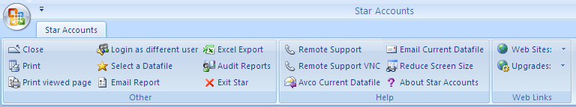

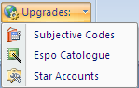
To run the upgrade select ‘Star Accounts’ from the drop down list.

