

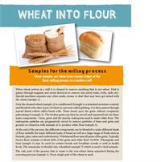
NEW Teaching Resource - Wheat into Flour
This summer grainchain.com have reprinted the Wheat into Flour packs, which include samples of wheat during the milling process to show how wheat is turned into flour. Due to limited quantities these are available free to all schools on a on-per-school basis and can be ordered by emailing grainchain@nabim.org.uk.
To bring the milling process to life a supporting video has been produced to accompany the printed material, presenting the modern flour mill and the machinery used. Click here to view the video. These resources can be used independently or in conjunction with each other.


Schools - Time to Bake Off!
Have you got what it takes for the Schools Bake Off? This summer grainchain.com is looking for talented bakers from schools to test their skills at the Cake & Bake Show on 22 September 2012. Those that are successful and shortlisted for the event will be tested on the taste of their best cake or bread bake by one of our secret celeb bakers! To enter by 31st August 2012 and for more information visit www.grainchain.com/competitions.

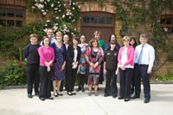
Inspiring Teachers - Winners Announced
Last week the four winning teachers of the Inspire competition came together to celebrate their inspiring lesson plans at Heygates Mill in Northampton.
- Georgina Arnold - Cansfield High School, Ashton-in-Makerfield
- Jane Atterby - Chenderit School, Banbury
- Liz Nicholl - Preston Lodge High School, Scotland
- Wendy Strain - Antrim Grammer School, Northern Ireland
During the prize day the teachers enjoyed a personal baking lesson with Paul Hollywood and were given a tour of the historical mill as well a £500 prize money towards cookery equipment for their school. The winning lesson plans will be available to view on grainchain.com in the new school year.



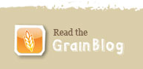

Click here to unsubscribe

