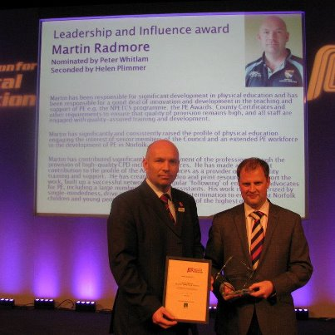
Norfolk PE Leading the Way!

Norfolk has achieved national recognition for the work that it does in Physical Education. Norfolk's PE adviser, Martin Radmore, one of the few left, has been recognised by the Association for Physical Education (afPE) for his work here in Norfolk - winning the "Leadership and Influence in Physical Education Award".

Norfolk is passionate about PE and has developed a unique High Quality PE Chartermark Award and various specialist CPD programmes, including the Norfolk PE Teaching Competence Standards, to support the quality of teaching and learning. Our Assessment Framework is widely used and we will be developing a new system as soon as the new curriculum is available. Our grateful thanks to all those who feedback to us on how useful they find this framework, including ITT lecturers, staff in schools and Teaching Assistants.

If you would like to know more about our work, or ask how we might be able to support you, your school, staff, college or setting - then please do not hesitate to contact us.

Visit Norfolk PE at: www.schools.norfolk.gov.uk/go/pe

