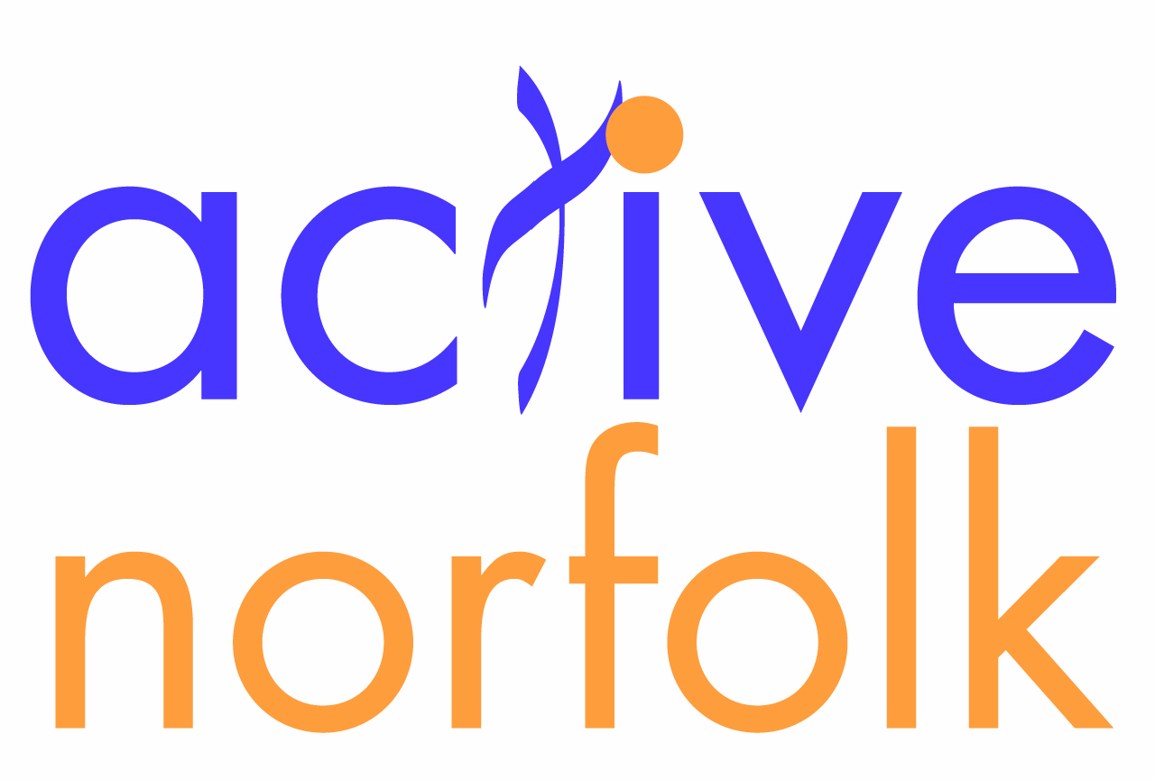

BBC Radio Norfolk & Active Norfolk Sports Awards 2012
Nomination Categories and Criteria

Title | Criteria
Sports Personality of the Year Award | - A performer who has made great progress over time, has achieved a great deal or has made a big difference to a team.  - Must be aged 19 or over on 30th September 2012
Young Sports Personality of the Year Award | - A performer who has made great progress over time, has achieved a great deal or has made a big difference to a team.  - Must be aged 18 or under on 30th September 2012
BBC Unsung Hero Award | - A volunteer who has made an outstanding contribution to local sport  - This could be an official, committee member, helper or anyone else who you feel deserves recognition for their dedication  - Please note – qualified coaches should be nominated for the ‘Community Coach of the Year’ award instead
Inspirational Sports Personality Award | - An individual who has gone to great lengths to raise the profile of disability sport within Norfolk  - An individual who has made great progress over time, has achieved a great deal or has made a big difference to disability sport in Norfolk  - This could be someone who has gained funding, helped provide opportunities for disabled athletes or encouraged people with disabilities to get involved with sport
Community Coach of the Year Award | - An inspirational coach who holds a current, recognised National Governing Body coaching qualification  - This should be someone who is committed to delivering the highest standard of coaching to their performers and / or to helping other coaches to develop
Community Club of the Year Award | - A club or team that has made great progress over time, has achieved a great deal or has made a big difference to a community
The Sports School of the Year Award | - A school that gives its pupils a wide range of opportunities to participate in high quality physical education and extra-curricular sport  - The school should show a continued commitment to school-club links and the extended school’s ethos
The Sporting Village of the Year Award | - A village or community that has increased participation in sport and physical activity  - A village or community that has developed sports provision and encourages regular participation
The Sporting Business of the Year Award | - An organisation that has increased participation in sport and physical activity through workplace health programmes  - An organisation that has developed sports provision and encourages regular participation as part of the working day (before, during and after work)
The Active Norfolk Winner of Winners Award | Chosen by the judging panel from the nine other award category winners  - Could include clubs, performers, coaches, organisations, officials, committee members or other volunteers who the panel feel deserves further recognition for their efforts in overcoming adversity or raising awareness, enjoyment and/or participation in Norfolk sport

General Notes
- All individuals nominated must either reside in Norfolk or be involved with a Norfolk sports organisation
- All organisations nominated must be based in Norfolk
- Nominees for “…….of the Year” categories will be assessed primarily on their achievements during the past year. The ‘Year’ runs from 1st October 2011 to 31st September 2012, although you can also refer to achievements beyond the past year if relevant
- Nominees for the BBC Unsung Hero category will be assessed on all relevant achievements and maybe nominated for the regional and national BBC Award.
- Winners of the Norfolk awards may be nominated by Active Norfolk for regional or national Awards (run by Sport England, BBC, sportscoachUK or other similar organisations) where corresponding categories exist

