2/10/13 – Norwich
3/10/13 – King’s Lynn
8/10/13 – Dereham

2pm – 4pm

For further information please contact: Rita Adair, Senior Lead Psychologist
rita.adair@norfolk.gov.uk
Josie Wells, Healthy Norfolk Schools
josie.wells@nhs.net
To book places please contact:
Jenni Barber, Business Support Officer
jenni.barber@norfolk.gov.uk
01603 307756
***Schools who secure a place on this course will automatically receive ongoing support in using the training to achieve
Enhanced Healthy School Status.***

95% of young people in Britain use homophobic language and 55% experience homophobic bullying in school - Stonewall
New Government legislation requires schools to be proactive in preventing homophobic bullying and making all children and young people feel included. The Public Duty requires schools and academies, to eradicate discrimination, advance equality and foster good relations - this means preventing and tackling homophobic bullying and language.

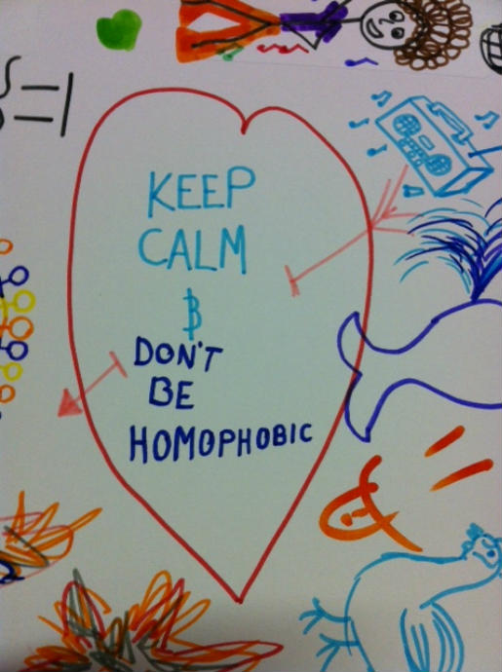

ADDRESSING HOMOPHOBIC BULLYING IN YOUR SCHOOL
COURSE AIMS:
- Identify what constitutes bullying and define homophobic bullying.
- Clarify what responsibilities schools and academies have to address homophobia and homophobic bullying.
- Know how to develop a policy that meets Ofsted criteria for challenging homophobia.
- Explore a range of cross curricular teaching activities and resources.
- Consider how to support children and young people, and their families.


