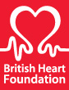
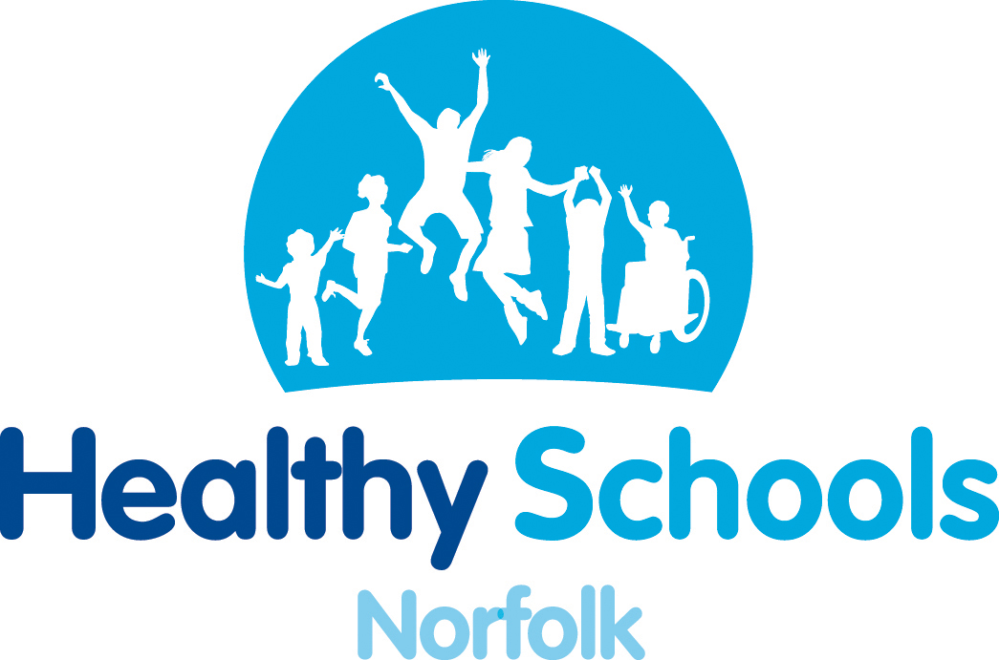
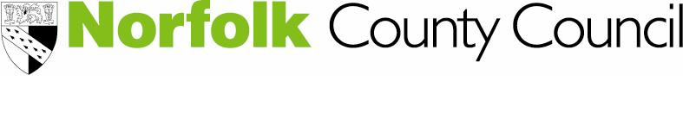

Healthy Hearts in the Classroom
Resources for your whole school day
A free half day workshop designed to showcase a range of resources suitable for use in a primary school setting.
Healthy Schools Norfolk is delighted to be working with the British Heart Foundation National Centre for Physical Activity & Health to offer this half day workshop at no cost to schools.
Workshop details:
Date: Thursday 7th November 12:30 – 16:00, a light lunch will be provided for participants.
Venue: Norwich Professional Development Centre.
How can Healthy Hearts in the Classroom benefit your school?
This interactive workshop has been designed to help you promote health and well-being across the school day through lessons, projects and activities. The British Heart Foundation workshop tutor will be demonstrating how their wide range of resources can be used to inject new ideas into lessons and activities including working with parents.
Participants will have the opportunity to explore the resources and share ideas with others about how these can be used to introduce fun learning experiences.
Who should attend?
These workshops have been designed to support primary school teachers and others working in primary schools including: Teaching Assistants, PE Co-ordinators, PSHE leads and Extended Schools Co-ordinators.
To book a place please contact Jenni Barber at jenni.barber@norfolk.gov.uk
For more information about the course please contact Adele Godsmark, Schools Health Partnerships Adviser 01603 221812 adele.godsmark@nhs.net
*Please can you state at the time of booking if you have any special dietary requirements.
Cancellation Policy
This course does incur a £20 administration fee for non-attendance or if cancelled within 5 working days of the course date.

