**Glazing in critical areas**

Unfortunately, an incident recently occurred in a Norfolk school where a pupil suffered significant cuts to her hand and forearm as result of running into a fire door and her hand going through a glass panel. This MI sheet highlights safety requirements for glazing in high risk areas and requires you to take action.

Glazing in areas at greatest risk of being broken – known as critical areas – should be of an appropriate toughness to prevent it being broken and injury being sustained. The diagram below shows the areas considered to be critical locations.

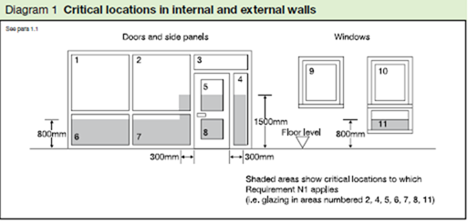

All new glass installed in critical areas should be purchased and installed to a standard that meets these requirements. For existing glass that doesn’t comply, additional protection will be needed. The aim is to ensure firstly that the glass is difficult to break, but secondly, so that if it does break, it breaks safely i.e. without jagged edges.

You can check your glazing in these critical areas by looking for labelling or marking referring to BS6206 (older British Standard) or BS EN 12600, which replaced BS6206. Within these standards, there are further sub classes:

* BS6206 has classes A, B and C (A offering highest level of safety)
* BSEN12600 has classes 1, 2 and 3 (1 offers highest level of safety)

A number of years ago, a programme was undertaken to upgrade glazing in critical areas and where BS6206 was not being met. This involved applying a safety film over the glass so that if it did break, it would be held together and not shatter dangerously.

In the incident in question, a sticker on the panel stated the film had been applied and met BS6206 but the investigation revealed the film had never been applied. All other critical areas had had the film correctly applied except the door in question and so the strong likelihood was that this was due to human error rather than a deliberate omission. As the sticker had been applied to the door and the film is difficult to see, there is no reason school staff would have known the film had not been applied.

**Action that must be taken**

All schools must check their glazing in critical areas to ensure it meets the appropriate BS6206 or BSEN12600 standard (either manufactured or upgraded to this standard). Where the glazing has a sticker to confirm it has been upgraded, you should check the film has actually been applied. You should look carefully for the following:

* Air pockets/bubbles, particularly where the film covers the sticker
* Peeled corners or scratches that show the glass beneath
* A very slightly raised edge to the film where it hasn’t been applied up to the very edges of the pane (where it enters the beading)

Where you have concerns over any glazing or difficulties establishing whether it meets the standards above, you should seek further advice from your appointed glazier and arrange for remedial works to be undertaken as required.