
24 May 2010
Dear Colleague

TEACHERS’ SUMMER FAIR – 14 JULY 2010
Norwich Cathedral’s Hostry Visitor and Education Centre
Norwich Cathedral, 2 The Close, Norwich NR1 4DH

On WEDNESDAY 14 JULY, the Norwich Education Network (NEN) is offering our second free teachers’ day at Norwich Cathedral’s new Hostry Visitor and Education Centre. NEN is a group of heritage, cultural and education providers based at venues across the city who deliver a wide range of courses and activities for schools and learners of all ages and abilities.

You are invited to join us for drinks and nibbles at any time between 3pm and 6pm. Come and celebrate the end of term and meet representatives from the network who will give details about their educational activities and services.* There will be a range of activities on offer designed to inspire both primary and secondary level teachers and you will also be able to take a tour of the beautiful Cathedral and experience the recently opened Hostry Centre.

As this is likely to be a popular event, it would be helpful if you could let us know if you plan to attend by either completing and posting the response form to me at Cinema City, St Andrews Street, Norwich NR2 4AD or else email me: guy@cinemaplus.org.uk with the required information.

Yours sincerely
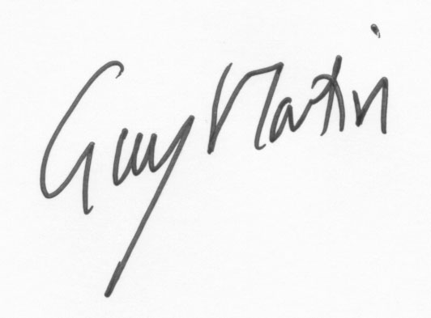

Guy Martin
Chair, Norwich Education Network

PARKING: We can offer disabled parking for badge owners and general parking for teachers after 5pm – up to then the nearest car parking and the cheapest is St Andrews Car Park on Duke Street or Magdalen Street under the fly-over. The Hostry will be signposted from the gateways and it is the main entrance to the cathedral.

*NEN member organisations: Norwich Cathedral, Cinema City, Norwich Theatre Royal, Norwich Playhouse, Inspire Discovery Centre, Castle Museum, Norwich Puppet Theatre, Dragon Hall, The Julian Centre, The Cathedral of St John the Baptist, Norwich Heritage and Economic Regeneration Trust (HEART), Norfolk Record Office, Norfolk and Norwich Millennium Library, Hungate Medieval Art, the Sainsbury Centre for Visual Arts and University of East Anglia.

To download a map of NEN members, go to: www.cinemaplus.org.uk/About/norwicheducationnetwork.aspx
…………………………………………………………………………………………………………………………..

RESPONSE FORM
Teachers’ Summer Fair at Norwich Cathedral Hostry - 14 July 2010 3pm-6pm

Main contact name………………………………………………….. ……….No. of people attending ……
Job Title………………………………………………………………………………………………………..
School/ Organisation…………………………………………………………………………………………
Phone number…………………………… Email address……………………………………………..
Access requirements (e.g. disabled parking)………….…………………………………………………..

Please return (by Friday 25 June) to Guy Martin at Cinema City, St Andrews Street, Norwich NR2 4AD

