Norfolk County Council - Children’s Services

Operations and Integrated Services
from October 2010

This document sets out how Children’s Services will deliver local services to support children, young people and their families from 25th October 2010. It is intended to act as a guide for schools, voluntary organisations and agencies so that they know who to contact.

The Children’s Services Department is organised into three Operational Divisions in Norfolk:
- North and East
- West and Breckland
- City and South

These divisions are made up of the seven district council areas:
- North Norfolk, Broadland, Great Yarmouth
- Kings Lynn & West Norfolk, Breckland
- South Norfolk, Norwich
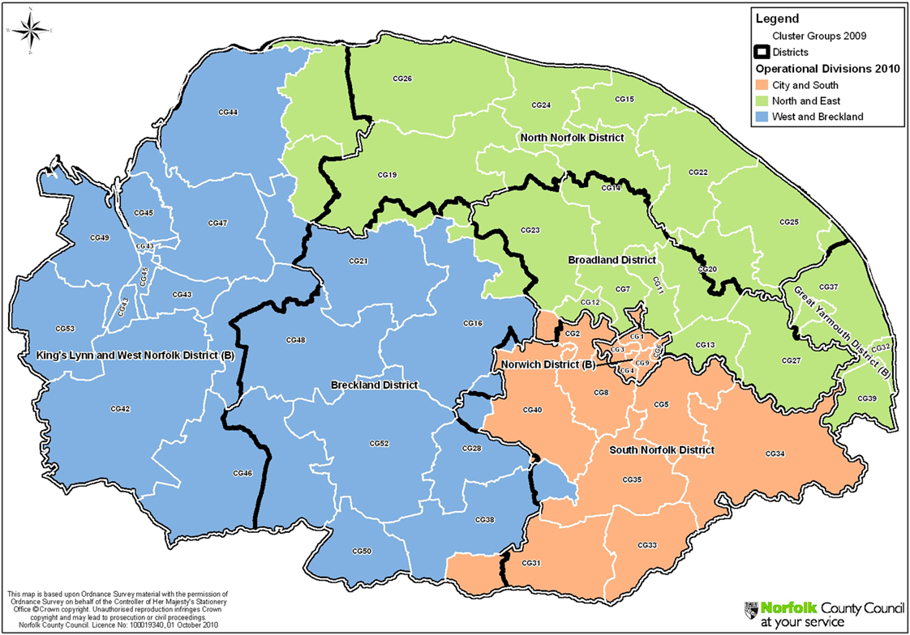

There are three senior operational managers for each of the operational divisions:

Role | North East | West & Breckland | City & South
Safeguarding Manager | Cathy Mouser | Peter Ronan | Paul Corina
Localities & Integration Manager | Ali MacPhail | Sandra Summerfield | Laura Sutton
Locality Co-ordinator | Phil Beck | vacant | Carey Cake

Each of these divisions provides local services to children and families through:

- Public services
- Schools
- Voluntary organisations
- Independent providers

Additionally, specialist county resources are available to supplement local provision and support specialist needs within families. These services are managed by two senior operational managers:
- Additional Needs: Christopher Butwright
- Corporate Parenting: Malcolm Griffiths
Children’s Services will draw together countywide and local services from the following range of services to form a team around the child, involving partners from all sectors:

Norfolk County Council Children’s Services - county services

Care Connect Norfolk County Council Customer Service Centre
Team Supervised Contact Service

Family Group
Conference
Service

Sensory Support
Team

Pupil Referral Units

County Adolescent
Prevention Team

County
Placement
Provider Team

Fostering Services

Specialist Social Work Service –
Diverse Communities
Home Based Care Unthank Centre
Adoption & Family
Finding Unit Residential Units

Children’s Services delivered within operational divisions:

- Consultation Service
- Duty Teams
- Safeguarding Teams
- Children in Need
- Corporate Parenting
- Integrated Youth Support
- Early Years
- Family Placement
- Education Psychology &
School Support
- Family Solutions
- Children with Disabilities

Pupil Referral Units

The following principles underpin the work of all teams within Children’s Services:

Principles

- The best interests of the child/young person are paramount.

- Children’s needs are best met by their own family and community and when this is not possible are best met in Norfolk.

- We will be a good and prudent corporate parent.

- We will support all children to achieve their full potential.

- We will ensure equality of opportunity and work in partnership with children and families.

- We will actively listen to the voice of the child.

- Our work is child centred and rooted in an understanding of child development.

- Our work is holistic, focused on improving outcomes in a timely way.

- Meeting a child’s needs is all our responsibility.

- Where a child is identified at risk we will identify strengths and concerns and robustly work to achieve change and review outcomes.

- We will be ambitious, accountable and trusting.

- We will work across organisational boundaries to meet the identified needs of children.

- We expect high professional standards from ourselves and we will not unnecessarily duplicate assessments using the priority matrix as a shared tool.

- We are committed to multi and inter agency working and will actively promote restorative approaches.

- We will work from a strengths model where we continuously assess, plan and review.

- Our practice will be informed by evidence.

How we will work:

We will implement a “Team Around the Child” model bringing together professionals from all the teams and agencies available, informed by the individual needs of the child and family. The priority matrix is a toolkit used to score the level of need in each case. Within the team around the child, services will be provided by statutory agencies, independent providers and voluntary organisations. This approach will apply to all situations, whatever the level of need within the family, so will include:

- Using the priority matrix to determine the level of intervention
- Using the common assessment framework (CAF)
- Using Family Support Planning Meetings
- Using Core Group meetings when a child is the subject of a Protection Plan.

General process:
Identify a concern early

Assess the need

Form a team around the child

Agree a plan to provide assistance and services

Review progress and agree a new plan

Whenever a team around the child is formed a lead professional will be identified according to the following guidelines:

Level of need | Priority Matrix score | Lead professional | Type of team around the child meeting
Early Intervention  CAF | Under 10 | Any professional | CAF
Section 17 Child in Need | 10-11 | Member of Children in Need team | Family Support Planning meetings
Section 17 Child in Need | 12+ | Member of the Safeguarding Team | Family Support Planning meetings
Child Protection Plan | 12+ | Social Worker from Safeguarding Team | Core Group meetings

The lead professional will be responsible for ensuring there is a delivery plan in place, coordinating involvement of services, ensuring a review of the delivery plan takes place within the agreed timescale, ensuring meetings and plans are recorded and the record distributed to Team Around the Child members, including family members as appropriate.

A new Multi-Agency Service Hub made up of Children’s Services, Police and Health staff is being designed to deal with referrals for services. It is anticipated that this will be in place by April 2011. In the meantime cases will continue to be referred via the current referral routes. The priority matrix will be applied to every referral and the score will determine which team the case is passed to for follow up. No longer will cases have to reach the threshold for child protection in order to access services.

Consultation Lines

The consultation line will also continue to be available although there are important changes to accessing the Consultation Service. In future if the child you are worried about lives in:

Breckland District Council and Borough Council of King’s Lynn and West Norfolk areas please call: 01553 669300

Norwich City Council and South Norfolk District Council boundaries please call: 01603 224134

North Norfolk District Council, Broadland District Council or Great Yarmouth Borough Council please call: 01493 850317

If you are not sure which district council a child lives in, Please refer to the following hyperlink to the “Where I live” website: www.whereilive.norfolk.gov.uk/

Contacts from 25th October 2010 for the new teams are:

North and East Contact Numbers
Safeguarding Operational Manager: Cathy Mouser 01603 894653
Locality and Integration Manager: Ali MacPhail 01493 414531
Locality Co-ordinator: Phil Beck 01493 414514
Duty Manager: Suzie Thurlow 01493 845015
Safeguarding Manager (Gt Yarmouth): Tracey Whittaker 01493 845055
Safeguarding Manager (Nth Walsham): Arlene Moore 01603 894690
Children in Need Gt Yarmouth: Nicola Brown 01493 414518
Children in Need North Norfolk: Lea Gurling 01263 710195
Children in Need Broadland: Carol Manning 01603 894690
Integrated Youth Support Team (East) Teresa Gonzalez 01493 845407
Integrated Youth Support Team (North): Roger Allen 01692 408211
Integrated Youth Support Team (Broadland): Jeff Leak 01493 414566

West and Breckland
Safeguarding Operational Manager: Peter Ronan 01842 855685
Locality and Integration Manager: Sandra Summerfield 01553 669632
Locality Co-ordinator: tbc to be confirmed
Duty Manager: Peter Hurst 01553 669350
Safeguarding Manager (West Norfolk): Jo Diggines 01553 669366
Safeguarding Manager (Breckland): Anne McKendrick 01842 855660
Children in Need West Norfolk: Colin Spinks 01553 614875
Children in Need Breckland: Liz Thom 01953 450530
Integrated Youth Support Team (West): Christopher Murray 01553 773565
Integrated Youth Support Team (Breckland): Penny Churchard 01842 855819

City and South
Safeguarding Operational Manager: Paul Corina 01603 223750
Locality and Integration Manager: Laura Sutton 01603 223565
Locality Co-ordinator: Carey Cake 01603 223876
Duty Manager: Jane Kett 01603 223582
Safeguarding Manager (Norwich): Marie Underwood 01603 223687
Safeguarding Manager (South Norfolk): Flo Watson 01953 602071
Children in Need Norwich: Carol Haynes 01603 223827
Children in Need South Norfolk: Treloar Sheppard 01953 602071
Integrated Youth Support Team (City): Nicki Rider 01603 215361
Integrated Youth Support Team (South Norfolk): Andre Sloos 01379 642425

Countywide contacts:
Assistant Director, Operations & Integrated Services:
Lesley Whitney 01602 223747
Corporate Parenting Operational Manager:
Malcolm Griffiths 01603 222574
Additional Needs Operational Manager:
Christopher Butwright 01603 638049

