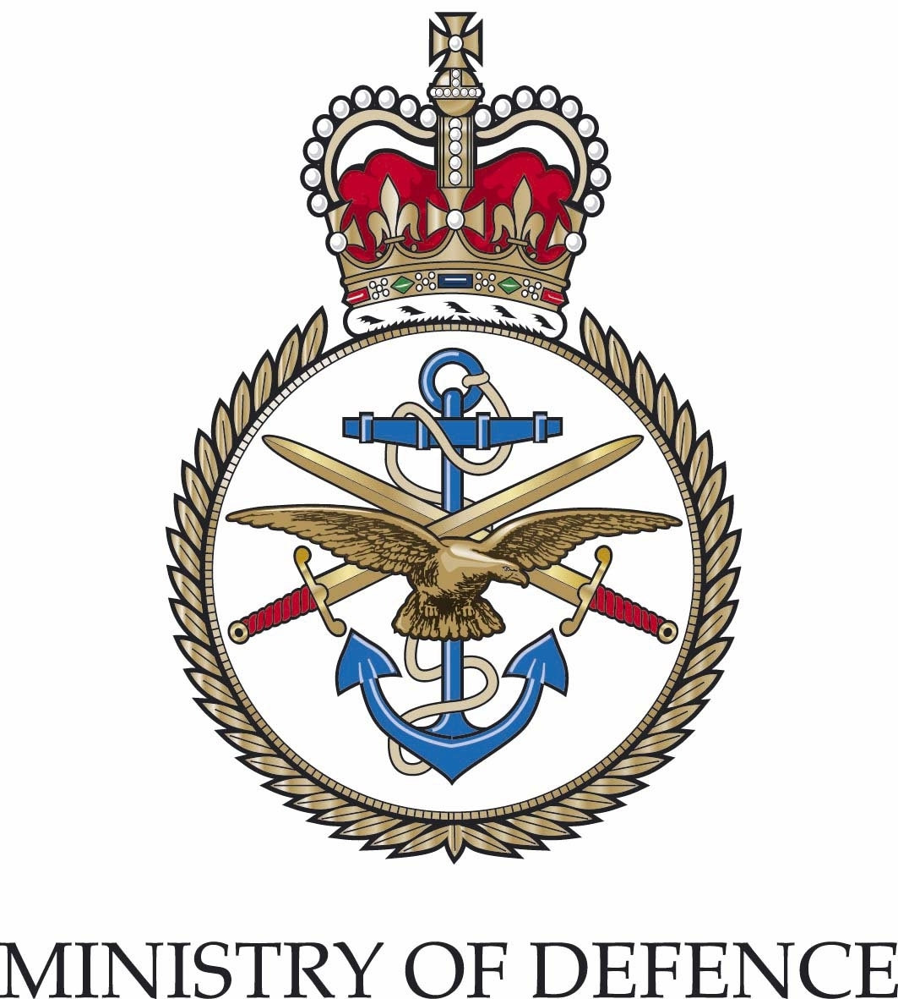 | Children’s  Education  Advisory  Service | Trenchard Lines, Upavon, Pewsey Wiltshire SN9 6BE  Tel Upavon Mil 94 344 8244 Tel Civil 01980 618244  Fax Upavon Mil 94 344 8245 Fax Civil 01980 618245  E-mail: enquiries@ceas.detsa.co.uk
For the attention of :  The Director of Children’s Services |  |  | Your reference:  Our reference: D/AG/208.1/CEAS  Date: 30th November 2010

Dear Colleague,

Service children

Thanks to the inclusion, from 2008, of a Service children’s marker in the Annual School Census (ASC) in England, better information about their whereabouts is emerging. Service families are not obliged to disclose their children’s status and this, together with the career-induced mobility of Service life and the annual nature of the ASC means that a comprehensive, accurate picture is difficult to establish.

Although the DfE published, in the summer of 2010, a research report entitled, ‘The Educational Performance of Children of Service Personnel’ which provided some evidence that the attainment of Service children nationally was on a par with their ‘civilian’ peers, one local authority providing for a significant number of Service children has produced evidence, following a more detailed analysis of attainment in its area that the attainment of some Service children (e.g. more able children) did appear to suffer.

Whilst it is not possible, yet, to provide definitive conclusions nationally about the effects of Service-induced mobility and the deployments, to hostile locations overseas, of parents and siblings on the attainment and well-being of Service children, there are many professionals and Service parents around the country who continue to be concerned about the particular needs of these children and those of the schools and local authorities that serve them.

Within this context, I am writing to you to draw to your attention and that of the schools in your area, the sources of information, advice and support which are available to Service families, schools and local authorities in respect of the education of Service children.

- The Children’s Education Advisory Service (CEAS)

CEAS is the U.K. arm of the MOD’s Directorate of Children and Young People (DCYP) and, currently, is established to provide information, advice and support to Service families about anything to do with their children’s education in the U.K. or overseas. Much of the focus of our work is on working with Service parents and those that provide for them educationally on issues such as admissions to schools, SEN, managing the implications of curricular discontinuity and access, for eligible families, to MOD supported boarding placements in both the state-maintained and independent sectors.

CEAS also works with all relevant stakeholders - including the armed Services, the MOD, DfE, local authorities and schools – to try to address strategically the needs of Service children and their families as well as the needs of local authorities and schools in making effective provision for them. Colleagues in your schools and in your Directorate centrally may have come across CEAS staff working in support of individual Service families and/or representing the needs of Service communities at, for example, your local Schools’ Admissions’ Forum.

In addition to the contact details displayed at the head of this letter, you may find further information form the CEAS web site at: www.mod.uk/ceas

2. Service Children in State Schools (SCISS)

SCISS is a consultative body, representing the interests of those state schools in England which have Service children on their roll, established on behalf of the MOD, by CEAS, in 2005. SCISS was established to provide a forum for discussion and action on those issues which impact on the provision of education for Service children which arise as a result of Service-induced mobility. Furthermore, SCISS champions the needs of State schools with Service children by representing their interests to DfE and MOD and provides a forum for sharing good practice, liaison and support for schools through, amongst other things, local groups set up by members, the SCISS Handbook and regional meetings. SCISS is represented at the MOD’s Children and Young People’s Trust Board and the Service Children and Young People’s Forum.

SCISS aims to:

- Develop an informed national perspective about the issues facing schools providing education for Service Children;

- Work with the MOD, DCSF and Local Authorities on solutions to issues facing schools with Service Children;

- Share and exchange information with the Scottish and NI Service Children’s Forum and with Service Children’s Education (SCE), the overseas arm of the MOD’s DCYP;

- Facilitate the development of good practice in Schools through regional conferences and the Handbook (access to the Handbook is available through the CEAS web site).

Any school that has pupils that are Service children may put themselves forward for affiliation to SCISS, simply by following the instructions given at the end of this letter.

The SCISS National Executive meets three times a year in February, June and October. A list of members of the SCISS National Executive is attached for your information.

Regional Meetings

CEAS holds regional meetings every two years, on behalf of the SCISS Executive, to give headteachers, local authority representatives and local military points of contact the chance to meet and discuss their continuing work and any other recent educational issues affecting Service children.

The next round of meetings will take place in between 14-25th March 2011 and will be held in Farnborough (Hampshire), Catterick (North Yorkshire), Plymouth (Devon), High Wycombe (Bucks), Larkhill (Wiltshire), Rutland and London. The venues and dates are yet to be confirmed.

I would be grateful if you would draw this letter and its contents to the attention of all the headteachers of all maintained schools and academies in your local authority area. Whilst colleagues in authorities serving significant concentrations of Service personnel may be aware of both CEAS and SCISS, SCISS National Executive members remain concerned about those schools and local authorities with smaller or more dispersed Service communities where the needs of Service children may be overlooked. If you or any of the schools within your authority would like to be included on the SCISS database, please complete and return, as directed below, the attached pro-forma.

Please do not hesitate to contact me if you require any further information or would like to discuss any aspect of this letter.

Yours sincerely,

Olivia Denson

Mrs O M Denson
AD CYP(IAS)
Head of CEAS

------------------------------------------------------------------------------------------------------------------------

Please complete the pro-forma below and return to:

Ms J Muspratt
CEAS
Bldg 190, Trenchard Lines
Upavon, Pewsey
Wiltshire
SN9 6BE

Or email your details to: jmuspratt@ceas.detsa.co.uk

Headteacher:
Name of School:
Address:
Telephone & Fax Number
Email*

* Please complete your email address as we would like to contact you by email in the future.

SERVICE CHILDREN IN STATE SCHOOLS

WORKING GROUP MEMBERS

Name | Post / Organisation
Grahame Shepherd | Headteacher, Le Cateau Primary School (North Yorkshire) Chair
Olivia Denson | Head of Service, CEAS – MOD Vice Chair
Jeremy Watt | Deputy Head of Service, CEAS - MOD
Martin Bull | DfE School Standards
Lt Col Andrew Purdy | SO1, Directorate of Service Personnel Policy (SPPol)
John Stephens | Headteacher, Goosewell School (Plymouth)
Mike Curtis | Headteacher, Carterton Primary (Oxfordshire)
Coryn Bell | Assistant Headteacher, The Priory Academy (Lincolnshire)
Alex Bostock | Headteacher, Clarendon School (Wiltshire)
Hilary Alcock | Headteacher, Buntingsdale School (Shropshire)
Amanda Rowley | Headteacher, Wavell School (Hampshire)
Mike Chislett | Inspector Adviser, SCE Germany
Jan Chambers | Local Authority Representative (Wiltshire)
Matt Blyton | Local Authority Representative (North Yorkshire)
Joy O’Neill | School Governor, Halton Community Combined School (Bucks)
Paul Spencer-Ellis | Headteacher, Royal Alexandra & Albert (State Boarding) School (Surrey)

