This Upgrade must be completed as it contains the revised Standard VAT Rate of 20% (Vat Code ‘A’). It will available with the December (Period 09) from 6th January 2011

1. AVCO Automatic Upgrade

Please Note: The Automatic Upgrade will only work if AVCO is accessible on the same PC that operates Star Accounts.

If AVCO is not accessible, copy the file Upgrade_Star.exe from your AVCO Finance Inbox into the folder designated as your Inputs Path (see Records, School Details). If the file does not exist please copy it from the AVCO Archive folder.

Start a call in AVCO. Once the call has completed you should see a file called

Upgrade_Star.exe in the Finance folder within the Inbox.

If you are logged into Star Accounts whilst the AVCO call is being made you will need to log out completely, and then log-in again for the upgrade to take place.
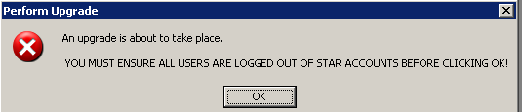
Click ‘OK’

The upgrade will take approximately 1-5 minutes. Please wait for the following message to appear:
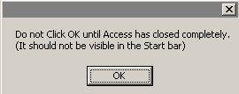
Click ‘OK’

NB: If you are not sure if Access is still open, check that the following is no longer visible in the bar at the bottom of the screen.

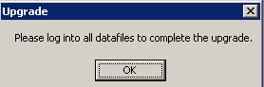
Click ‘OK’

The Main Menu should say 5.0.
Only perform the following upgrade from within Star Accounts if the Automatic Upgrade was unsuccessful!

2. Upgrade from within Star Accounts

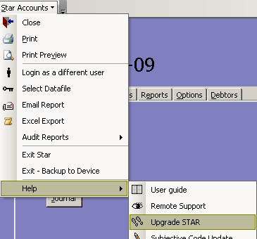
Click on the Star Accounts dropdown in the toolbar; select ‘Help’ and then ‘Upgrade STAR’.

Star Accounts will close and run the upgrade. Once the upgrade is complete a message box will appear stating the upgrade was successful. Click ‘OK’ to this message and Star Accounts will open.

When you log back into Star Accounts the Main Menu should say 5.0.

3. Upgrade Release Notes and Current Version Number

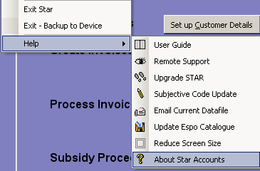

The ‘Current Upgrade Release Notes’ and Version number can be viewed within “About Star Accounts”.

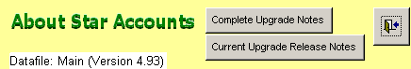
Datafile: Main (Version 5.00)

4. Subjective Code Update

Once the upgrade has been completed please perform a Subjective Code Update as per the Userguide (Section 15 page 17)

