This Upgrade must be completed as it contains the revised Standard VAT Rate of 20% (Vat Code ‘A’). It will available with the December (Period 09) from 6th January 2011

1. AVCO Automatic Upgrade – Main PC

Please Note: The automatic upgrade will only work if AVCO is accessible on the same PC that operates Star Accounts. If AVCO is not accessible, copy the file Upgrade_StarSQL.exe from your AVCO Finance Inbox into the folder designated as your Inputs Path (see Records, School Details). If the file does not exist please copy from the AVCO Archive folder.

The automatic upgrade will only upgrade the PC that has access to the AVCO Finance Inbox. A copy of the current version of Star Accounts.mdb will be placed into the Star\Backup folder on the server to enable additional users to upgrade.

Start a call in AVCO. Once the call has completed you should see a file called Upgrade_StarSQL.exe in the Finance folder within the Inbox.

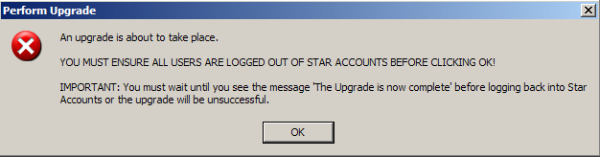
Click ‘OK’
(Please note: If you get an ‘Open File – Security Warning message’ appear click ‘Open’ to continue the upgrade)

The upgrade will take approximately 1-2 minutes so please wait for the following message to appear.
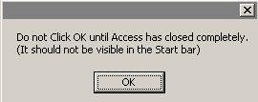
Click ‘OK’

NB: If you are not sure if Access is still open, check that the following is no longer visible in the bar at the bottom of the screen.
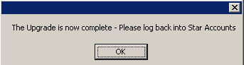
Click ‘OK’

The first time you login the upgrade will update all data files held on your server (including prior year data files). This will take a while but you must wait for the following message to appear:
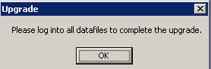
Click ‘OK’

The Main Menu should say 5.0. Remember to log into all other datafiles to complete the upgrade.

If the version number is not 5.0 you need to run the Upgrade as per the instructions in step3.

To view the Release Notes refer to Section 4.

2. Upgrade Additional Users

As soon as the data files have been upgraded, when other users attempt to log into Star from their PC they should see the following message:
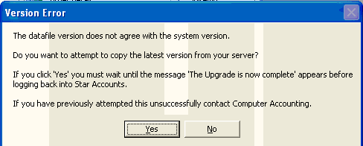

Click ‘Yes’ to copy the current version of Star Accounts from the server to the PC. You must wait for the following messages to appear.
Click ‘OK’

Click ‘OK’

The Main Menu should say 5.0.

3. Upgrade from within Star Accounts

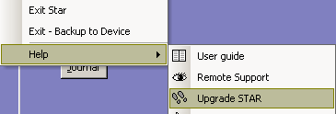
Click on the Star Accounts dropdown in the toolbar; select ‘Help’ and then ‘Upgrade STAR’.

Star Accounts will close and run the upgrade.

When you log back into Star Accounts you will get the following error message.
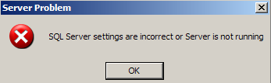
Click ‘OK’

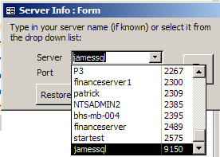
Select your server from the drop down list (Referenced by your Location Code).

Click the exit button to continue to the ‘Select Datafile’ screen. DO NOT CLICK THE ‘RESTORE DATAFILE’ BUTTON.

The first time you login the upgrade will update all data files held on your server (including prior year data files). This will take a while but you must wait for the following message to appear:
Click ‘OK’

The Main Menu should say 5.0. If the version number is not 5.0 you need to contact Computer Accounting.

To view the Release Notes and upgrade version please refer to Section 4.

4. Upgrade Release Notes and Current Version Number

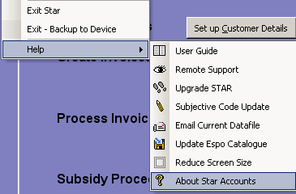

The ‘Current Upgrade Release Notes’ and Version number can be viewed within “About Star Accounts”.

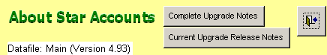
Datafile: Main (Version 5.00)

5. Subjective Code Update

Once the upgrade has been completed please perform a Subjective Code Update as per the Userguide (Section 15 page 17)

