To download the 2011-12 Budget Planner Spreadsheet please take the following steps.

1. Download the Installation File

Start a call in AVCO AnyComms. Once the call is completed open the Finance folder within the AVCO Inbox Folder. Ensure the file ‘Upgrade_Budget_Planner_2011_12.exe’ has been downloaded.

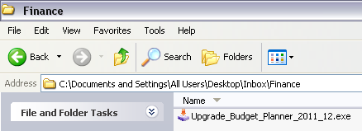

If you have any issues receiving this file via AVCO please contact ICT Solutions (0845 303 3003).

If you wish to install the budget plan onto a different computer, copy the ‘Upgrade_Budget_Planner_2011_12.exe’ file to a memory stick and follow the instructions below on the other machine.

2. Run the Installation File

Double click the ‘Upgrade_Budget_Planner_2011_12.exe’ file.

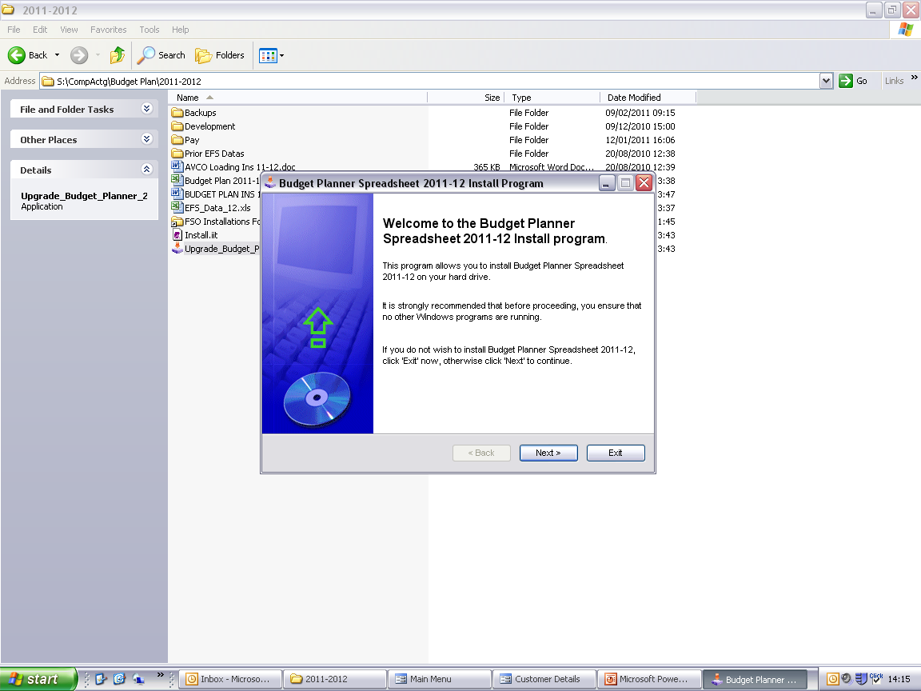
Click ‘Next’.

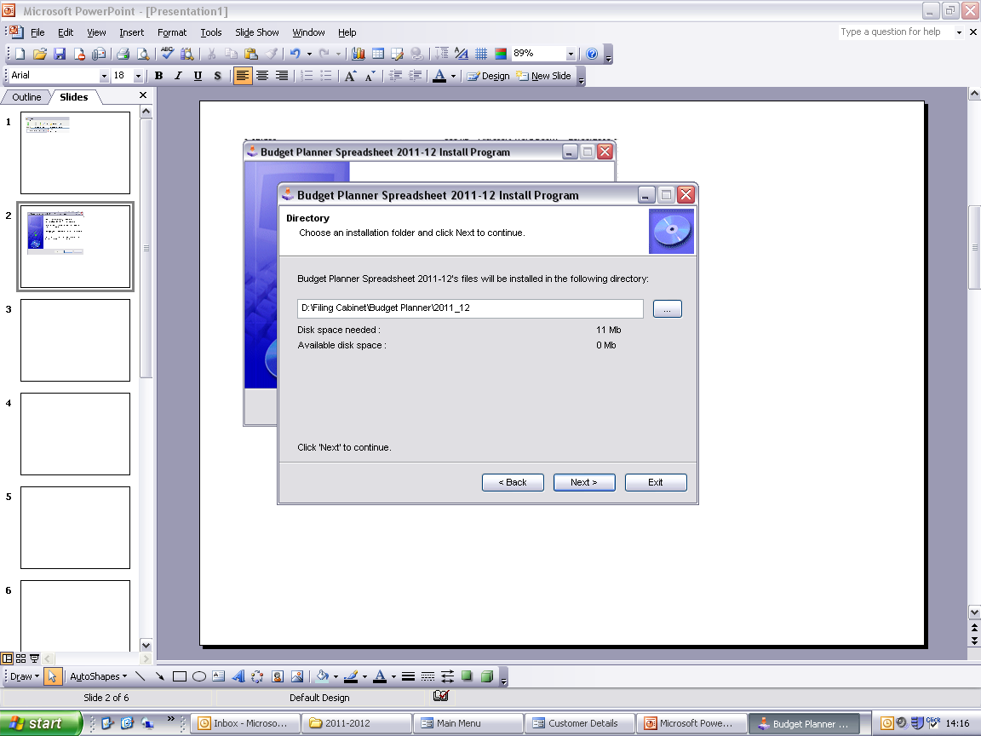
The Budget Plan will default to installing in the directory shown. If you wish to install the budget plan to a different click here to browse in the required location.
Click ‘Next’.

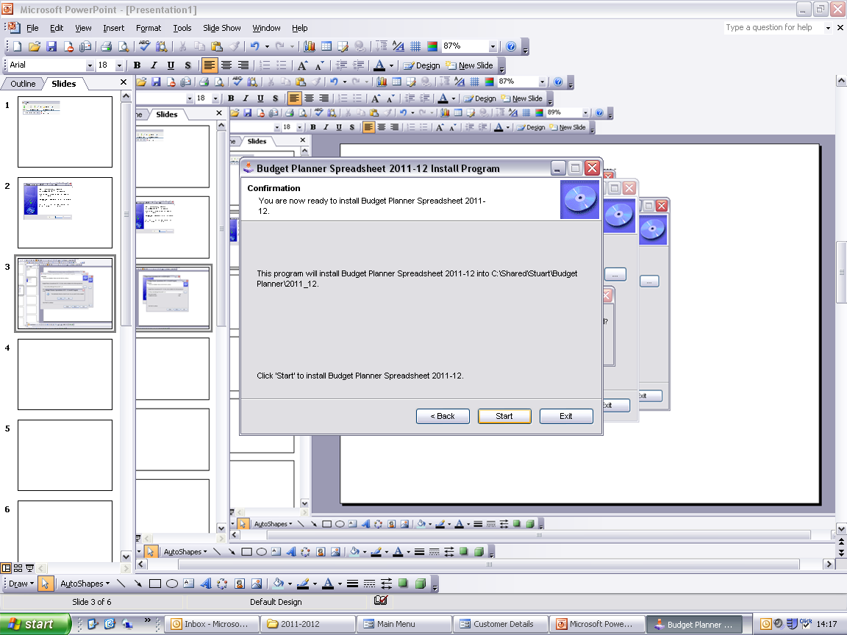
Click ‘Start’.

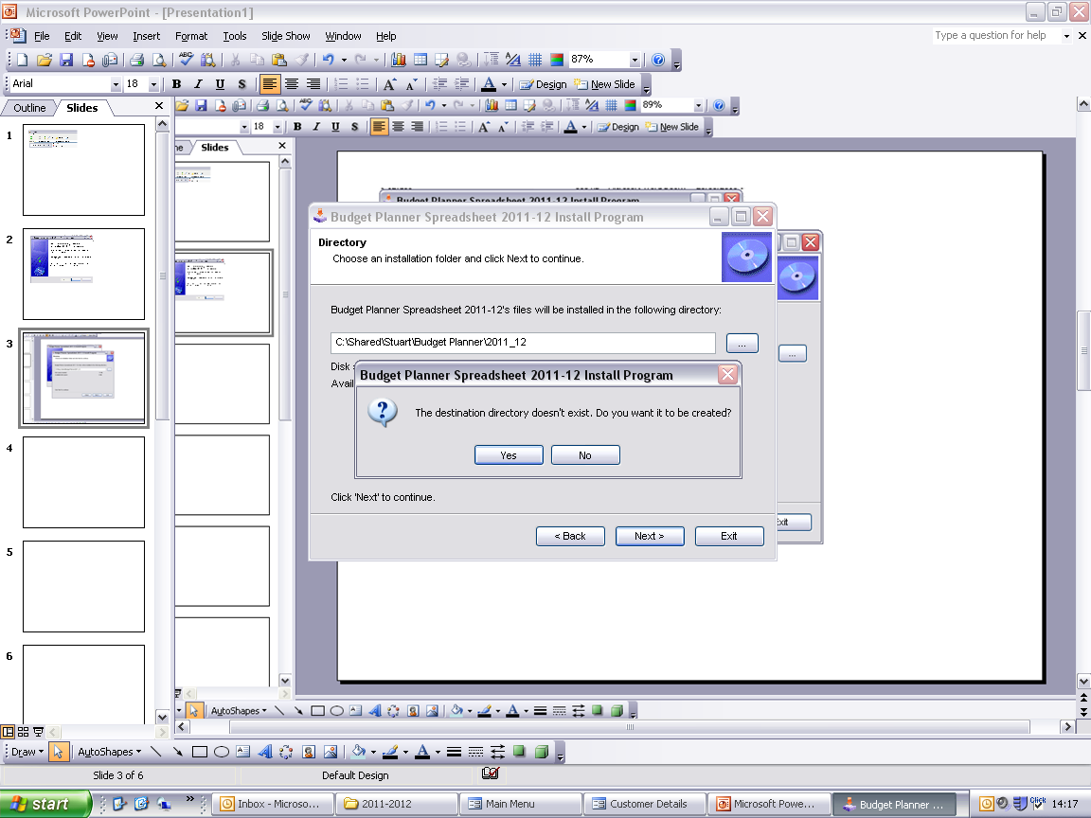
Click ‘Yes’.

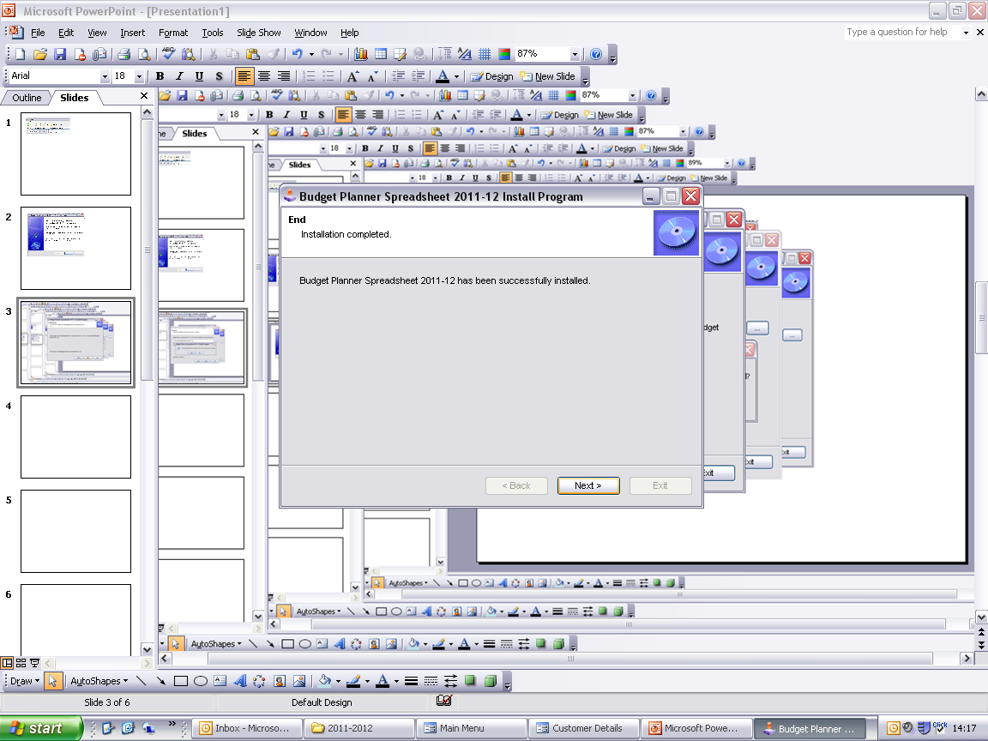
Click ‘Next’.

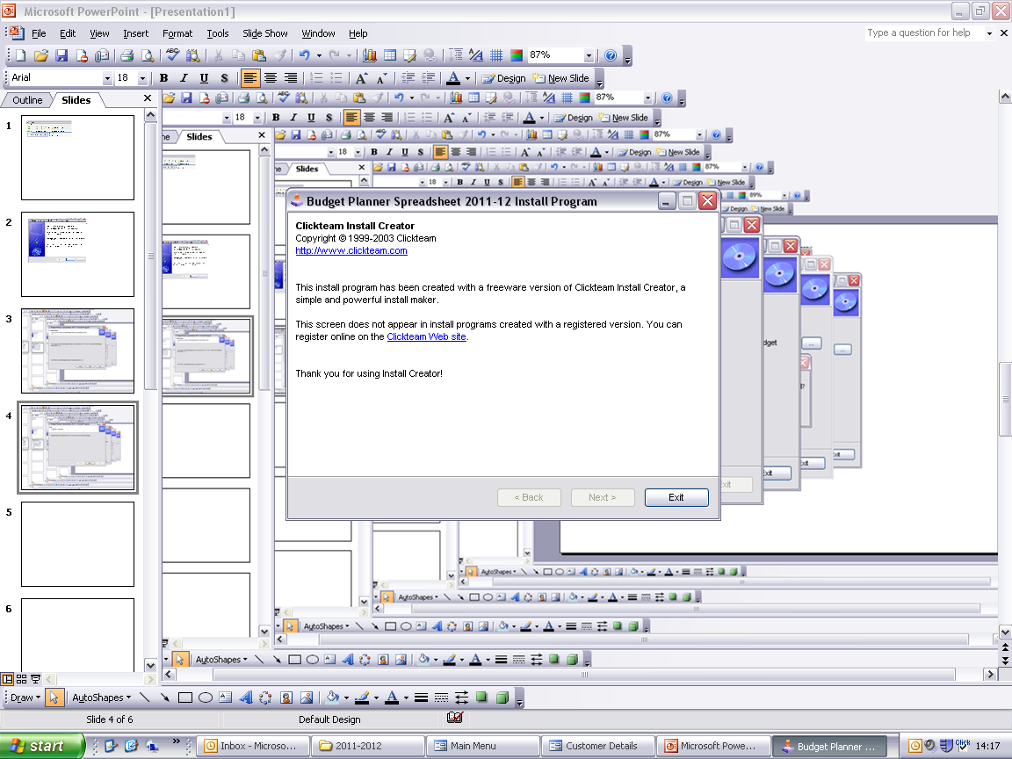
Click ‘Exit’.

3. Opening the Spreadsheet

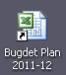
A shortcut to the budget plan will be created as part of the installation process. Double click the shortcut to open the spreadsheet.

Please Note: When opening the Budget Planner spreadsheet you should always click ‘Enable Macros’ and ‘Don’t Update’ when prompted.

If you are operating the budget planner spreadsheet using Microsoft Excel 2007 you will be required to complete the following steps to ensure that the full functionality of the spreadsheet can be utilised.

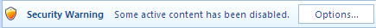

Click the ‘Options’ button on the security warning.

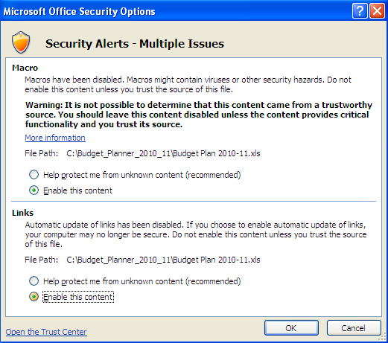

Click ‘Enable this content’ for both the Macro and Links options, and then click ‘OK’. If you do not enable the content you will not be able to use the Budget Planner Spreadsheet!

4. Enter / Amend School Name

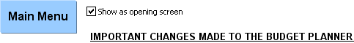

The first screen you will see when logging into the Budget Planner provides a list of the important changes that have been made to the Budget Planner for 2011-12. Once everyone who uses the budget planner has seen this screen it can be turned off by removing the tick from the “Show as opening screen” box.

Click the “Main Menu” button to enter the spreadsheet. The first time you log in to the spreadsheet you will be prompted to enter your school name. Select your school name from the drop-down list and click OK.

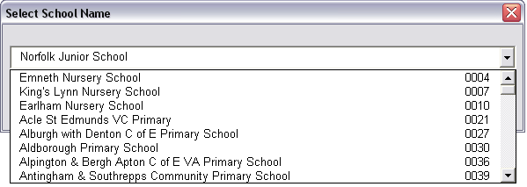

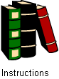
It is highly recommended that once the spreadsheet has been installed you view the updated user guide as several changes will have been made to the software for the current financial year. The user guide can be accessed via the ‘Instructions’ link on the Main Menu.

