Sickness Insurance Scheme 2011-12

From Period 01 2011-12 (April 2011) all schools buying into Norfolk County Council’s Sickness Insurance Scheme will be required to complete and return their monthly claims electronically.

The Sickness Insurance database will be released for schools to download in April 2011 – a further MI sheet will be released when the database is available.

The main reason behind this change in procedure is to introduce efficiencies into the payment of sickness insurance claims:

- The database will calculate the number of payable days for each sickness record without the user needing to make adjustments for the type of contract purchased – all the user needs to enter is the start and end date for each period for sickness.
- Queries can be dealt with more efficiently as the data provided will be held electronically at County Hall for Finance Support Officers to monitor.

The Sickness Insurance Database has been successfully trialled in 11 schools since November 2010. A demo version of the database has been created to enable schools to view the database and try entering data before getting the live version. Please follow the installation instructions below to install the demo version.

If you have any queries regarding the Sickness Insurance Database please refer to the online User Guide, or contact your Finance Support Officer.

Demo Version Installation

The Demo Version of the Database can be downloaded by clicking the ‘Sickness Insurance Database DEMO’ link at the bottom of the following screen:

http://www.eficts.norfolk.gov.uk/Finance/SicknessInsurance/default.asp

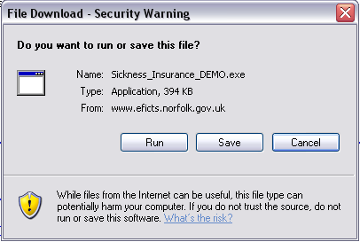

Click ‘Run’.

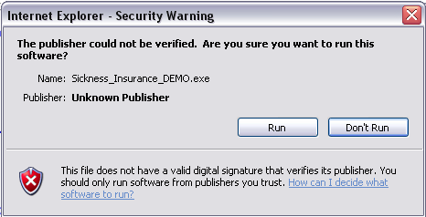

Click ‘Run’.

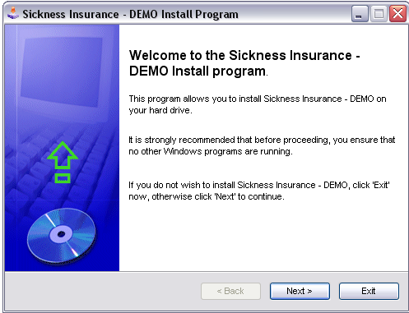

Click ‘Next’.

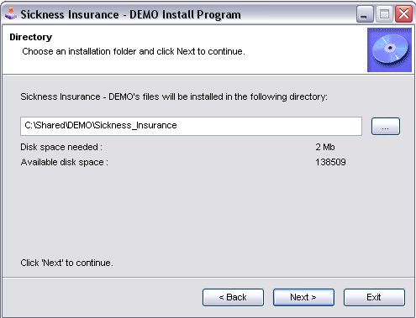
The Demo database will default to install to the users “C:\Shared\” folder. If you wish to install this to another location click here and browse in the required location.

Please Note: If you change the location you must ensure the location saved to ends with ‘\Sickness_Insurance\’.

Click ‘Next’ when you are happy with the installation directory.

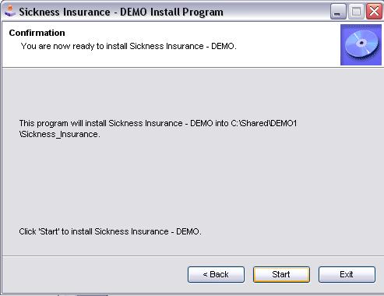

Click ‘Start’.

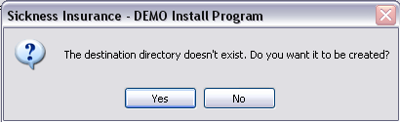

Click ‘Yes’.

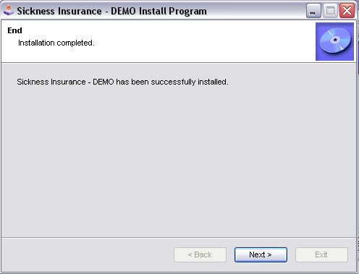

Click ‘Next’.

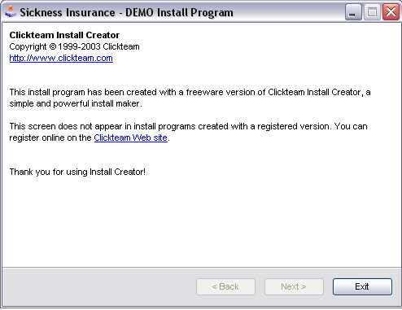

Click ‘Exit’.

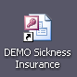
As part of the installation process a shortcut to the demo database will be created. Double click this shortcut to open the database.

The User Name for the demo database is “Demo”, with a password of “SISDemo1”.

