Headteachers' Association of Primary Years
in Norfolk
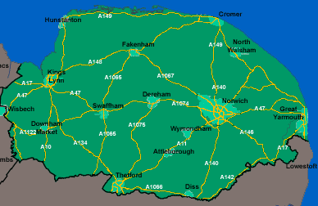
Would you enjoy the supportive network of other Headteachers who work with Key Stages 1 and 2?
Would you welcome opportunities to discuss matters surrounding the Primary years?

In relaxed and informal surroundings, HAPYIN has arranged the following conferences for 2011/12:

Autumn Conference 17th November 2011 (9.00 start)
at Weston Park
‘Narrowing the Gap’
Speaker: Neil MacKay, Training Consultant
‘Simple Changes can bring better results in the classroom’

Spring Conference 8th & 9th March 2012
at the Blakeney Hotel, Blakeney
2 day Residential
Theme: Ofsted 2012 and the SEF

Summer Conference 24th May 2012
at Weston Park
Theme: Assessment and AGM

If you would like to find out more, contact:
Kim Breen 01692 580053, Paul Stanley 01603 867740 Mel Fearns 01493 843476.
Enquiries welcomed from Headteachers of any schools with primary-aged pupils.
To book, complete and send off slip below.
……………………………………………………………………………………………………………………………………………………………

Headteacher’s Name: ______________________________________(please print)

School: __________________________________________________

Full Membership of HAPYIN entitles you to attend all conferences,

including 2-day residential £250

Day rate £90

I enclose a cheque for £……………………..payable to HAPYIN

Please send to June Sewell, George White Junior School, Silver Road, Norwich, NR3 4RG

