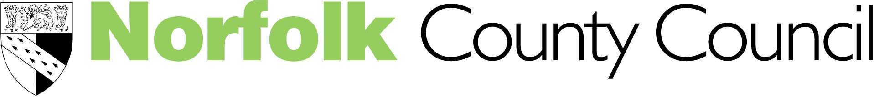Children’s Services

"So Sad, so Young... so Listen!"

Philip Graham & Carol Hughes

Understanding and supporting Mental Health in Schools

Come and join the Behaviour & Emotional Well-Being Team, EPSS

Venue : Neatherd High School, Norwich Road, Dereham, NR20 3AX
(4.00 – 6.00 pm)

for seven twilight sessions to raise your awareness and provide strategies
for supporting children and young people with mental health concerns

These sessions are appropriate for teachers of children from Year 5 upwards

- COMPULSORY Thursday 19th April - Supporting children and young people’s Mental Health, (Rita Adair, Senior Educational Psychologist)
- COMPULSORY – Wednesday 25th April - Tackling the stigma of mental health in schools, (Pat Jones, Educational Psychologist)
- Thursday 3rd May - Anxiety, (Ian Mann, Educational Psychologist)
- Tuesday 8th May - Depression, (Rita Adair, Senior Educational Psychologist)
- Thursday 17th May - Stress, (Ian Mann, Educational Psychologist)
- Thursday 24th May – Self Harm, (Chris Ducker, Educational Psychologist)
- Tuesday 29th May - Eating Disorders, (Chris Ducker, Educational Psychologist)

Cost of all Seven sessions = £150 / Cost for 1 session = £40
The FIRST AND SECOND SESSIONS ARE FREE AND COMPULSORY

Please complete/return the slip below if you would like to attend, with your payment/Journal Number
……………………………………………………………………………………………………………
I would like to attend all seven sessions Or (tick appropriate boxes)
Journal No …………………….

Thursday19th April Wednesday 25th April Thursday 3rd May

Tuesday 8th May Thursday 17th May Thursday 24thMay

Tuesday 29th May

Name ……………………………………………………………………………………………………

Title ………………………………………………………………………………..……………………

School/Address ………………………………………………………………………………..….…

…………………………………………………………………………………………………………...

Email Address ………………………………………………… Tel No …………………….……...

Please return your reply slip to: Michèle Blazey, email michele.blazey@norfolk.gov.uk

If you require further details contact Rita Adair on rita.adair@norfolk.gov.uk or phone 01603 307567


