1 Download the Installation File

Start a call within AVCO AnyComms. Once the call is completed open the Finance folder within the AVCO Inbox Folder and ensure that the ‘Upgrade_ClusterBudget_Planner_2013.exe’ file has been downloaded.

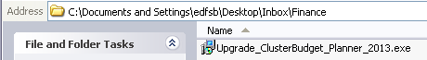

If you have any issues receiving this file via AVCO AnyComms please contact the ICT Shared Services helpdesk on 0845 303 3003.
Please Note: This file will only be made available to schools that are listed as the either the chair or finance chair of the cluster.

2 Run the Installation File

Please Note: If you wish to install the Budget Planner onto a different computer please copy the installation file to the required computer before running the installation process.

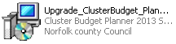
Double click the ‘Upgrade_ClusterBudget_Planner_2013.exe’ file.

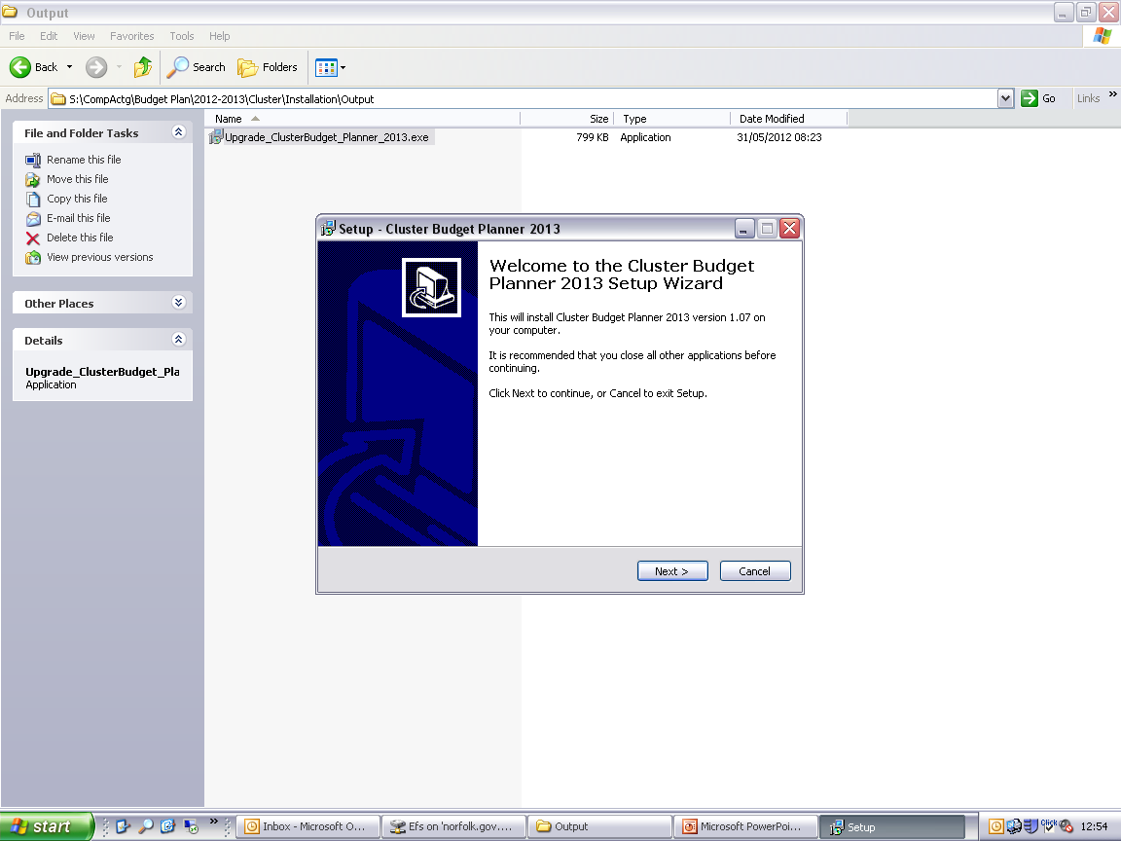
Click ‘Next’.

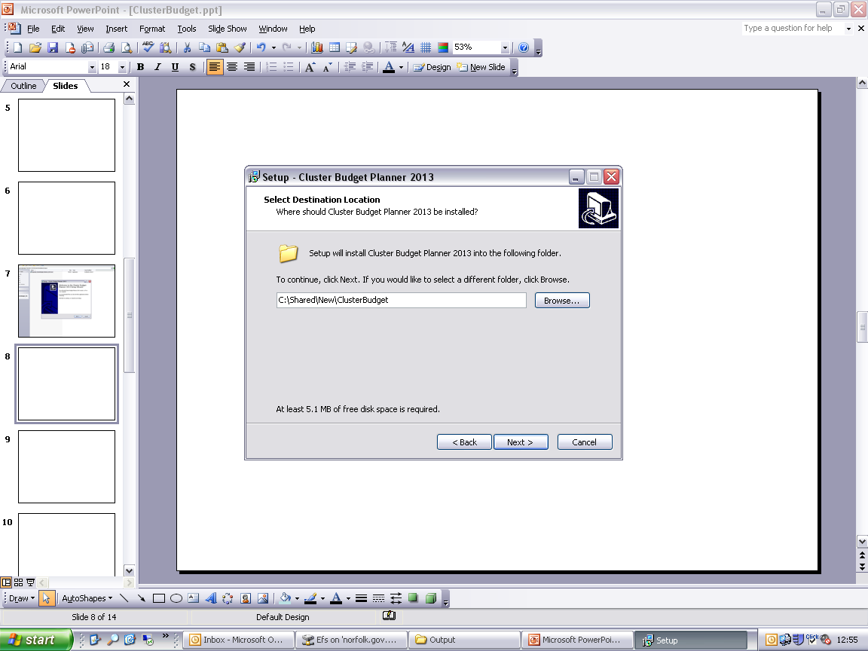
Click ‘Browse’ to select a new location for the Budget Planner to be installed to if you do not wish to accept the default shown.
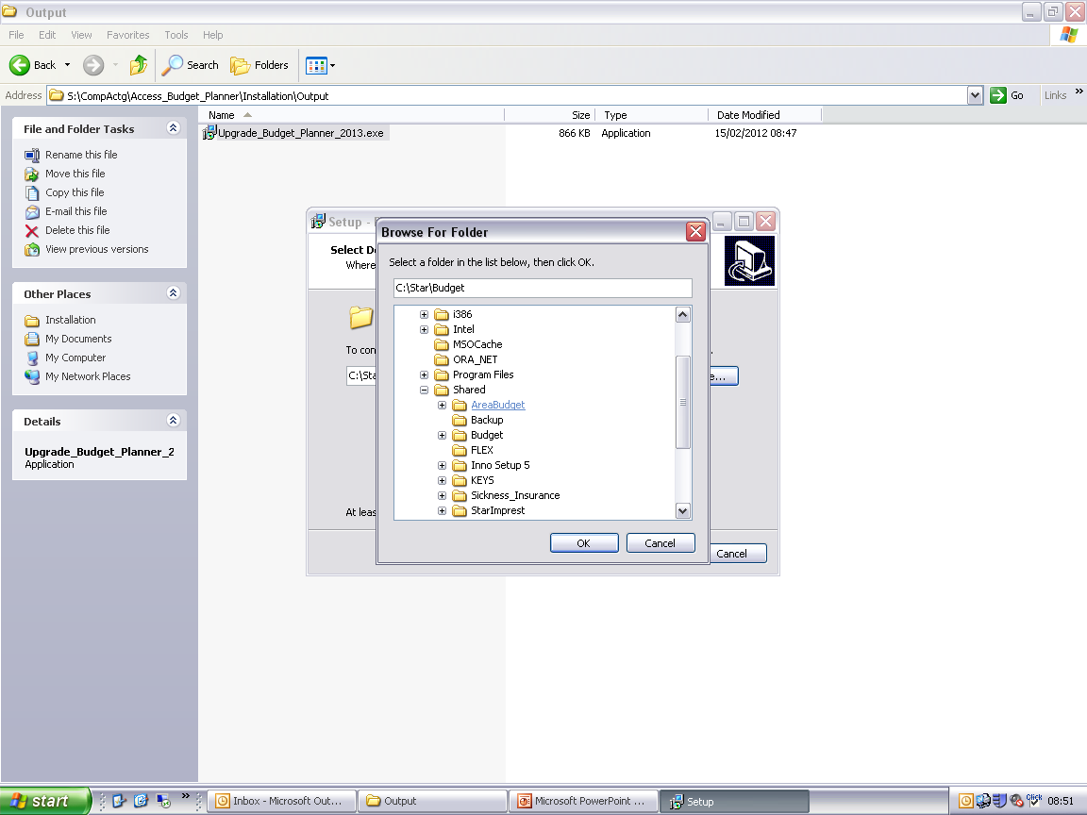
Browse the Location required then click ‘OK’.

Please Note: A Folder called ‘ClusterBudget’ will automatically be added to the location chosen within the browse screen above.

Please Note: You must ensure that the cluster budget planner is not installed into the same folder as the existing school budget planner. If the cluster budget is installed to the same folder the schools budget will be overwritten.

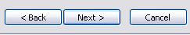
Click ‘Next’ once you are happy with the directory selected to install the Budget Planner to.

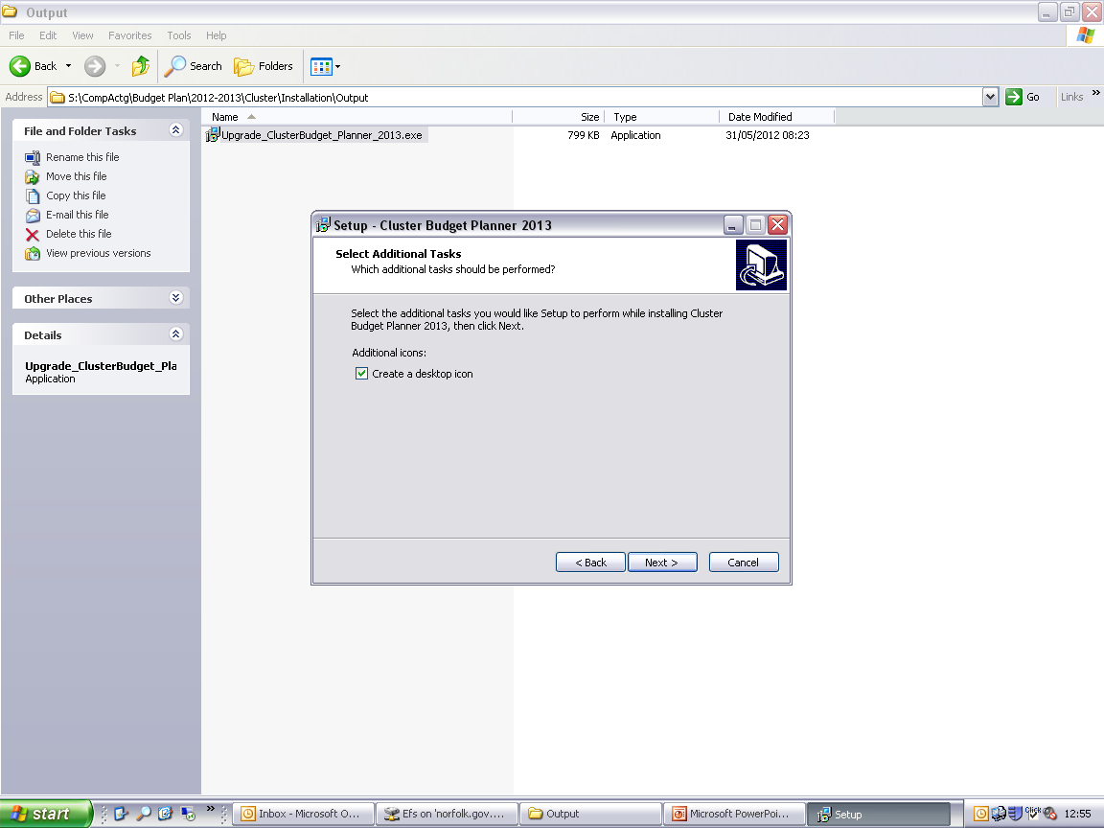
Click ‘Next’.

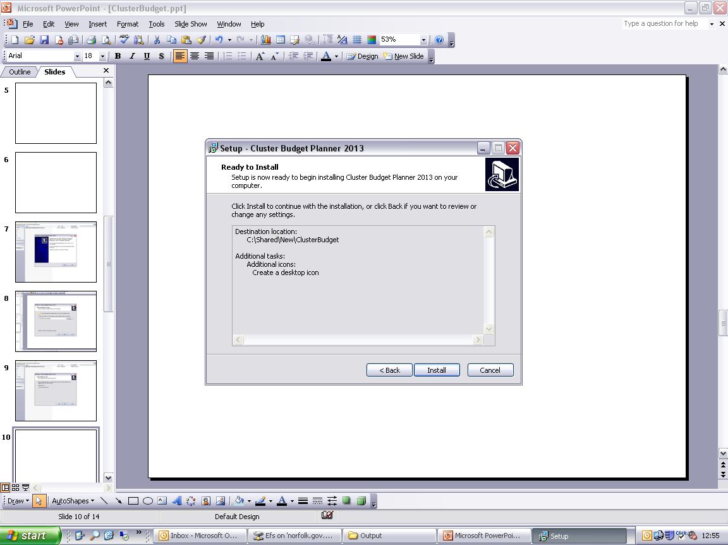
Click ‘Install’.

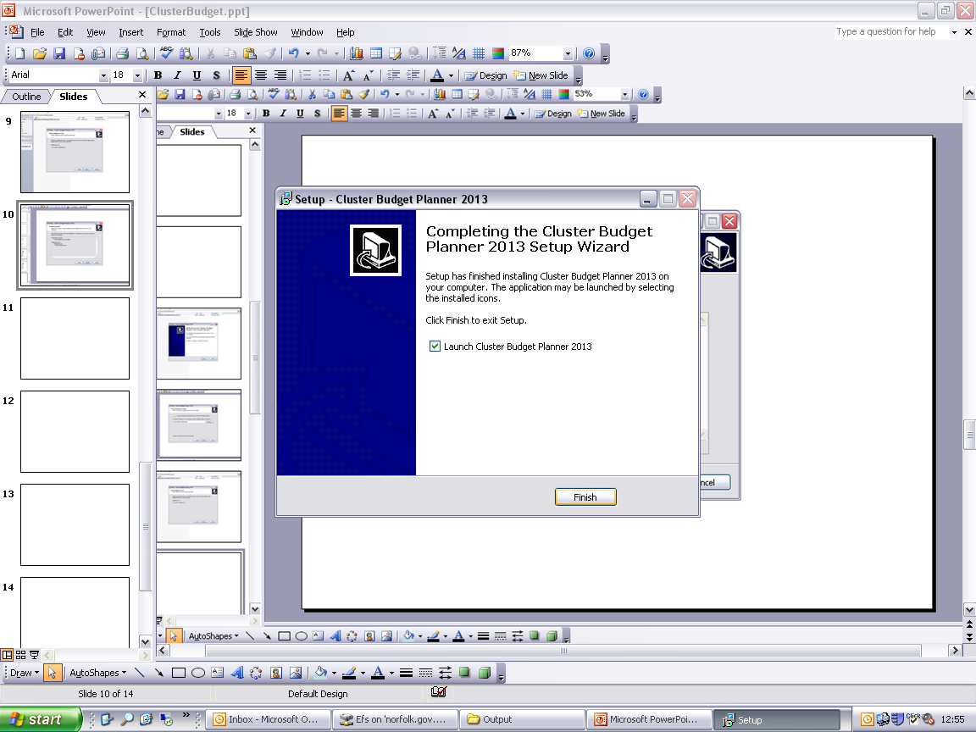
Remove the tick from ‘Launch Cluster Budget Planner 2013’ if you do not want the Budget Planner to automatically open once the installation is complete.

Click ‘Finish’.

3 Opening the Budget Planner
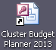
During the installation process a shortcut to the Cluster Budget Planner will be created on the desktop of the computer used to run the installation process.

Double click this shortcut to open the Cluster Budget Planner then follow the instructions within Section 1 of the Budget Planner User Guide to complete the initial set up of the Cluster Budget Planner.

Please Note: If you are experiencing issues opening or using the Cluster Budget Planner please ensure that the required Macro Security level has been selected within Microsoft Access.

Please refer to the Frequently Asked Question “How do I enable macros within Access and Excel.doc” for further guidance.

http://www.eficts.norfolk.gov.uk/Finance/StarAccounts/FAQ/

