Dinner Monies Database Version 2011.4

Upgrade Instructions

To complete the Upgrade please take the following steps:
Please Note: You should only complete this upgrade if you are currently using Version 2011.3 of the Dinner Monies Database.

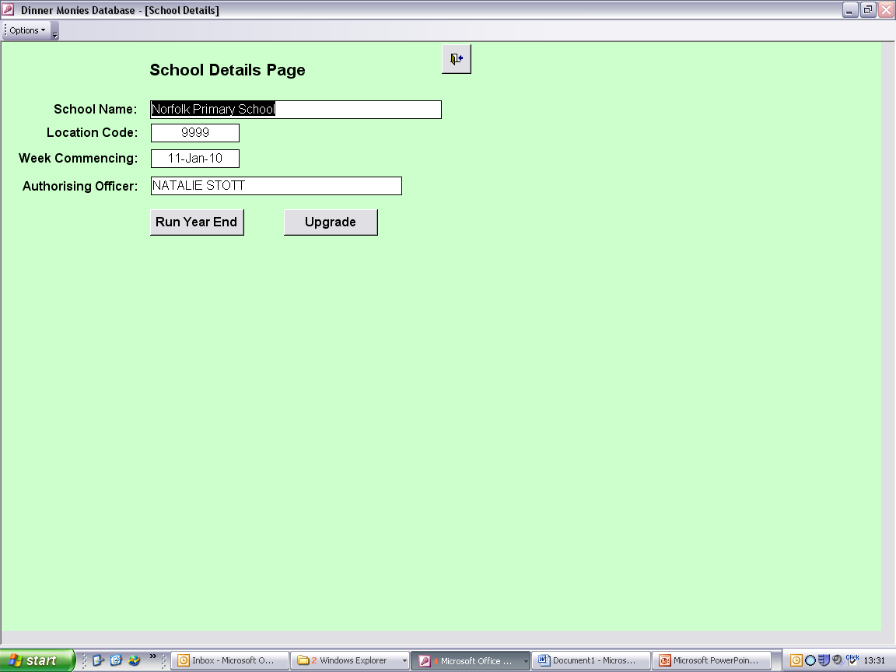
Within the Dinner Monies Database click the ‘Upgrade’ button within the ‘School Details’ screen.

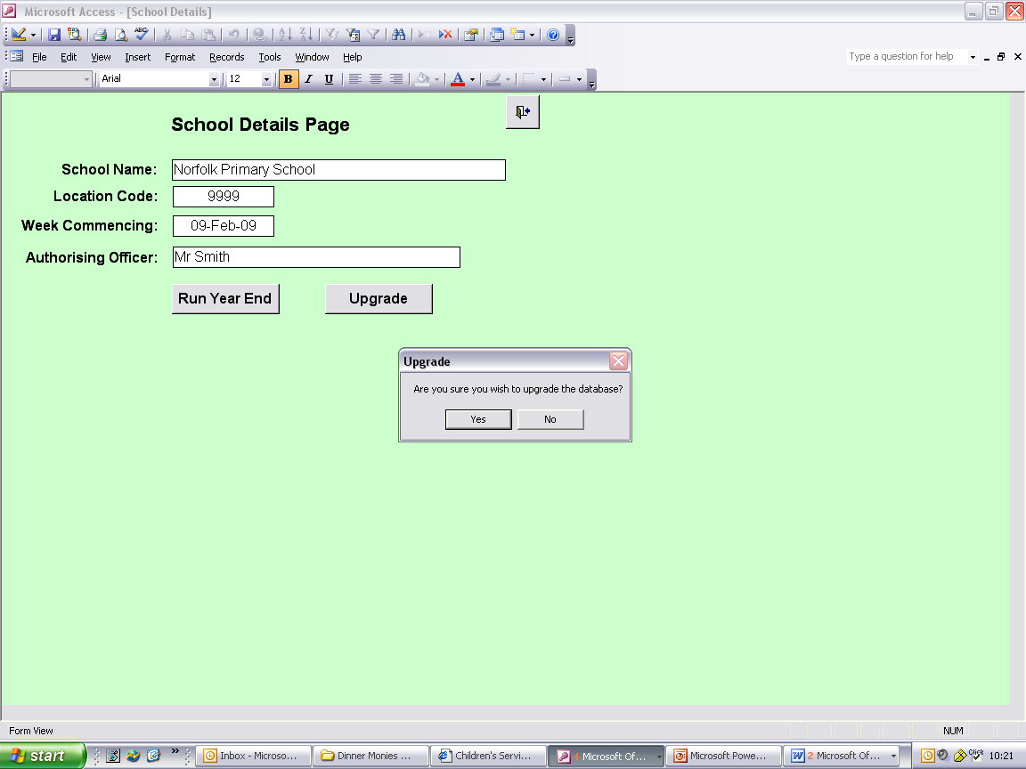

Click ‘Yes’ to continue with the upgrade process, or ‘No’ to cancel.

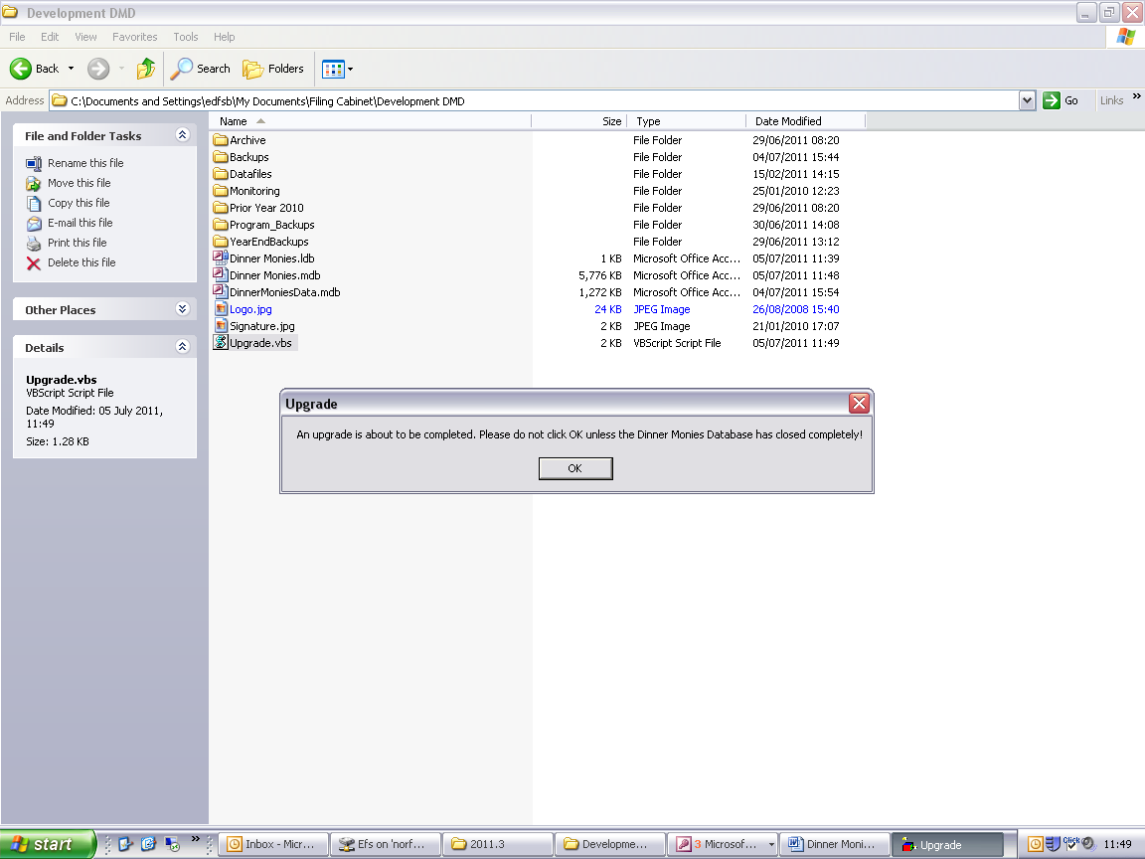

Click ‘OK’ to the above message once the Dinner Monies Database has closed completely.

This process may take a few minutes, depending on the speed of the computer. Please must wait for the following message before logging back into the database.
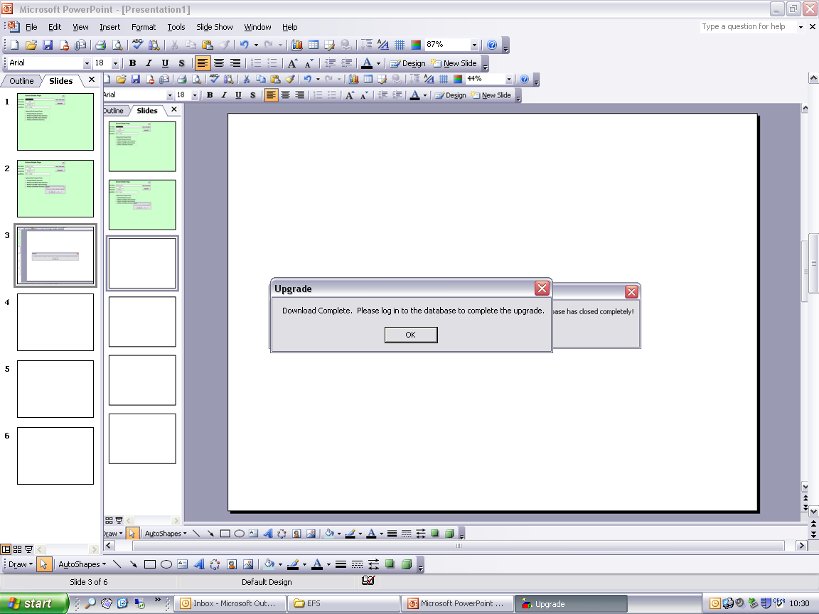

Click ‘OK’, then log back into the database.

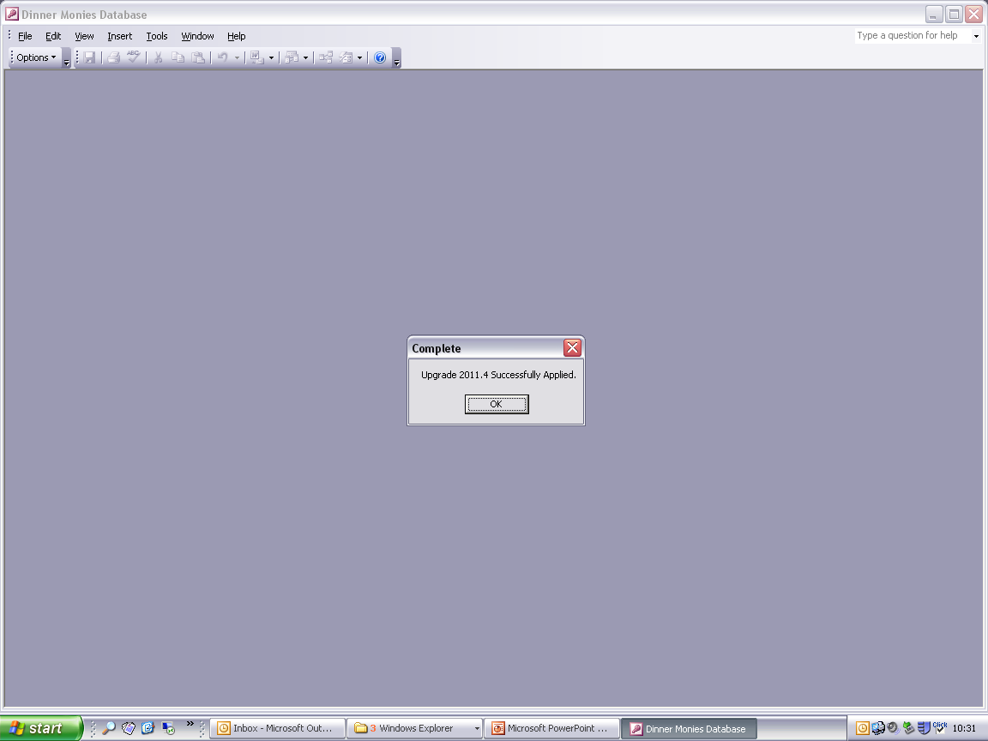
When logging back in to the database several updates will take place, which may take several minutes to be applied. Please wait for this message before proceeding.
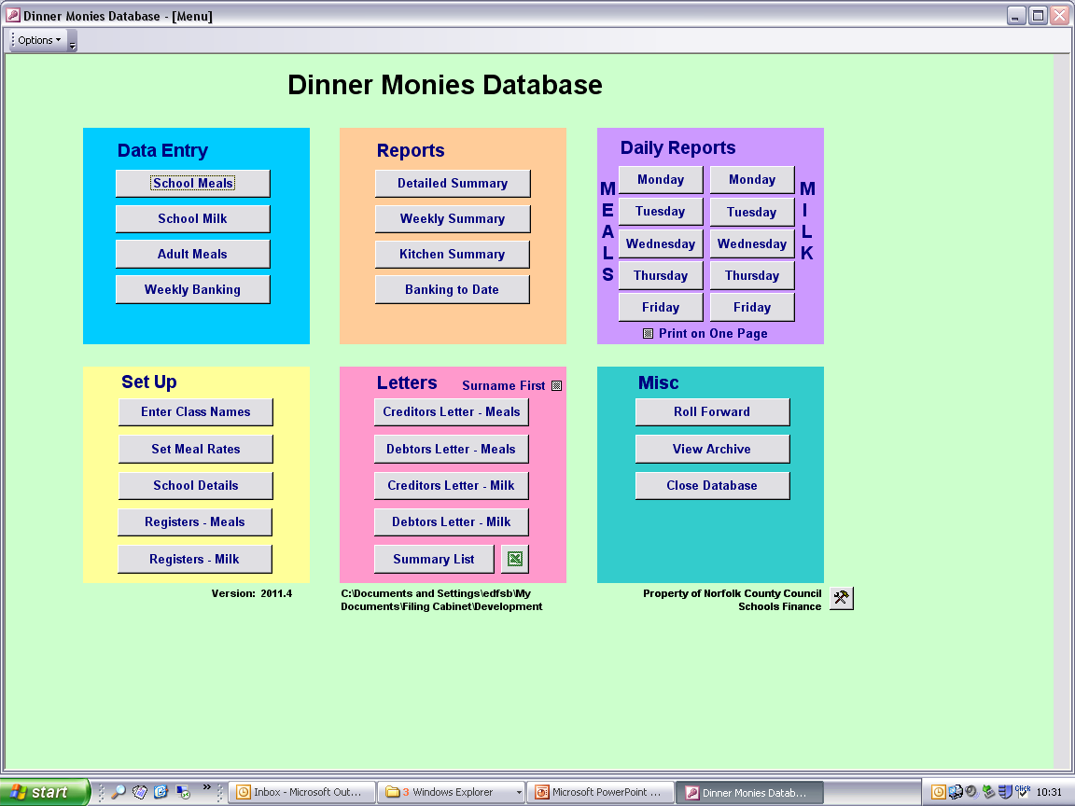
Once the upgrade is complete please ensure that the version stated on the Main Menu is 2011.4.

If the version does not state 2011.4 please contact Accounting Software Support for assistance.

Restate Archives

Whilst viewing the Main Menu press “Ctrl + Shift + P” on the keyboard.
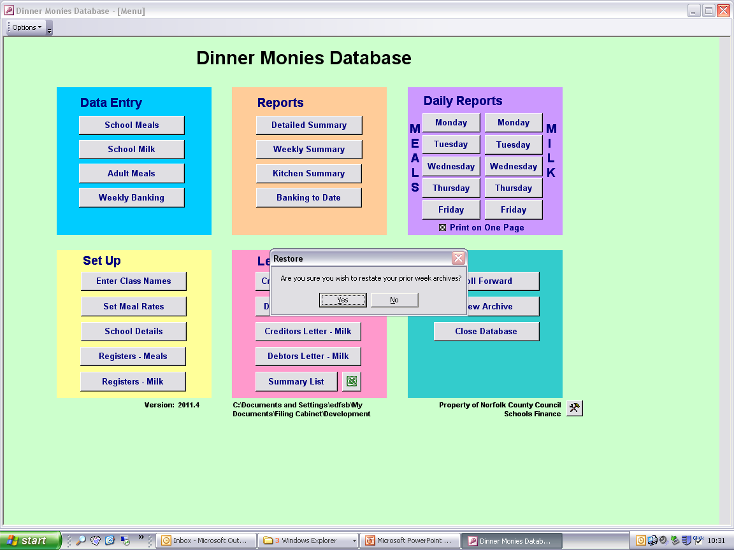

Click ‘Yes’ to continue or ‘No’ to cancel. If you clicked ‘Yes’ you must wait for the message below to appear before performing any other functions within the Dinner Monies Database.

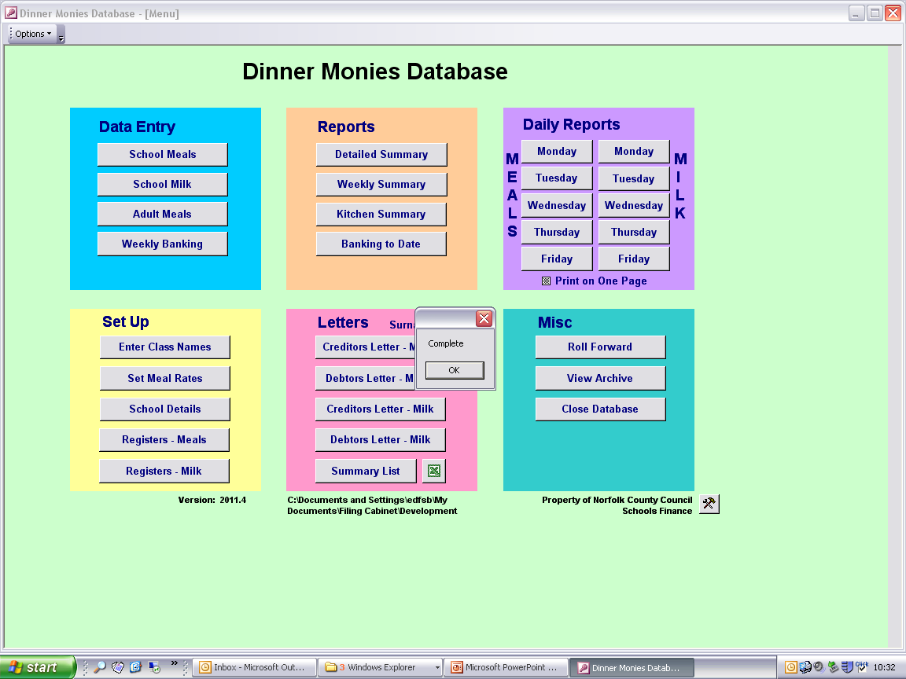
Click ‘OK’.

Within the School Details screen double click the name of a pupil you wish to see the history for:

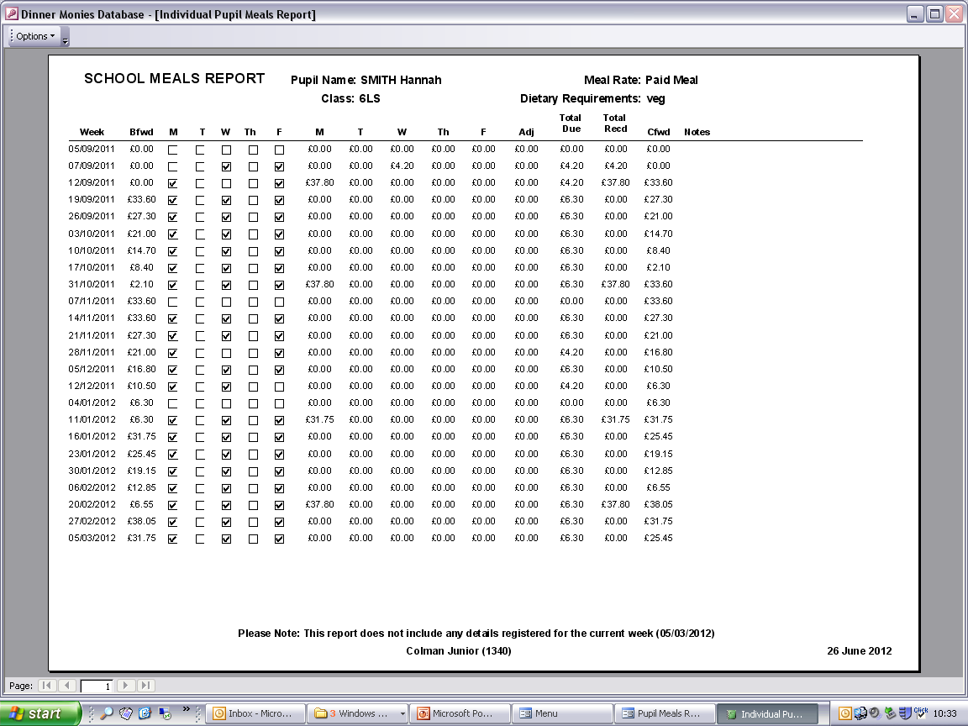
The details held within this report should now match the records for the selected pupil, and the CFwd amount should match the BFwd amount of the line below for each week.

