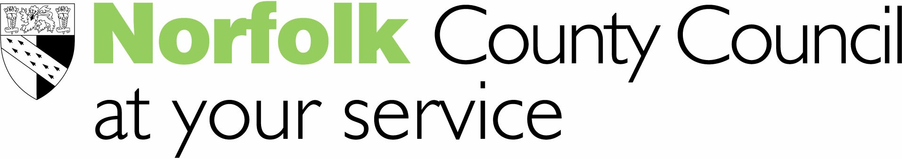
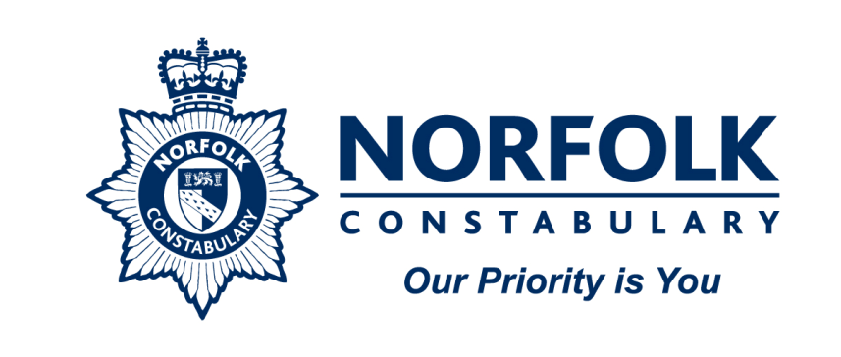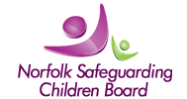
Norfolk MASH – service update, July 2012
“The Multi-Agency Safeguarding Hub physically and virtually co-locates key professionals to facilitate early information sharing, analysis and decision making in relation to vulnerable children, young people and adults. The Norfolk MASH provides a central multi-agency point of access to assessment, maximising the effectiveness of all agencies.”
The MASH has been building its service in phases, starting with children’s safeguarding:

- Phase 1, from September 2011: dealing with police C39d notifications.
- Phase 2A, from March 2012: dealing with NSCB1 forms, e-safety alerts and police referrals and intelligence reports.
- Phase 2B goes live on Monday 30 July, when the MASH will take on all enquiries and contacts (phone, email or letter) about children and young people, from members of the public and agency workers. This phase completes the daytime service provision for children’s safeguarding within the MASH.

Members of the public and agency workers who phone our Customer Service Centre on 0344 800 8020 because they are concerned about a child or young person will be put through to the MASH triage workgroup, a team of specialist childcare workers, supported and managed by qualified and experienced childcare social workers. The move to the MASH Triage service should feel seamless for callers as the changes surround the childcare safeguarding focus of internal MASH processes.
Where there is a need to seek further information on the needs of the child to know whether a full safeguarding referral should be made, the MASH Triage workgroup will pass the enquiry to the MASH Operational Desk for further information gathering and analysis and where appropriate a referral will be made to the children’s Duty Teams for an Initial Assessment to be completed.
**Please note; agencies wishing to have a professional consultation about a safeguarding issue for a child or young person must contact the appropriate children’s Duty Team.

The MASH continues to be a service in development. Work is currently being undertaken to develop a model for Adult Safeguarding processes within the MASH and the delivery of the service over 24 hours. We will keep you updated as this development moves forward.

If you have any queries about the delivery of the MASH service please contact Sally Sinclair, Team Manager sally-ann.sinclair@norfolk.gov.uk 01603 729194, or Detective Inspector Richard Ellis ellisr@norfolk.pnn.police.uk
For queries about the development of the MASH service please contact Jenny Sproule (Children’s Services), Development Manager on 01603 306335, jenny.sproule@norfolk.gov.uk or Becky Booth, Development Manager (Adult Care) on 01603 223241 rebecca.booth@norfolk.gov.uk

