Norfolk County Council - Children’s Services

Operations and Integrated Services
From 1 September 2012

This document sets out how Children’s Services will deliver local services to support children, young people and their families updated as from 1 September 2012. It is intended to act as a guide for schools, voluntary organisations and agencies so that they know who to contact.

The Children’s Services Department is organised into three Operational Divisions in Norfolk:
- North and East
- West and Breckland
- City and South

These divisions are made up of the seven district council areas:
- North Norfolk, Broadland, Great Yarmouth
- Kings Lynn & West Norfolk, Breckland
- South Norfolk, Norwich
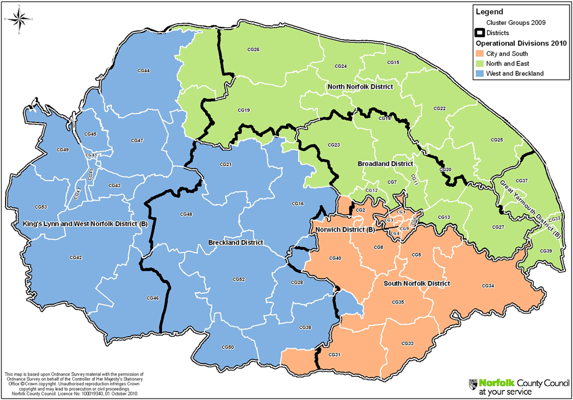

There are three senior operational managers for each of the operational divisions:

Role | North East | West & Breckland | City & South
Safeguarding Manager | Cathy Mouser | Ann McKendrick | Paul Corina
Localities & Integration Manager | Ali MacPhail | Sandra Summerfield | Laura Sutton
Locality Co-ordinator | Phil Beck | Christopher Murray | Carey Cake

Each of these divisions provides local services to children and families through:

- Public services
- Schools
- Voluntary organisations
- Independent providers

Additionally, specialist county resources are available to supplement local provision and support specialist needs within families. These services are managed by three senior operational managers:

- Additional Needs: Christopher Butwright
- Adoption, Fostering and Residential Care: Peter Ronan
- Youth Justice – Chris Small

Children’s Services will draw together countywide and local services from the following range of services to form a team around the child, involving partners from all sectors:
Norfolk County Council Children’s Services - county services

MASH Norfolk County Council Customer Service Centre
Team

Sensory Support
Team

Pupil Referral Units

County
Placement
Provider Team

Fostering Services

Specialist Social Work Service –
Diverse Communities

Adoption & Family
Finding Unit

Residential Units

Children’s Services delivered within operational divisions:

- CAF Integration Managers
- Consultation Service
- Duty Teams
- Safeguarding Teams
- Children in Need
- Corporate Parenting
- Early Years
- Family Placement
- Education Psychology &
School Support
- Family Solutions (Tier 2 CAMHS)
- Supervised Contact & Home Based Support Service
- Children with Disabilities
- County Adolescent
Prevention Team
- Youth Justice Services

Pupil Referral Units

The following principles underpin the work of all teams within Children’s Services:

Principles

- The best interests of the child/young person are paramount.

- Children’s needs are best met by their own family and community and when this is not possible are best met in Norfolk.

- We will be a good and prudent corporate parent.

- We will support all children to achieve their full potential.

- We will ensure equality of opportunity and work in partnership with children and families.

- We will actively listen to the voice of the child.

- Our work is child centred and rooted in an understanding of child development.

- Our work is holistic, focused on improving outcomes in a timely way.

- Meeting a child’s needs is all our responsibility.

- Where a child is identified at risk we will identify strengths and concerns and robustly work to achieve change and review outcomes.

- We will be ambitious, accountable and trusting.

- We will work across organisational boundaries to meet the identified needs of children.

- We expect high professional standards from ourselves and we will not unnecessarily duplicate assessments using the priority matrix as a shared tool.

- We are committed to multi and inter agency working and will actively promote restorative approaches.

- We will work from a strengths model where we continuously assess, plan and review.

- Our practice will be informed by evidence.

How we will work:

We will implement a “Team around the child” model bringing together professionals from all the teams and agencies available, informed by the individual needs of the child and family. The priority matrix is a toolkit used to score the level of need in each case. Within the team around the child, services will be provided by statutory agencies, independent providers and voluntary organisations. This approach will apply to all situations, whatever the level of need within the family, so will include:

- Using the priority matrix to determine the level of intervention
- Using the common assessment framework (CAF)
- Using Family Support Planning Meetings
- Using Core Group meetings when a child is the subject of a Protection Plan.

General process:
Identify a concern early

Assess the need

Form a team around the child

Agree a plan to provide assistance and services

Review progress and agree a new plan

Whenever a team around the child is formed a lead professional will be identified according to the following guidelines:

Level of need | Priority Matrix Case Type score | Lead professional | Type of team around the child meeting
Universal | 1
Single Agency | 2 | Any professional
CAF | 3 | Any professional | CAF
Early Intervention (CWD, CAMHS Tier 2, Early Years) | 4 | Any professional from an early intervention service.
Child in Need /  Looked After Child with | 5 | Professional member of Children in Need or Specialist Support team  Social Worker | Family Support Planning meetings
Child Protection | 6 | Social Worker from Safeguarding Team | Core Group meetings
Sec 47 enquiry | 7 | Social Worker | Strategy Discussion/Meeting

The lead professional will be responsible for ensuring there is a delivery plan in place, coordinating involvement of services, ensuring a review of the delivery plan takes place within the agreed timescale, ensuring meetings and plans are recorded and the record distributed to the team around the child professionals plus family members as appropriate.

A new Multi-Agency Safeguarding Hub made up of Children’s Services, Police and Health staff has been designed to deal with referrals for services. In the meantime cases will continue to be referred via the current referral routes. The priority matrix will be applied to every referral and the score will determine which team the case is passed to for follow up. No longer will cases have to reach the threshold for child protection in order to access services.

The CAF Integration Managers are available to provide advice and support to professionals about the CAF approach :-

Amanda Johnson West & Breckland 07789 033 772
Vacant City & South 07770 692 665
Louise Penn North & East 07833 901 853

Consultation Lines

The consultation line is also available. Phone the following numbers if the child you are worried about lives in:

Breckland District Council and Borough Council of King’s Lynn and West Norfolk areas please call: 01553 669300

Norwich City Council and South Norfolk District Council boundaries please call: 01603 224134

North Norfolk District Council, Broadland District Council or Great Yarmouth Borough Council please call: 01493 448190

If you are not sure which district council a child lives in, please refer to the following hyperlink to the “Where I live” website: www.whereilive.norfolk.gov.uk/
Contacts for the teams are:

North and East

Team/Job Title | Name | Contact Number
Operational Manager - Safeguarding | Cathy Mouser | 01603 894653
Operational Manager - Localities and Integration | Ali MacPhail | 01603 306406
Locality Co-ordinator | Phil Beck | 01493 448158
Duty Manager | Suzie Thurlow | 01493 448218
Safeguarding Manager – team 1(Gt Yarmouth) | Tracey Whittaker | 01493 448237
Safeguarding Manager – team 2 (Nth Walsham) | James Mason (acting) | 01692 502236
Safeguarding Contact & Home Based Care Service (North & East) | Susan French | 01493 448300
Children in Need (Gt Yarmouth) Team Manager | Vacant | 01493 448163
Children in Need (North) Team Manager | Lea Gurling | 01692 409540
Children in Need (Broadland) Team Manager | Carol Manning | 01603 894690
Family Solutions (North & East) Team Manager | Caroline Marriott | 01263 711498
School Support Team (North & East) | Stephen Hobbs | 07825 099447
Short Stay School – Brooklands, Gorleston | Mark Taylor | 01493 660222
Short Stay School (PRU) – Douglas Bader | vacant | 01603 737764
Corporate Parenting Fieldwork Team 1 (East) Team Manager | Karen Beales | 01493 448283
Corporate Parenting Fieldwork Team 2 (North) Team Manager | Peter Barron | 01263 710195
Children With Disabilities Fieldwork Team (North & East) Team Manager | Sue Connor | 01493 448190
Youth Offending - East Team Area Manager | Helen Taylor | 01493 448148
Early Years Team Manager (North & East) | Laura Feeney | 01692 409540
Aylsham & Reepham Children’s Centre  (until 1 October 2012) | Lisa Adams | 0791 904 5559
Broadland Children’s Centre  (until 1 October 2012) | Linda Bullimore | 01603 784954
West and Breckland

Team/Job Title | Name | Contact Number
Operational Manager - Safeguarding | Ann McKendrick | 01842 855660
Operational Manager - Localities & Integration | Sandra Summerfield | 01553 669632
Locality Co-ordinator | Christopher Murray | 01553 669277
Duty Manager (West & Breckland) | Peter Hurst | 01553 669350
Safeguarding Manager – team 1 (West) | Jo Diggines | 01553 669366
Safeguarding Manager – team 2 (Breckland) | Claudia Jarratt | 01842 855680
Safeguarding Contact & Home Based Care Service (West & Breckland) | Catherine Dickson | 01553 669335
School Support Team (West & Breckland) | Stephen Higgins | 01553 669213
Corporate Parenting Fieldwork Team 1 (West) Team Manager | Lou Rouse | 01553 669646
Corporate Parenting Fieldwork Team 2  (Breckland) Team Manager | Kay Hathway | 01362 654542
Children In Need (West) Team Manager | Vacant | 01553 669369
Children In Need (Breckland) Team Manager | Liz Thom | 01953 450530
Family Solutions Team (West & Breckland) Team Manager | Mary Baldwin (acting TM) | 01362 654823
Children With Disabilities Fieldwork Team (West & Breckland) Team Manager | Will Wright | 01362 654503
Youth Offending - West Team | Joseph Nwokobia | 01553 614973
Short Stay School - Rosebery | Peter Roberts | 01553 612000
Resource Centre - Marshfields | Nicola King | 01553 819812
Early Years (West & Breckland) Team Manager | Valerie Heath | 01553 614931
West & Breckland Children’s Centres  (Methwold & Downham Market)  (until 1 October 2012) | Sue McNeilly | 01366 387403  01842 815928
Swaffham Children’s Centre  (until 1 October) | Elizabeth Thurston | 01760 721101
Dereham Central & South Children’s Centre  (until 1 October) | Chris Murray | 01362 654052

City & South

Team/Job Title | Name | Contact Number
Operational Manager - Safeguarding | Paul Corina | 01603 223750
Operational Manager - Localities & Integration | Laura Sutton | 01603 223565
Locality Co-ordinator | Carey Cake | 01603 223582
Duty Manager (City & South) | Jane Kett | 01603 223582
Safeguarding Manager – team 1 (City) | Marie Underwood | 01603 223687
Safeguarding Manager – team 2 (South) | Flo Watson | 01603 679167
Safeguarding Contact & Home Based Care Service (City & South) | Denise Saunders | 01603 223252
Children in Need (City) Team Manager | Hayley Griffin | 01603 223701
Children in Need (South) Team Manager | Treloar Sheppard | 01603 679155
Family Solutions (City & South) Team Manager | Ian Griffiths | 01603 224334
School Support Team (City & South) | James Thatcher | 01603 307562
Corporate Parenting Fieldwork Team 1 (City)  Team Manager | Wendy Jones | 01603 306301
Corporate Parenting Fieldwork Team 2 (South) Team Manager | Owen Garrod | 01603 638201
Children With Disabilities Fieldwork Team (City & South) Team Manager | Caroline Horton | 01603 692471
Youth Offending - Central Team Area Manager | Valerie Crewdson | 01603 679108
Short Stay School (PRU) Locksley | Des Reynolds | 01603 508520
Resource Centre – Foxwood | Joanne Nudd | 01603 692453
Early Years Team Manager (City & South) | Alison Woodcock | 01603 306320
Hellesdon and Drayton & Taverham Children’s Centres  (until 1 October 2012) |  | Drayton/Taverham  01603 864338  Hellesdon  01603 890216
Team/Job Title | Name | Contact Number
Spixworth & Sprowston Children’s Centre  (until 1 October 2012) | Emma Broom | 01603 301408
City & Eaton Children’s Centre  (until 1 October 2012) | Ian Hollis | 01603 729808
Long Stratton, Harleston & Loddon Children’s Centres  (until 1 October 2012) | Nikki Glennon-Bird | 01953 451196
Woodside One Nursery |  | 01603 434945

Countywide contacts:

Team/Job Title | Name | Contact Number
Assistant Director, Operations and Integrated Services | Lesley Whitney | 01603 223747
Operational Manager - Adoption, Fostering and Residential Care | Peter Ronan | 01603 222574
Operational Manager - Additional Needs | Christopher Butwright | 01603 638049
Service Manager, Youth Justice | Chris Small | 01603 223585
MASH Team Manager | Sally Sinclair | 01603 729194
Specialist Social Work Services for Diverse Communities | Sue Gee | 01603 729279
Adolescent Support Team | Tina Cissell (Acting) | 01603 306373
Head of Sensory Support | Karen Taylor | 01603 704040
CWD County  Service Manager | Stuart Marpole | 07887 647475
Children With Disabilities – Access and Services | Amy Brooke | 01603 714185
Portage Service | Joann Mitchell | TBC
Adoption & Fostering Recruitment Team | Helen Schofield/Sheila English | 01603 306634
Adoption Family Finding Unit Team Manager | Rachel Agnew | 01603 638345
Adoption Support Team | Elaine Noakes | 01603 638350
Mainstream Fostering Support Team 1 | Mike Woodward | 01603 306326
Mainstream Fostering Support Team 2 | Suzy Holman | 01553 669631
Adolescent Support Fostering Team | Martyn Lovett | 01603 306366
Residential Co-ordinating Manager  15 Norwich Road, Dereham | Lee Napper | 01362 693250
Registered Manager  15 Norwich Road, Dereham | Alan Barker | 01362 693250
Registered Residential Manager – long term unit Easthills | Neil Marjoram | 01603 638230
Registered Manager  The Lodge, Harvey Lane, Norwich | Tony Warner | 01603 702043/053
Team/Job Title | Name | Contact Number
Registered Manager  Well Green, Frettenham | Aaron Napper | 01603 736381
Registered Manager  Waterworks Road, Norwich | Emma Cooper | 01603 620185
Registered Manager  Sparrow Hall Farm, Blofield | Sarah White | 01603 716614

