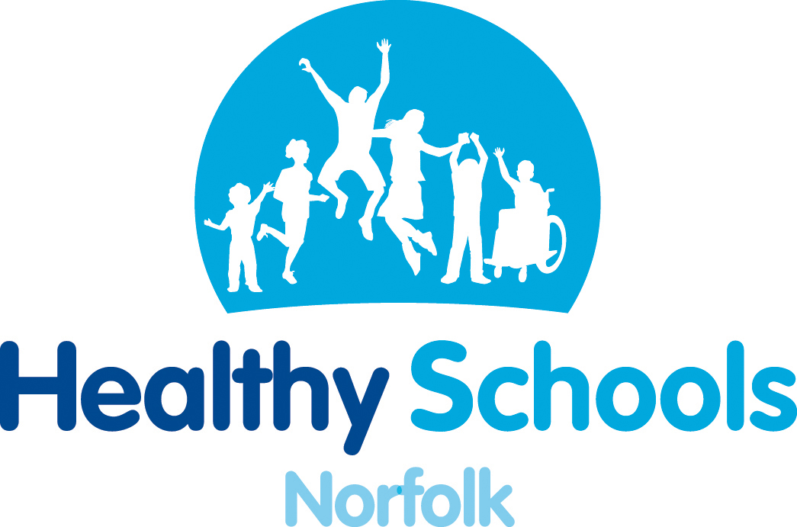
Healthy Norfolk Schools Enhancement Model
‘Providing evidence of schools commitment to health and wellbeing outcomes for pupils’

Health and wellbeing continues to be a priority for schools across Norfolk in improving academic attainment and healthier life styles for children and young people. The Healthy Schools Enhancement Model is a robust model for implementing health improving change in schools that will help you prioritise your own health and wellbeing agenda and decide what really matters to your school and its pupils.

The enhancement model will:
- equip schools to promote health improvement effectively for all pupils
- target support specifically to those pupils in challenging circumstances
- help embed healthier behaviours and well-being outcomes into the everyday activities of school life, through a whole school approach.
- continue to support schools in achieving the Every Child Matters outcomes
- provide schools with rigorous health and well-being evidence for School Improvement Plans and the Ofsted Self Evaluation (SEF).

Schools will be fully supported throughout this process by the Healthy Norfolk Schools Team.
Introduction to the Healthy Norfolk Schools Enhancement Model
Monday 22nd October 2012 | 2.30 – 4pm | Kestrel House, Norwich
Tuesday 6th November 2012 | 3 – 4.30pm | West Norfolk PDC, Kings Lynn

The Enhancement Model is open to schools who have current National Healthy Schools Status.
- For more information on the Enhancement Model please contact The Healthy Norfolk Schools Team:
Marian Fox
01603 221810, marian.fox@norfolk.nhs.uk
Josie Wells
01603 221826, josie.wells@norfolk.nhs.uk
Paul Macardle
Paul Macardle, paul.macardle@norfolk.nhs.uk

- To book a place contact Jenni Barber
01603 307756, jenni.barber@norfolk.gov.uk

