The Cluster Budget Planner is an abridged version of the existing School Budget Planner, and as such, many of the functions performed within the Cluster Budget Planner can be carried out following the instructions given in the User Guide for the School Budget Planner.

These additional notes explain the differences between the Cluster and School Budget Planner. The main differences relate to the addition of department codes within the Cluster Budget Planner.

Initial Set-Up

The initial set-up procedures for the Cluster Budget Planner are the same as those shown in Section 1 of the School Budget Planner User Guide. In addition to these details a ‘Default Department’ code is required. Any budget lines, or staffing forecasts, found within the Cluster Budget Planner without a department code will be assigned to this Department Code automatically when any validation or data updates are applied.

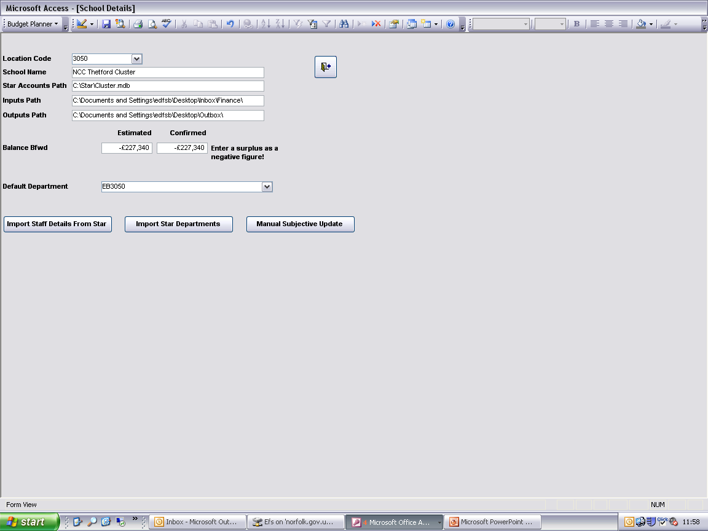
The Department Codes within the budget planner can only be imported from Star Accounts. Click ‘Import Star Departments’.

If a list of department codes has previously been imported into the Cluster Budget Planner the following message will appear:

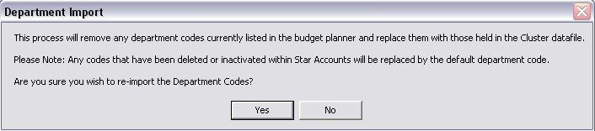
Click ‘Yes’ to continue or ‘No’ to cancel. Please Note: If ‘Yes’ is selected any departments that no longer exist, or have been made inactive, within Star Accounts will be removed from the Cluster Budget Planner. The default department code will replace any budgets or staff forecasts assigned to those departments within the Cluster Budget Planner.

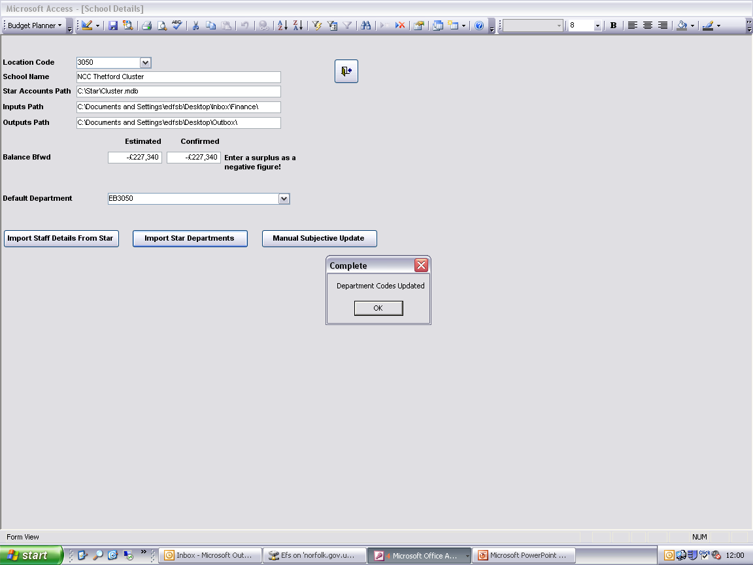
Click ‘OK’.

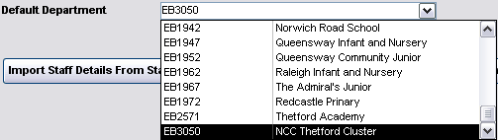

Select the required department code from the drop down list. It is recommended that the department chosen is the clusters generic department code, rather than one of the individual schools department code.

Building the Budget

The procedure for entering budgets into the budget planner is the same as those listed in Section 2 of the School Budget Planner user guide, with the exception of the need for a department code to be selected on each line:

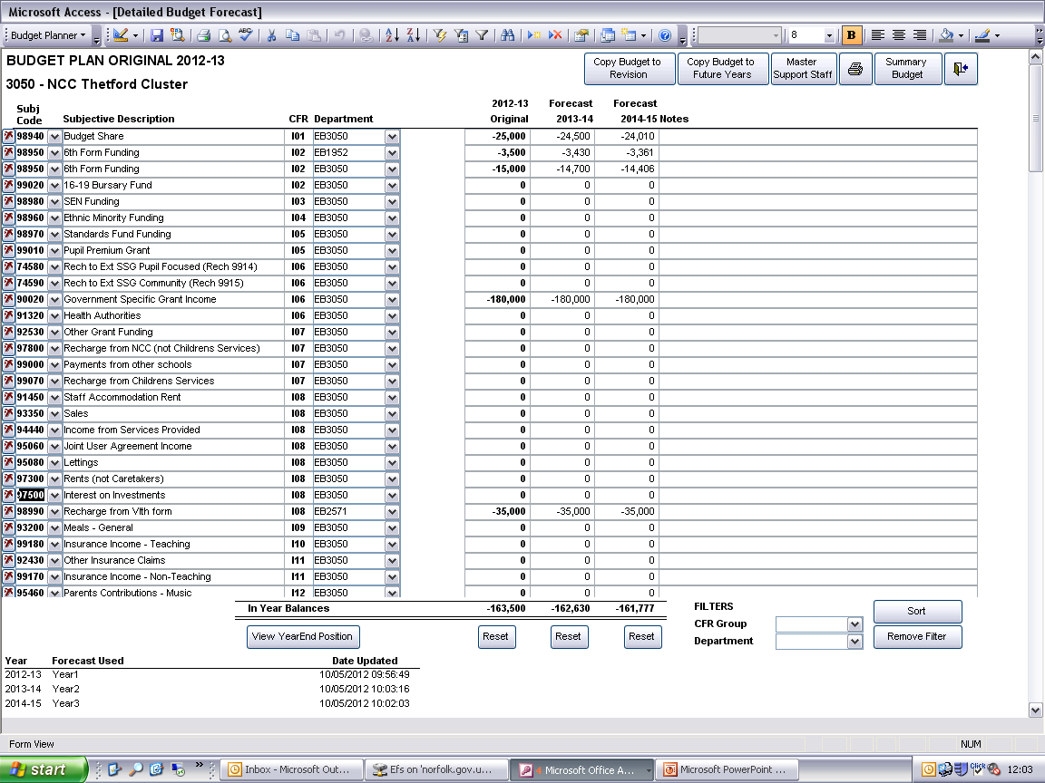
Select the required department from the drop down list.

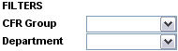
An additional filter has been added to this screen to allow the screen to be filtered per department code.

Support Staff Forecast

The procedure for entering support staff forecasts is the same as those listed in Section 4 of the School Budget Planner user guide, with the exception of the need for a department code to be selected on each line:

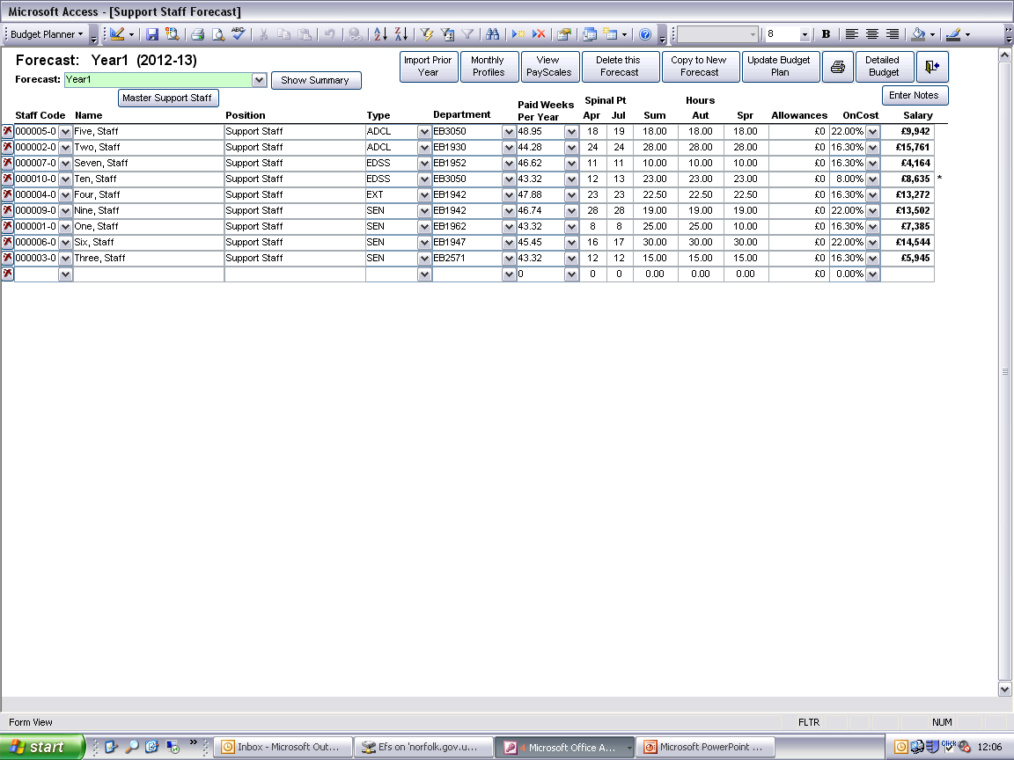

When updating the detailed budget with Support Staff costs, the amounts entered will be shown at subjective and department code level.

Printing Budget Plans

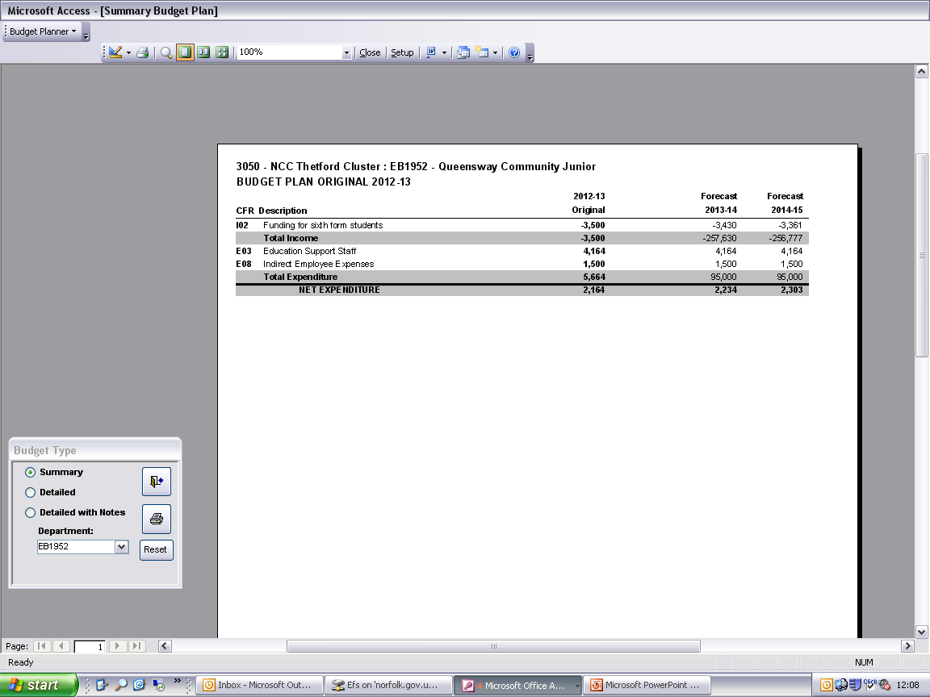
All Budget Plans printed from the Cluster Budget Planner can be filtered per department code if required.

From the ‘Budget Type’ form select the required department from the drop down list.
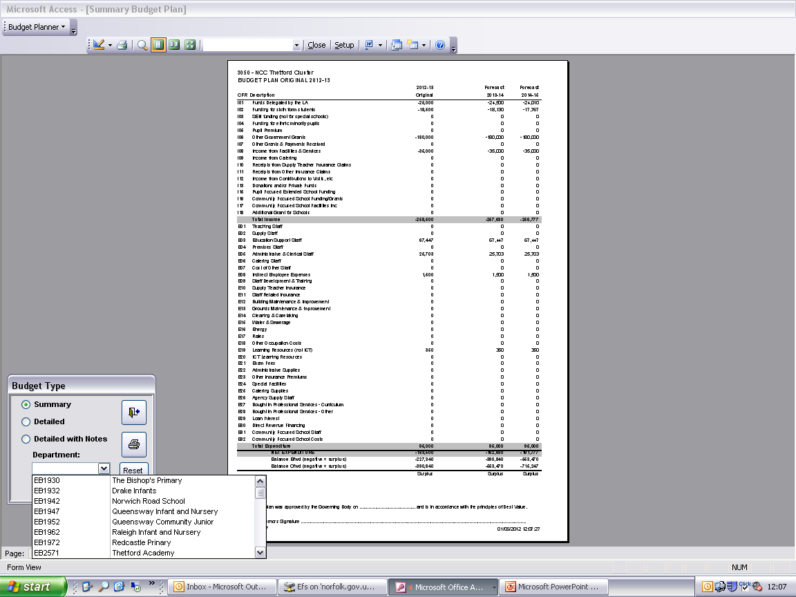

Click ‘Reset’ to view the full Budget Plan.

