NCC Internal Journal Request

Schools within Norfolk are not permitted to invoice other schools for services provided, such as the provision of school meals to a school which does not have a kitchen. These charges are processed via Internal Charge Requests at County Hall via Form F0088/V2 (pink Internal Recharge Form).

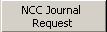
These requests are now able to be submitted electronically through Star Accounts. Within the journal screen click ‘NCC Journal Request’.
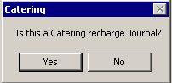

Click ‘Yes’ or ‘No’ as required. Catering Recharges are to be used where your school provides meals to another school.

The output file (see below) for both options is exactly the same except for the subjective codes which can be selected:
Catering 74660 Catering Contract Provided by another School
99190 Catering Sales to Other Schools

Other 74520 Payments to Other Schools
98770 Internal Recharge SEN Cluster
99000 Payments from Other Schools

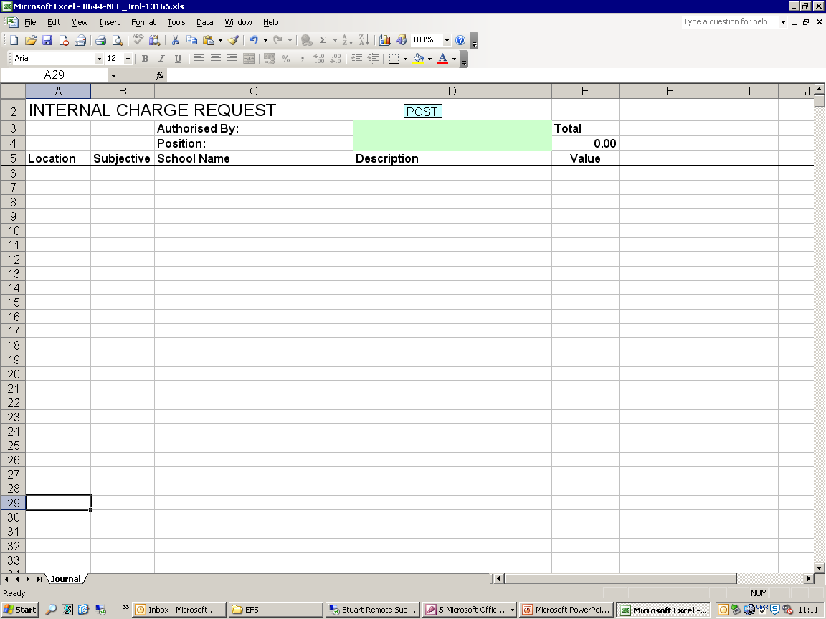
A Microsoft Excel Spreadsheet will be created within your ‘My Documents’ folder called “XXXX-NCC_Jrnl-$$$$$$.xls” where XXXX is your schools location code, and $$$$$$ is a randomly generated unique reference for the journal between 1 and 1,000,000. The spreadsheet will open on screen once it has been created:

Please Note: As part of the creation of this spreadsheet any previously created spreadsheets will be deleted from the ‘My Documents’ folder.

Data Required

Authorisation: An authorising name and position should be entered at the top of the spreadsheet. This will usually be the person completing the journal request.
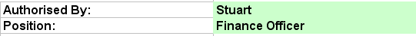

Location: Enter the location code of either your school or the school you wish transfer to funds to. Double-clicking the cell will automatically enter your schools location code (and school name) into the spreadsheet.
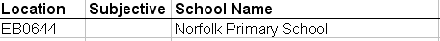

The location code must be entered as 2 letters and a 4-digit number, e.g. EB0019. If the journal relates to a catering recharge the 2 letters entered must be entered as EC, all other recharges should be entered as EB.

Subjective: Select the required subjective code from the drop down list.

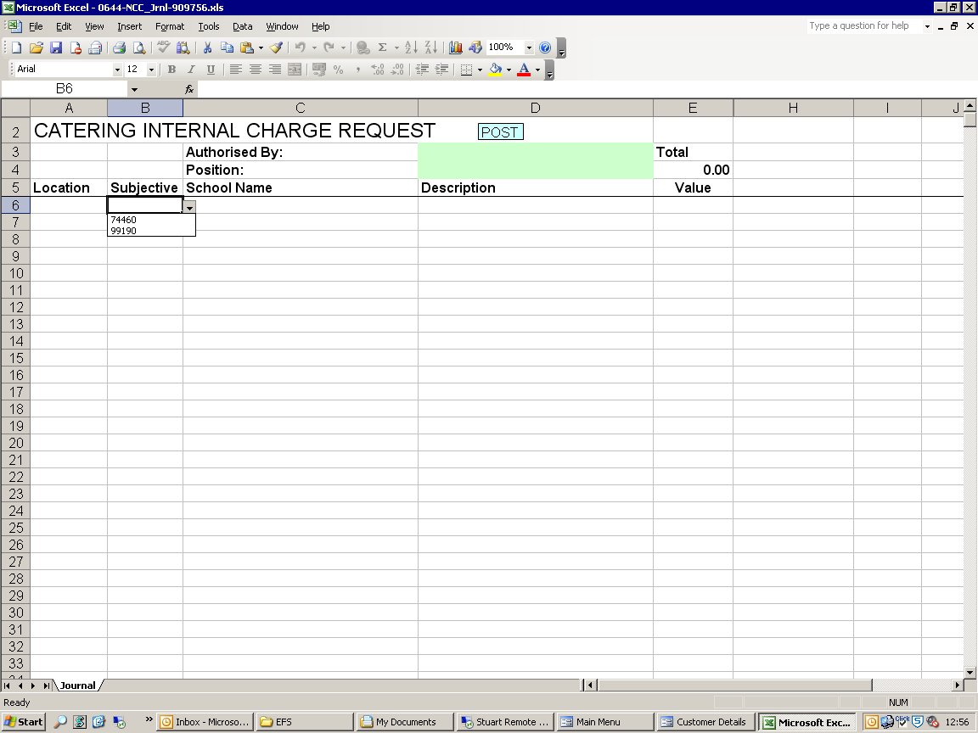
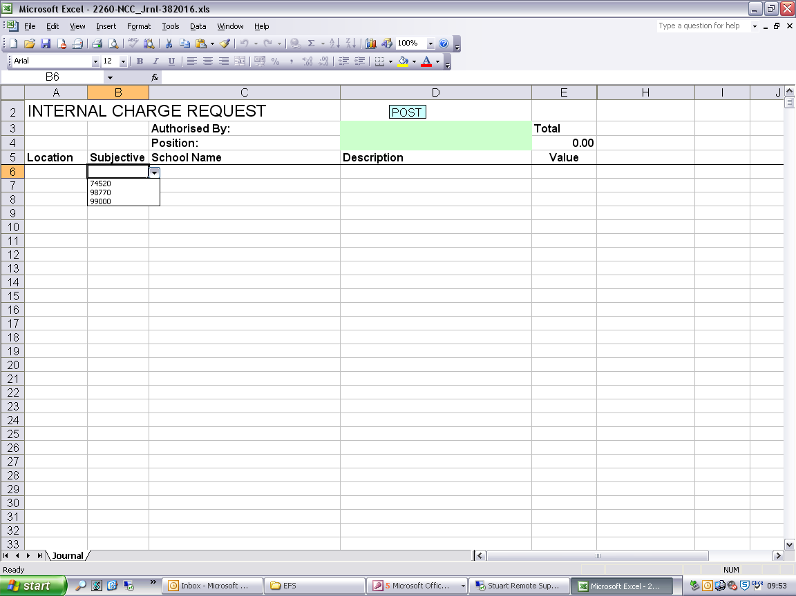
Catering
Other Recharges

Please Note: You are only permitted to debit (charge) your schools location code and credit (pay) other schools, therefore, the Subjective Code chosen against your Location Code should be the subjective that begins with ‘7’.

It is the debiting schools responsibility to ensure that those schools being credited via this journal are informed that the journal is taking place.

School Name: Enter the name of the school that the charge/payment relates to if this has not been pre-filled.

Description: Enter a meaningful description for the recharge which should be as succinct as possible. This description will be used when the recharge is downloaded to the receiving school.
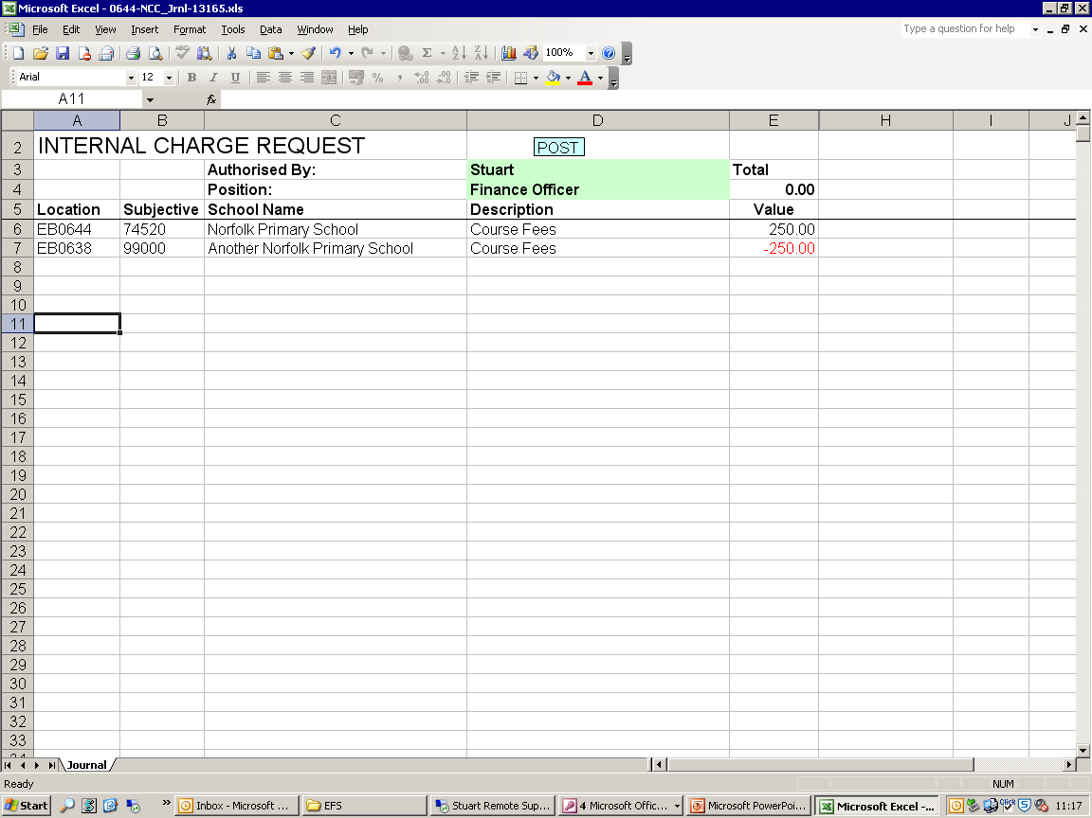

Value: Enter the amount of money to be transferred.
Remember: You can only debit (charge) your schools Location Code, therefore, the amount entered against your school should be a positive figure, and the amounts entered against the receiving school/s should be a negative figure.

Processing the Recharge:

Once you are satisfied that the recharge details have been entered click the ‘Post’ button at the top of the screen.

Once ‘Post’ has been clicked the spreadsheet will validate the data that you have entered and report any errors found. All errors must be rectified before the journal can be posted.

Errors that may occur:
- The recharge does not balance to 0
- The authorising details have not been completed
- The Location Code has been entered in the incorrect format
- A subjective code is missing
- A School Name is missing
- A description has not been entered
- A Value has not been entered

If any of these errors are found a note will be added to the screen next to the line on which the error occurred. Please correct the stated issue and click ‘Post’ again.

If the recharge passes the validation it will be copied to both the Output Path location contained within the Star Accounts datafile used to create the file, and the ‘Archive’ folder within the Star folder for future reference. The posting process will also attempt to email the file to efs.ca@norfolk.gov.uk.

If the system appears to freeze at this point it may be that an email prompt is hidden behind the spreadsheet. If you do not see the prompt on screen (as below) please click on the Microsoft Outlook tab within the start bar to view it:

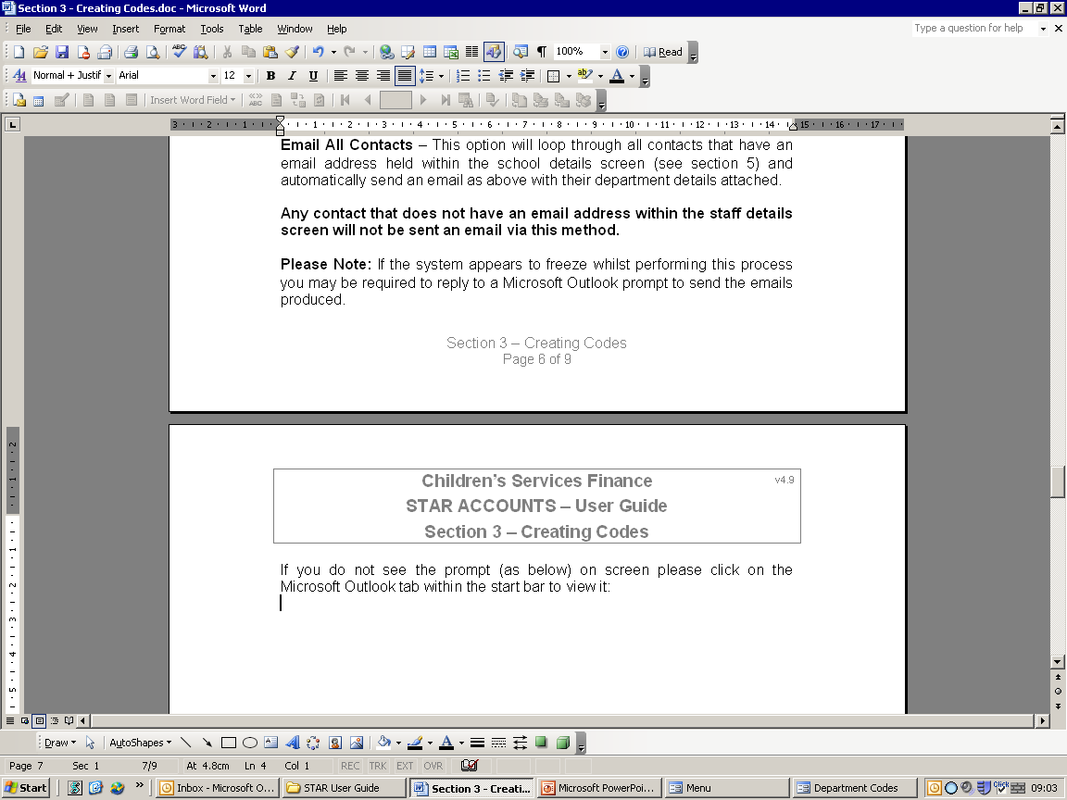

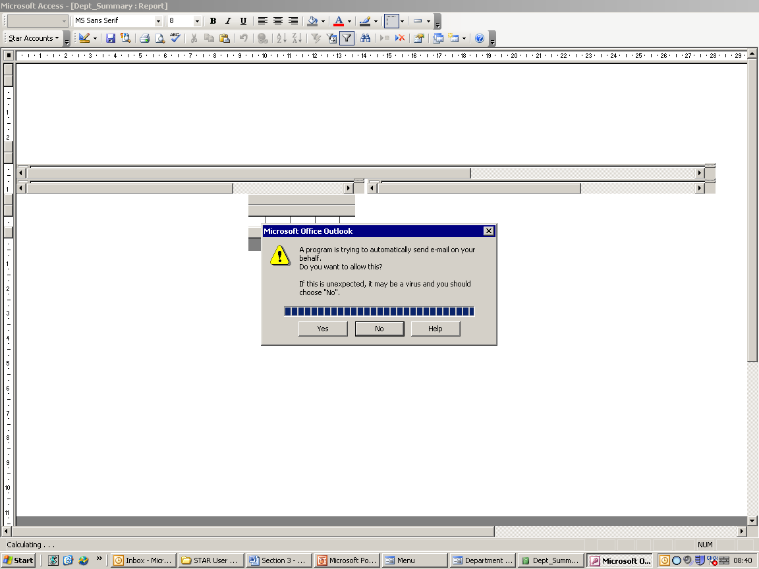
Click ‘Yes’ to send the email.

If you click ‘No’ to this message the process will continue unaffected.
You must ensure that this file is forwarded via AVCO AnyComms or email for the recharge to take place.

Receiving the Recharge:

Electronic recharges will be received via the download in the same way that the manual recharges are currently received. The description that is downloaded for the processing school (your school) will be shown as the Journal Reference ($$$$$$ from above) and the description. The receiving schools will be downloaded the item with your location code and then the description to help identify where the monies have been received from:

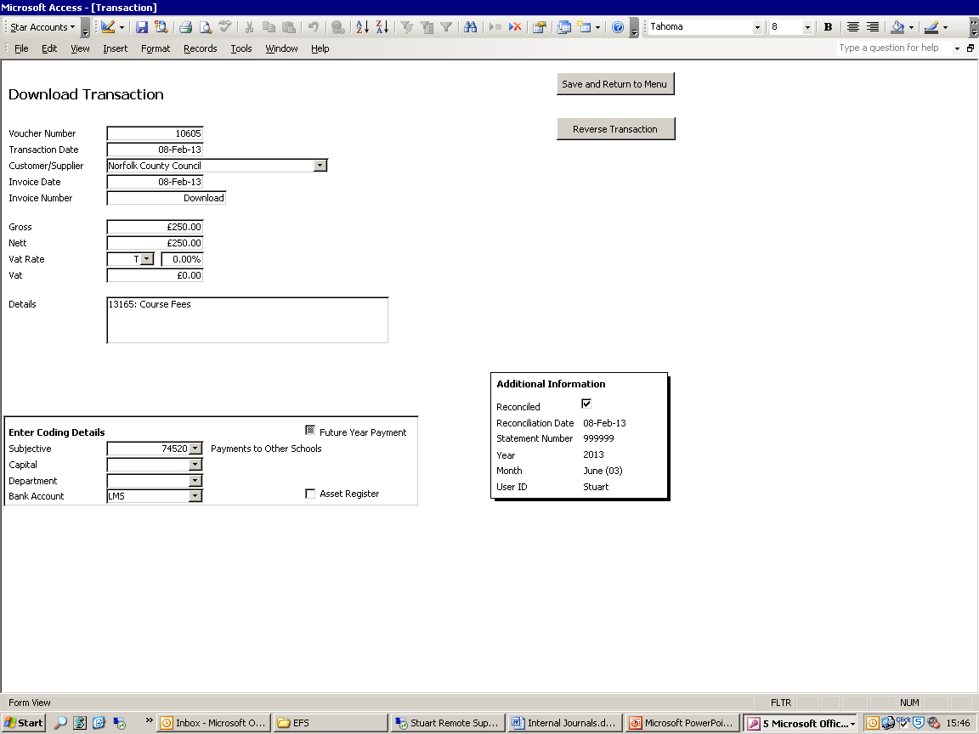
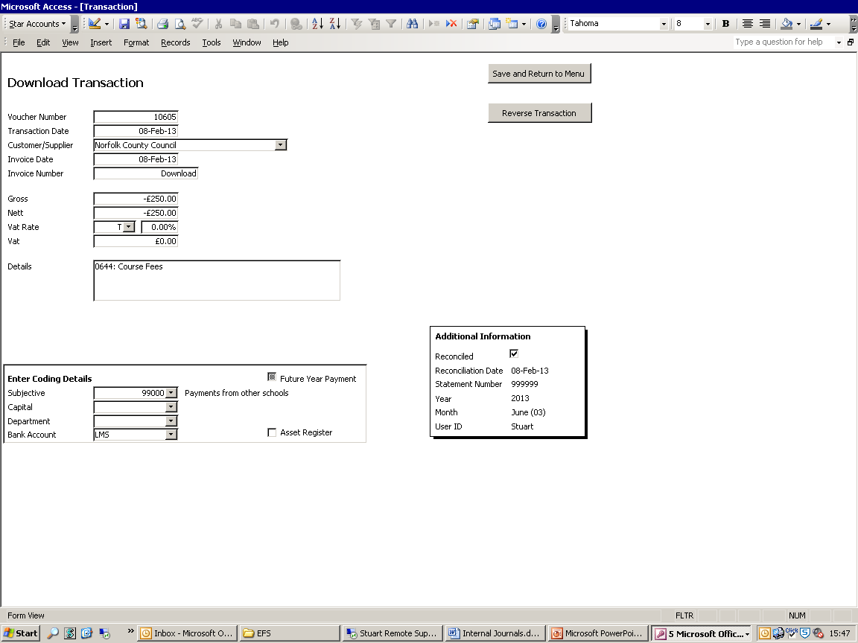
Processing School
Receiving School

