2013-14 | NIEAS  Professional Networks | 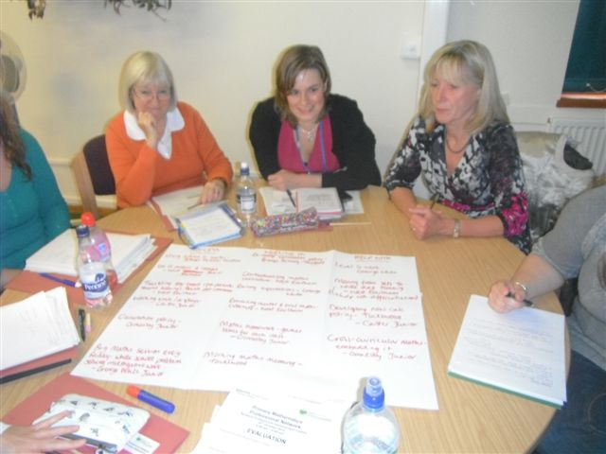

Norfolk Integrated Education Advisory Services (NIEAS) | Ofsted challenges middle leaders to maintain their knowledge and understanding of national developments and latest good practice in their subject/aspect areas; the Professional Networks support teachers to meet this challenge.  With the New National Curriculum rolling out in 2013/14, now is the time to join a professional network and be supported through these changes by an expert specialist adviser and have the opportunity to share concerns, ideas and solutions with colleagues across the county.  The Professional Networks are designed to support primary and secondary practioners who wish to work and learn together to bring about sustained school improvement.  Our professional networks:  - enable schools to keep abreast of international, national and local developments  - facilitate cooperation, mutual support, the sharing of resources and best practice  - help develop competent and confident leaders  - encourage debate about improvements and developments  - draw in wider expertise as fits in with developments within the subject/aspect.  We provide professional networks for:  Each Professional Network package includes:  - three half or whole day meetings (one per term) each academic year  - regular access to electronic resources through an online network space  - email and telephone support from specialist advisors  For more information and booking – http://www.cpd.norfolk.gov.uk/sdms/  Or email  CS.NIEASTraining@norfolk.gov.uk  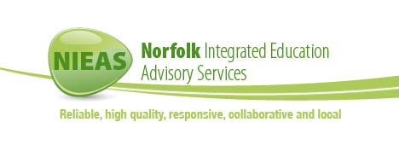  
  EPND6 | EYFS | £450
  EPNB1 | Primary English | £450
  EPNB2 | Primary Mathematics | £450
  EPNB5 | Primary Science | £250
  EPND1 | Cross Phase Behaviour and Safety | £450
  EPND5 | Cross-phase RE | £250
  EPND7 | Cross-phase PSHE and SMSC | £250
  EPNC1 | Secondary English | £450
  EPNC2 | Secondary Mathematics | £450
  EPNC3 | Secondary Science | £450
  EPNC5 | Secondary Geography | £250
  EPNC6 | Secondary History | £250
  EPNC4 | Secondary MFL | £250



