A good education for all: inspection of local authority services
A report on the responses to consultation
This report sets out the outcomes of the consultation on the introduction of arrangements for the inspection of local authority arrangements for supporting school improvement from 1 June 2013.
If you would like a version of this document in a different format, such as large print or Braille, please telephone 0300 123 1231 or email enquiries@ofsted.gov.uk.
Age group: 0-19
Published: May 2013
Reference no: 130152

Contents
Introduction 4
The consultation method 5
Summary of findings 5
Findings in full 7
The way forward 14
Annex A – Local authorities and stakeholder organisations who responded to the consultation 16

Introduction
- This report summarises the responses to Ofsted’s consultation on the proposals for a new inspection of the local authority arrangements to support school improvement. Under Section 136 of the Education and Inspections Act 2006, Ofsted has powers to inspect particular functions that are carried out by a local authority. This includes inspection of the local authority’s performance of its duties in relation to education and training. Her Majesty’s Chief Inspector (HMCI) may inspect a local authority at any time, but must inspect when required to do so by the Secretary of State
- HMCI’s Annual Report 2011/12 acknowledges that the role of local authorities has reduced in terms of the direct control they have over schools, particularly if a school is no longer a local authority maintained school. However, local authorities retain statutory responsibilities, as set out in section 13A of the Education Act 1996, and a range of powers that they may use to drive school improvement.
- Ofsted intends to introduce a sharply focused and targeted inspection framework that will evaluate the effectiveness and impact of arrangements to support school improvement, whatever their diversity, that are provided or secured by the local authority. Ofsted only intends to inspect where schools and other providers are not yet uniformly good or where they are not improving quickly enough.
- Ofsted has consulted widely on six key questions that will underpin the new framework. Respondents were asked about the extent to which they agreed, or disagreed, with the following questions.
- To what extent do you agree or disagree that targeted inspections, rather than universal inspections of all local authorities, is the right approach?
- To what extent do you agree or disagree that the indicators that might be used to trigger an inspection (paragraph 10 of the consultation document) are appropriate?
- To what extent do you agree or disagree that the inspection proposals in paragraphs 10 to 11 cover the right areas?
- To what extent do you agree or disagree with our proposed inspection notice period?
- We do not intend to use a four-point grading scale for judging the effectiveness of local authority school improvement services. We propose to evaluate strengths and weaknesses and arrive at a summary judgement of how effectively the functions are being exercised. To what extent do you agree or disagree that this is the right approach?
- To what extent do you agree or disagree that we should publish the inspection report findings in a letter format?
- The results of the consultation will help Ofsted to develop and implement a new framework from 1 June 2013. Ofsted aims to publish the new framework and accompanying guidance on 14 May 2013.

The consultation method
- The consultation period ran from 5 February to 19 March 2013. Ofsted used a range of methods to consult with people. These included:
- an online questionnaire available through Ofsted’s website
- a survey of parents on the Ofsted parents’ panel
- a survey of children and young people from Ofsted’s children and young peoples’ panel
- a range of face-to-face events, including conferences, meetings and focus groups with key stakeholders.
- Ofsted received 186 responses to the online questionnaire. These came from teachers and headteachers, school governors, parents, local authority employees and senior officers, organisations working closely with local authorities and school improvement functions, as well as representatives from local and national organisations, stakeholders and unions.
- The parents’ panel consultation attracted 259 responses and the children and young peoples’ panel attracted 147. During the consultation period, Ofsted organised over 10 conferences, meetings and focus groups with external stakeholders, headteacher reference groups and local authority senior officers across the country to talk about the consultation proposals and to seek views.
- These responses have been carefully collated and considered and this report reflects the results of all of the feedback we have received.

Summary of findings
- Overall, the feedback received was positive. The majority of respondents agreed or strongly agreed with all the proposals for the inspection of arrangements put in place by local authorities to support school improvement.
- Of the 186 responses to the online consultation, 65 were official responses from local authorities. The majority of local authorities support the inspection proposals and agree that scrutiny of the effectiveness of school improvement services in local authorities is an important process in ensuring a good education for all.
- Face-to-face engagement with stakeholders also provided positive support for our proposals. Workshops held with local authority senior officers were very constructive, and the detailed comments they provided have helped to inform and develop the final inspection framework and handbook.
- Two major stakeholders, the Society of Local Authority Chief Executives (SOLACE) and the Local Government Association (LGA), disagreed in principle with the notion of inspecting local authority school improvement services because of the increased autonomy given to schools. Ofsted met with SOLACE at different points during the consultation process to gather their feedback and views, and, while the views expressed have been carefully considered and noted, they do not accord with the generally supportive responses received from 65 local authorities and other major stakeholders, including the Association of Directors of Children’s Services (ADCS). Ofsted intends to maintain regular communication and consider further helpful proposals such as the inclusion of local authority officers on inspection teams as ‘current practitioners’ and to develop further local authority survey work to help benchmark effective practice.
- A significant number of responses highlighted the changing role of local authorities in a more autonomous and diverse school system and sought clarification on the expectations on local authorities in supporting and challenging non-maintained schools. This is a matter of government policy, which needs to be addressed by the Department for Education. However, the Secretary of State has made his expectations clear and issued guidance for local authorities in the way that local authorities should support schools, including through their role as strategic commissioners. This includes academies and free schools.
- The National Deaf Children's Society (NDCS) submitted a significant volume of coordinated responses (just under 800) from individual parents who were encouraging Ofsted to include the inspection of services for vulnerable pupils as part of the proposed framework for inspection of local authority school improvement arrangements. Although Ofsted recognises that such services have a key role to play in protecting and supporting the interests of vulnerable pupils, Ofsted will not explicitly inspect local authorities’ support for them as this is a bespoke inspection of school improvement arrangements. However, we will highlight any instance where a local authority’s arrangements for supporting vulnerable pupils is seen to be helping or is detrimental to the effectiveness of, their support for school improvement in the inspection findings.
- Additionally, the duties on local authorities as outlined in the Education and Inspections Act 2006 remain and are applicable to all schools. The proposals for the inspection of local authority school improvement services will include consideration of the support and challenge offered to all schools. Many respondents asked for greater detail on the inspection proposals. The consultation process has been particularly valuable in helping to shape the final and full inspection proposals. The feedback we have received has been used to develop the full inspection framework, guidance and instruments. These documents will add necessary detail and clarity to the proposals and are published alongside this report.

Findings in full
- Respondents to the online consultation who identified themselves came from a range of roles. The largest group responding (47%) were senior officers in local authorities.

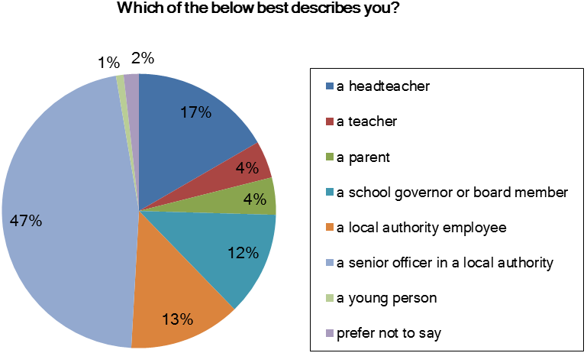
Based on 112 reponses
The detailed responses to each consultation question are set out below.
Q1. To what extent do you agree or disagree that targeted inspections, rather than universal inspections of all local authorities, is the right approach?

- There was strong support for this proposal, with the majority (62% of responses) agreeing or strongly agreeing:

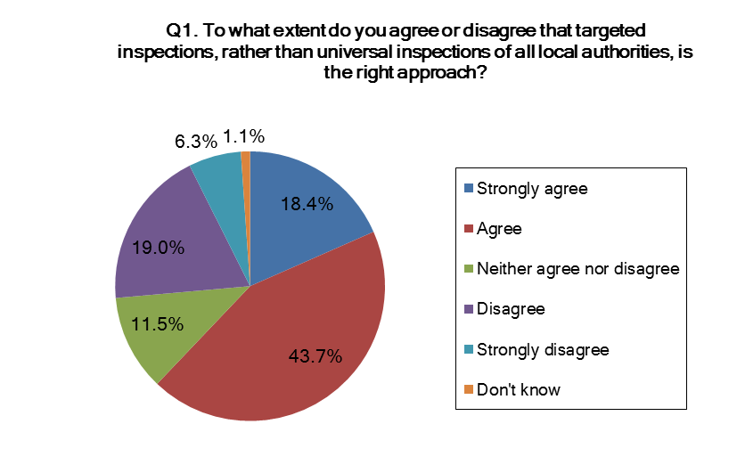
Based on 170 responses
- Over half of those who responded to the online consultaton (62%) agreed with targeted inspections, rather than a universal approach. These respondents felt that targeted inspections would focus resources on those who need it most and that this approach matches Ofsted’s proportionate approach to school inspection. Conversely, the majority of children and young peoples’ panel members were in favour of inspections for all local authorities. The question was worded differently for this group and 62% of respondents felt that Ofsted ‘should try to inspect every local authority in England’, rather than ‘give most attention to local councils who are struggling’.
- A common concern was that targeted inspection would not allow Ofsted to identify and share good practice across local authorities. To ensure that a balanced picture of local authority provision is gained, Ofsted will look to undertake regular surveys to identify and share good practice.
- It is also expected that local authorities who are inspected will have strengths in particular areas of their work. The inspection methodology will expect inspectors to identify case study material from these strengths for wider dissemination, adding to the good practice survey resources that will be available.
Q2. To what extent do you agree or disagree that the indicators that might be used to trigger an inspection (paragraph 10 of the consultation document) are appropriate?

- Again, the majority of those who responded to the online consultation (63%) supported the proposals for indicators which could trigger an inspection:
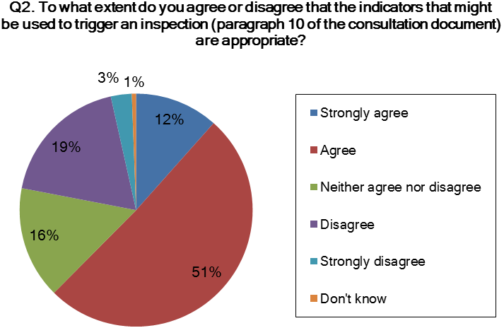
Based on 169 responses
- Over half of respondents to the online consultation agreed or strongly agreed with the proposals as set out in the consultation document. Support was consistent across different types of people and organisations responding to the consultation.
- Many respondents asked for more clarity on the use of indicators. It is intended that Ofsted will draw on the indicators three times a year when selecting local authorities for inspection. Ofsted’s new regional structure also means that greater engagement with local authorities will enable Ofsted’s Regional Directors to draw on local knowledge and this will be considered alongside the data indicators when determining which local authorities to inspect.
- Another common question raised was about the transparency of the indicators. The evidence and justification for the selection for inspection will be made available to the local authority at the point of announcing an inspection. We will also look to the possibility of regularly producing a dashboard of these indicators and sharing the data more widely, to aid self-evaluation.
- Some respondents raised concerns about the inclusion of the Secretary of State’s power to require Ofsted to undertake an inspection of a local authority as an indicator. The Secretary of State has the statutory powers to call for an inspection of any of a local authority’s services. Ofsted must inspect the local authority specified when required to do so by the Secretary of State. This is clearly set out in Section136(3) of the Education and Inspections Act 2006. Therefore this indicator will remain as part of the inspection framework.

Q3. To what extent do you agree or disagree that the inspection proposals in paragraphs 10 to 11 cover the right areas?

- Those who responded online were in favour (70%) of the proposals as set out in the framework. Again, there was no significant difference across different groups and people.
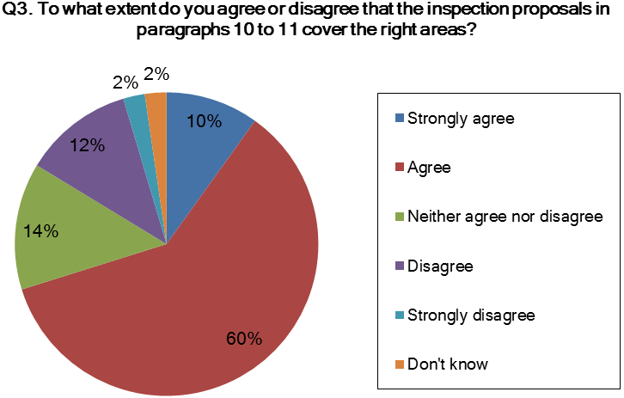
Based on 167 responses
- Responses from the parents’ and children and young peoples’ panels were also supportive, with 82% and 94%, respectively agreeing or strongly agreeing.
- The inspection proposals as outlined in the framework apply to all schools. The inspection framework will seek to evaluate the extent to which the arrangements for supporting school improvement are effective, taking into account local circumstances and context. At the commencement of the inspection, local authorities will be given the opportunity to provide contextual information that will be considered by inspectors as part of the evidence base.
- A number of those who responded to the consultation raised queries about the inspection of additional services local authorities offer, including their role in supporting groups of vulnerable children. Additional services will not be inspected discretely, but will be accommodated in the general evaluation of how well the local authority knows its schools and what it does to monitor, challenge, support and intervene in order to target resources where improvement is necessary. If the impact of those services is helpful or detrimental to improving outcomes, they will be highlighted as part of the inspection findings. Ofsted will review these areas before the end of 2013 in light of experience.

Q4. To what extent do you agree or disagree with our proposed inspection notice period?

- The majority of those who responded to the online consultation (59%) agreed with the proposed inspection notice period of five days:
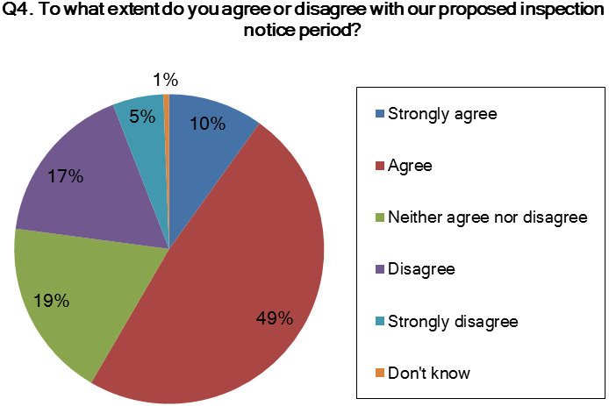
Based on 167 responses
- Over half of responses agreed or strongly agreed with the proposed inspection notice period. Many respondents recognised that five days would be required to make all the necessary inspection arrangements.
- While there was little difference between the groups who responded to the online consultation, the responses from the parents’ and children and young peoples’ panels were very different to this question. The parents’ panel reached no majority opinion, with 44% agreeing and 45% disagreeing. The children and young peoples’ panel tended to disagree, with 72% of responses falling into this category.
- Those who disagreed with this question had varying opinions about the inspection notice period that should be given. Some felt that more time was needed to ensure that all key staff were available at the point of inspection and others felt that a shorter notice period, comparable with that given to schools, would be preferred.
- Recognising the arrangements that need to be made ahead of an inspection commencing, we intend to retain the five day notice period. We will always endeavour to give five days’ notice of an inspection. Any instance where notice is less than this will be subject to the availability of local authority representatives in receiving requests.
Q5. We do not intend to use a four-point grading scale for judging the effectiveness of local authority school improvement services. We propose to evaluate strengths and weaknesses and arrive at a summary judgement of how effectively the functions are being exercised. To what extent do you agree or disagree that this is the right approach?

- Responses to this question were marginally positive, with 57% of those who responded online agreeing or strongly agreeing with the proposal:
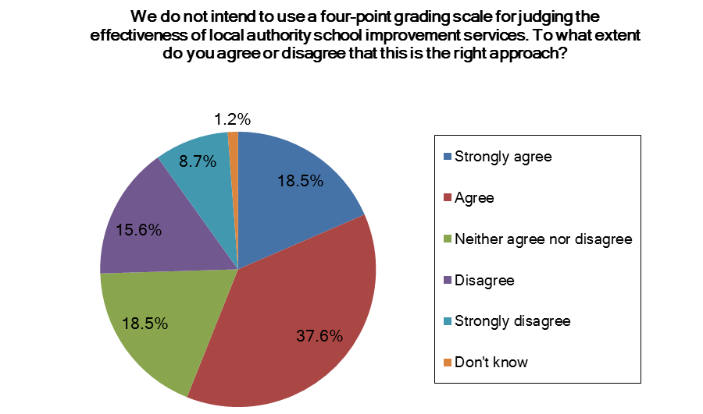
Based on 169 responses
- Similarly, 55% of parents’ panel respondents and 62% of children and young peoples’ panel respondents agreed with the proposal. There were fewer responses to this question than to others, and 33% of the parents’ panel and 23% of the children and young peoples’ panel representatives neither agreed or disagreed.
- Those who disagreed with this question felt that the four-point scale was recognisable and allowed for easy comparison, as well as being consistent with other inspection frameworks.
- While we have carefully noted these points, we believe that the four-point scale is not appropriate at this point as Ofsted does not have a duty, or intent, to inspect all local authorities to a regular cycle. Additionally, Ofsted will not be inspecting the full range of local authority services, only their arrangements for supporting school improvement. We therefore feel that a summary judgement of their effectiveness or otherwise in securing school improvement is more appropriate than using the four-point scale. However, Ofsted will review the process and methodology of inspection following the remit’s implementation by the end of 2013 and consider whether a four-point scale would be better serve the reporting arrangements.
Q6. To what extent do you agree or disagree that we should publish the inspection report findings in a letter format?

- The majority of those who responded online, 60%, agreed with this proposal. Just over a quarter of these respondents did not express an opinion on this proposal, with 26% neither agreeing or disagreeing.
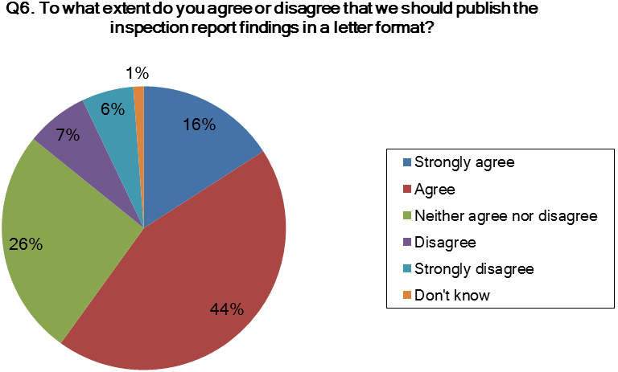
Based on 166 responses
- The parents’ panel and children and young peoples’ panel showed stronger support for this proposal, with 84% and 90%, respectively, tending to agree.
- Those who provided comments felt that the inspection findings should give sufficient detail on the strengths, weaknesses and areas for improvement for the local authority inspected. It is Ofsted’s intention to publish these findings in a letter report that will clearly explain these details.

The way forward
- We are grateful to all those who responded to the consultation. The views expressed highlighted many areas where respondents are content with the proposals, but also some important concerns that we have considered carefully. These have been valuable in helping us to develop the proposals. We aim to publish our revised inspection framework, handbook and inspection instruments alongside this report.
- In order to help clarify the position around academies and other non-maintained schools, the references to schools throughout the framework will be amended to ‘all schools’. Local authorities who are unclear about their role in supporting non-maintained schools should refer to guidance from the Department for Education. Ofsted will consider all schools when assessing the indicators which determine an inspection, as well as during the inspection, as set out in the framework but will take account of the circumstances of the schools and of the local authority.
- To respond to concerns around clarity of the inspection process and proposals, we intend to rename the inspection framework to ‘Framework for the inspection of local authority arrangements for supporting school improvement’. We hope this will make it clear that inspection will consider the effectiveness of the arrangements local authorities have in place to support school improvement, and that it is not a full inspection of local authority services in relation to schools. The terms ‘functions’ and ‘services’ will be amended to ‘arrangements’ where appropriate throughout the framework to reiterate this point. This change will also acknowledge that the configuration and provision of arrangements for supporting school improvement are now very diverse across England’s local authorities.
- Ofsted will not explicitly inspect local authorities’ support for vulnerable pupils as this is a bespoke inspection of school improvement arrangements. However, any instance where a local authority’s arrangements for supporting vulnerable pupils is seen to be helping, or detrimental to the effectiveness of, their support for school improvement will be highlighted in the inspection findings. References to pupils and groups will be amended to ‘all pupils’ throughout the framework to ensure clarity about the local authorities’ role in supporting all pupils, including vulnerable groups.
- In response to queries raised around the indicators that determine inspection, the revised framework will clearly state that the indicators for the selection of local authorities for inspection will be considered alongside contextual insight from Ofsted’s Regional Directors.
- We recognise the need to ensure that examples of good practice are gathered alongside the targeted inspection so that a full balanced picture of provision can be gained. We will be publishing a good practice survey report alongside this consultation and will look further into ways of gathering and sharing good practice in the future.

Annex A – Local authorities and stakeholder organisations who responded to the consultation
The following local authorities submitted responses to the online consultation:

Blackburn with Darwen Borough Council | London Borough of Redbridge
Bracknell Forest Council | London Borough of Tower Hamlets
Bristol City Council | Luton Borough Council
Buckinghamshire County Council, Children & Young People Services | Merton LA
Bury Council | Milton Keynes Council
Calderdale Local Authority | Newcastle City Council
Cambridgeshire County Council | North Somerset Local Authority
Cheshire East Council | Northamptonshire County Council
Children & Younger Adults Department, Matlock | Oxfordshire County Council
City of York Council | Peterborough City Council
Cornwall Council | Rotherham Local Authority
Coventry Local Authority | Sheffield City Council
Devon County Council | Shropshire Council
Durham County Council | Somerset County Council
East Sussex County Council | South Tyneside Council
EducationKingston (R.B. Kingston Upon Thames) | Southampton City Council
Essex County Council | Southend on Sea Borough Council
Harrow Council, London | Southwark Local Authority
Kent County Council | Staffordshire County Council
Knowsley Council | Suffolk County Councils
Lancashire County Council | Sunderland Local Authority
Leicester City Council | Surrey County Council
Leicestershire Children and Young People's Service | Surrey’s Secondary Phase Council
Lewisham | Swindon Borough Council
Lincolnshire County Council | Thurrock Council
London Borough of Barking and Dagenham | Trafford local authority
London Borough of Barnet | Wakefield Metropolitan District Council
London Borough of Bromley | Wandsworth Borough Council
London Borough of camden | Warrington Borough Council
London Borough of camden | West Sussex County Council
London Borough of Croydon | Wolverhampton City Council
London Borough of Enfield | Worcestershire Local Authority
London Borough of Islington

The following stakeholder organisation submitted responses to the online consultation:

AMiE (Association of Managers in Education) | NAHT
Aspect Group of Prospect | NASUWT
Association of Christian Teachers | National Foundation for Educational Research (NFER)
Association of Directors of Children’s Services (ADCS) | National Governors’ Association
Association of School and College Leaders | National Sensory Impairment Partnership (NatSIP)
BATOD, British Association of Teachers of the Deaf | National Union of Teachers
BeLGBT Bedfordshires LGBT community voice | NDCS policy and campaigns team
Best Practice Network | Norfolk Children’s Services
CfBT Education Trust | Royal National Institute of Blind People (RNIB)
Chartered Institute of Library and Information Professionals | School Councils UK
Chartered Institute of Library and Information Professionals | Scope
Cheshire East Association of Primary Headteachers | SOLACE
Children and Young People’s Mental Health Coalition | South West Heads of School Improvement Network
Children, Young People and Families team that will be part of Public Health England from 1 April 2013 | Stonewall
Children's Services- School Improvement Division | Surrey Governors’ Association
Cumbria County Council and partners from the Cumbrian Alliance of System Leaders | The Association of Teachers and Lecturers
Edyourself, independent home education consultancy | The Children’s Society
Home Education Advisory Service + Fiona Nicholson & Tricia Farey | The County Councils Network
Home Education Consultancy http://edyourself.org/ | The Dyslexia-SpLD Trust
London Assistant Directors and Heads of School Improvement | Tribal Inspections, Quality Review and Evaluation
London Council | Voice the Union for Education Professionals
London network of LA school improvement advisers | West Midlands Councils
Mick Seller Education Ltd | YoungMinds

