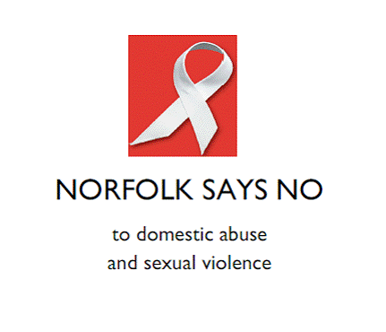
You are invited to a dramatic performance
depicting the impact of domestic abuse
on victim, perpetrator and witness:
‘No More!’
Based on real life events

Where: Blackfriars Hall, The Halls, St Andrew’s Plain,
Norwich, NR3 1AU

When: Friday 29 November, 4:00pm - 5.00pm
RSVP: joannasapsford@norwich.gov.uk by Wednesday 13 November to confirm attendance
This event is brought to you by Norwich City Council as part of ‘Norfolk Says No’ 2013 campaign
courtesy of Drama With Consequences

