Schools are asked to please include this item and image in their school newsletters to parents.

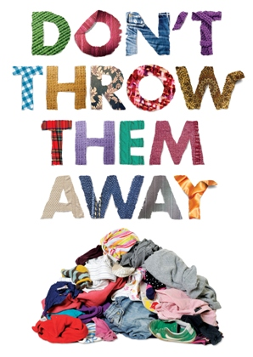
Recycle your old, worn out clothes
Your old textiles including: clothes, sheets and towels can be recycled and made into new products like padding for sofas.
You can recycle them at main recycling centres, many charity shops and textile banks or by using collection bags.
Find out more www.norfolk.gov.uk/textiles

