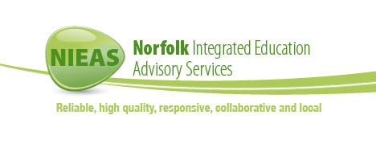
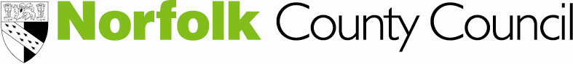
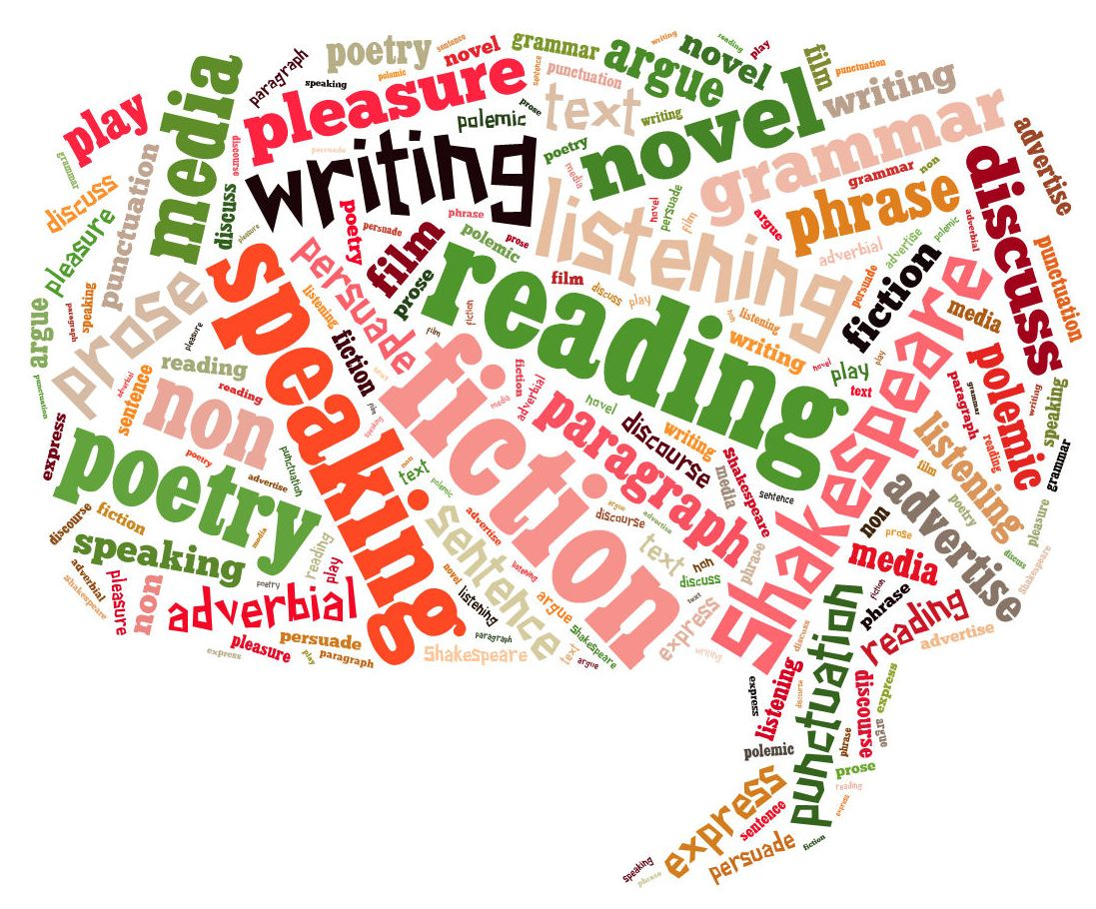

Norfolk Integrated Education
Advisory Services (NIEAS)
MAAS

Minority Achievement and Attainment Service (MAAS)
This is a training session in the use of Mantra Lingua’s TALKING PEN. Each delegate will receive training, a pen, access to software and 100 recordable stickers for the price of £75.

The TALKING PEN and its software can be used to:

- Read aloud Mantra Lingua dual language books in English and over 50 other languages
- Improve vocabulary by reading and translating words and pictures from the Mantra Lingua’s ‘My Bilingual Talking Dictionary’
- Make resources (e.g. story books, wall charts, talking labels) which can be read aloud by the Talking Pen

To book please email: tanya.ingram@norfolk.gov.uk

Session date: 10/06/14 1- 4 pm
Cost: £75. Payable to Mantra Lingua
Venue: Norwich PDC
Time: 13:00-16:00
Please note that lunch is not provided.

For further information please contact: the MAAS Team
Tel: 01603 307741
Email: elss@norfolk.gov.uk
Using a TALKING PEN – Supporting EAL learners

- Do you have EYFS or Primary EAL learners with little English?

- Would you like to attend a training session on a highly effective EAL resource which supports essential vocabulary development and translation?

