The file “Upgrade_StarSQL.exe” is available with the Period 5 Download on 4th September.

DO NOT OPEN THE FILE UPGRADE_STARSQL.EXE.
TO COMPLETE THE UPGRADE YOU MUST FOLLOW THE INSTRUCTIONS BELOW!

NB: Before attempting the Upgrade all other Access Programs must be closed.

1. AVCO Automatic Upgrade – Main PC

Please Note: The automatic upgrade will only work if AVCO is accessible on the same PC that operates Star Accounts. If AVCO is not accessible, copy the file Upgrade_StarSQL.exe from your AVCO Finance Inbox into the folder designated as your Inputs Path (see Records, School Details). If the file does not exist please copy from the AVCO Archive folder.

The automatic upgrade will only upgrade the PC that has access to the AVCO Finance Inbox. A copy of the upgraded version of Star Accounts.mdb will be placed into the Star\Backup folder on the server to enable additional users to upgrade.

Start a call in AVCO. Once the call has completed you should see a file called Upgrade_StarSQL.exe in the Finance folder within the Inbox.

Log into Star Accounts from your desktop as you would normally. If you were logged into Star Accounts whilst the AVCO call was being made you will need to log out completely, and then log-in again for the upgrade to take place.

Please Note: If you get the following message click ‘Open’ to continue.
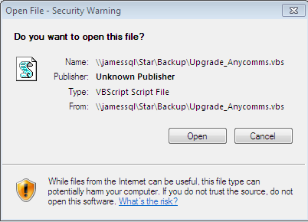

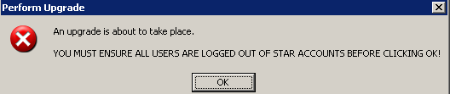

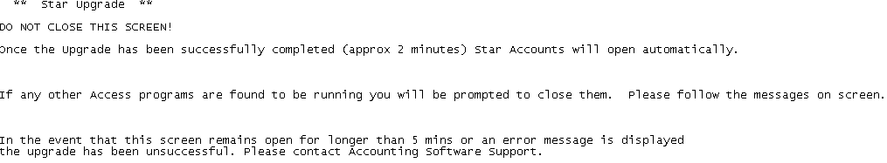
Star Accounts will close and the following screen will be displayed. Follow the directions on the screen.
The upgrade cannot continue unless Access is closed. If it detects any MSAccess programs are running you will be prompted with the following message. Reply to the prompts on the screen.
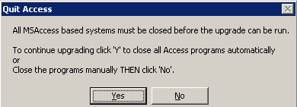

Access 2010 only!
Schools using Access Version 2010 will see the additional prompt
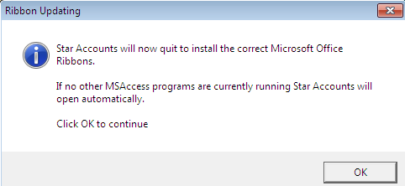

The first time you login the upgrade will update all data files held on your server (including prior year data files). This will take a while but you must wait for the following message to appear:
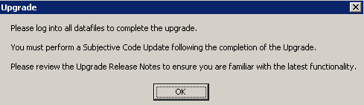

The Main Menu should say 5.80. Remember to log into all other data files to complete the upgrade. If the upgrade is unsuccessful please contact Accounting Software Support.

2. Upgrade Additional Users

As soon as the data files have been upgraded on the main PC, when other users attempt to log into Star from their PC they should see the following message:
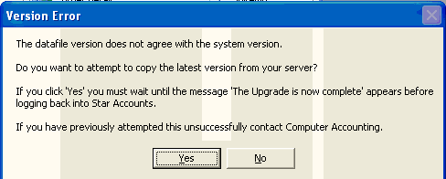

Click ‘Yes’ to copy the current version of Star Accounts from the server to the PC. You must wait for the following messages to appear.
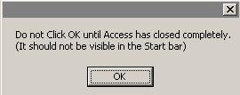
Click ‘OK’

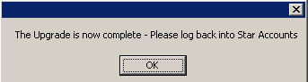
Click ‘OK’

3. Upgrade Release Notes and Current Version Number

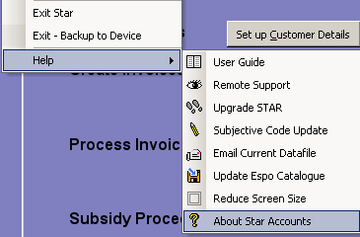
The ‘Current Upgrade Release Notes’ and Version number can be viewed within “About Star Accounts”.

(From the keyboard hold keys Ctrl & A)

4. Subjective Code Update

Once the upgrade has been completed please perform a Subjective Code Update as per Section 15 of the Star Accounts User Guide.

To view the currently active subjective codes from Records select ‘View Subjective Codes’.

