The file “Upgrade_Star.exe” is available with the Period 5 Download on 4th September.

DO NOT OPEN THE FILE UPGRADE_STAR.EXE.
TO COMPLETE THE UPGRADE YOU MUST FOLLOW THE INSTRUCTIONS BELOW!

1. AVCO Automatic Upgrade

Please Note: The Automatic Upgrade will only work if AVCO is accessible on the same PC that operates Star Accounts.

If AVCO is not accessible, copy the file Upgrade_Star.exe from your AVCO Finance Inbox into the folder designated as your Inputs Path (see Records, School Details). If the file does not exist please copy it from the AVCO Archive folder.

Start a call in AVCO. Once the call has completed you should see a file called

Upgrade_Star.exe in the Finance folder within the Inbox.

Log into Star Accounts from your desktop as you would normally. If you were logged into Star Accounts whilst the AVCO call was being made you will need to log out completely, and then log-in again for the upgrade to take place.

Please Note: If you get the following message click ‘Open’ to continue.
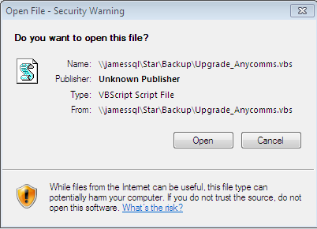

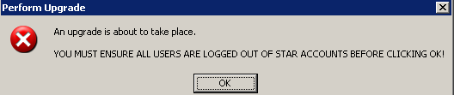

Star Accounts will close and the following screen will be displayed. Follow the directions on the screen.
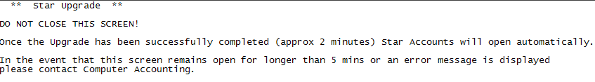

Access 2010 only!
Schools using Access Version 2010 will see the additional prompt

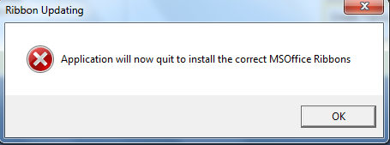
Click ‘OK’ to close Star Accounts

Once Star Accounts has closed you can log back into Star Accounts.

The first time you login the upgrade will update all data files (including prior year data files). This will take a while but you must wait for the following message to appear:
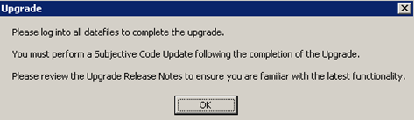

The Main Menu should say 5.80. Remember to log into all other data files to complete the upgrade. If the upgrade is unsuccessful please contact Accounting Software Support.
Please Note: Only the first user of Star Accounts can perform the required upgrade, i.e. the user whose shortcut links to the Star_Accounts.vbs file. Users whose shortcut links to a Star_Accounts2.vbs, Star_Accounts3.vbs etc file cannot perform the upgrade.

2. Upgrade Release Notes and Current Version Number
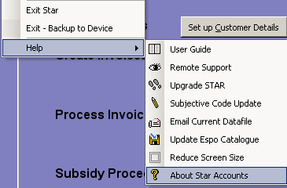

The ‘Current Upgrade Release Notes’ can be viewed within “About Star Accounts”.

(From the keyboard hold keys Ctrl & A)

3. Subjective Code Update

Once the upgrade has been completed please perform a Subjective Code Update as per Section 15 of the Star Accounts User Guide.

To view the currently active subjective codes from Records select ‘View Subjective Codes’.

