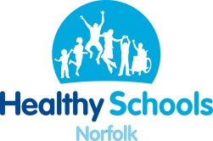

Professional Learning and
Development Booking Form

Return to:  Healthy Norfolk Schools  15 Hooper Lane  Norwich, NR3 4ED  Tel: 01603 221809  ecch.healthyschoolstraining@nhs.net |  | Booking from  Name:  School/organisation:  Telephone number: Date:
Course Title: FEE: £0.00
Venue: Date:

First Name | Surname |  | Title | Email address for booking confirmation
HEALTHY SCHOOLS STATUS: Healthy Schools is funded to provide training to those schools with current Healthy School Status (or actively working to achieve it or renew it.) Places may also be available for colleagues from the wider children’s workforce.
Cancellation Policy: Free courses will incur a £20 administration fee for non-attendance or if cancelled within 5 working days
of the course date
Booking authorised by Signature: Title: Date:

