
County Hall
Martineau Lane
Norwich
Norfolk
NR1 2DH
Tel: 01603

Date: 4 March 2015

To all Head Teachers and Principals,

Norfolk's budget and services 2015-18

Following the letter that I sent to you on the 30 October 2014 explaining the financial challenges being faced by the County Council for 2015/16, I wanted to write to you to update you on the decision regarding the subsidy that is paid to schools for use of the facilities by voluntary and community group.

On Monday 16th 2015 of February Norfolk County Council agreed the budget for 2015/16, which included agreeing the proposal to remove the subsidy that we pay directly to schools to help enable voluntary and community groups to use school facilities. All schools can currently decide what rates they charge for others to use their facilities and the removal of the subsidy is in line with broader changes to school funding.

From the 1st April 2015 the subsidy scheme will cease to operate and to enable claims for the financial year 2014/15 to be processed please ensure that they are submitted by the 31st March 2015.

Yours sincerely,

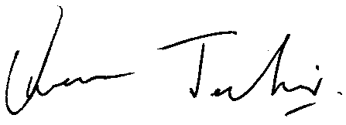

Owen Jenkins, Finance Business Partner (Children’s Services)

