
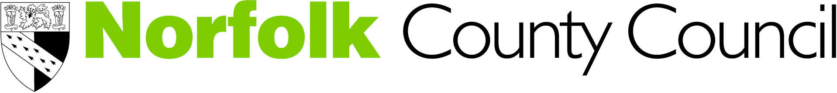

Tackling Mental Health Stigma with Children and Young People
Working together to improve the emotional and mental wellbeing of young people

Date: November 24th 2015 Location: Norwich

Time: 9.30am to 4.30pm

Number of places: 30-35

Aims and objectives
- To improve the knowledge and skills relating to tackling mental health stigma with children and young people
- Participants cascade the knowledge gained to other staff in their organisations

Outcomes
By the end of the course, participants will be able to:
- Understand what stigma is
- Recognise the effects that mental health stigma has
- Describe effective ways of tackling mental health stigma with children and young people on an individual and group basis
- Know about the evidence-base about mental health stigma

Target group
Staff working in Universal (non-specialist mental health settings) who have some understanding of, or responsibility to support children and young people with mental health issues. Ideally participants will have attended a previous foundation course, i.e. Emotional Health Awareness Foundation Training offered by CAMHS. This course is now available on line. For further information and to access this on line course via the Learning Hub please click here

Participants will be required to cascade knowledge gained with colleagues in their setting. A tool to help with this will be provided.

Training provider:
Associate Development Solutions Ltd is an organisation made up of people with extensive experience of the mental health of children and young people; working in child and adolescent mental health services, universal services and in training and education. Our aim is to support raising the profile of the mental health of children and young people and to provide a training experience that is informative and useful.

We want people to be as involved as possible. To facilitate this, we will include small group exercises, DVD clips and explore how we can tackle stigma on an individual and group basis.

Course length: One day

Cost
The course will cost £40.00. Refreshments will be provided but no lunch is included.

Venues
Venue information will be sent with confirmation of place.

Allocation of Places
Places will be allocated on a first come first served basis

Booking
To request a place, please fully complete and return the attached booking form by
5th November 2015 to HRSS Learning & Development, County Hall Annexe, Martineau Lane, Norwich, NR1 2UE: or email to hrld@norfolk.gov.uk

Please ensure a full invoice address is entered on the application or alternatively if you are a Norfolk County Council employee please ensure your departments cost centre code is entered.

Cancellations and non-appearance
A course will only run with a minimum number. In the event that a course is under-subscribed applicants will be notified and where possible offered an alternative date/venue.
No refund will be given for non-attendance: however, we are happy to accept a suitable delegate in your place. Any changes of delegate must be notified to HRSS Learning & Development, County Hall Annexe, Martineau Lane, Norwich, NR1 2UE: or email to hrld@norfolk.gov.uk prior to the course date.

Confirmation and course programme
If you are allocated a place we will email confirmation and joining instructions to you by 10th November 2015.The course programme and location map will also be emailed to you at this time.

To be added to the distribution list for courses, please email camhs@norfolk.gov.uk

