
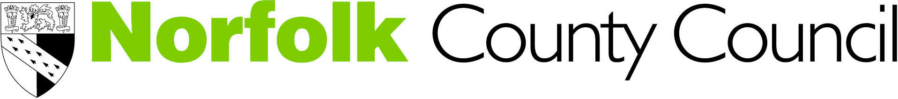
Understanding Self Harm in Young People
Working together to improve the emotional and mental wellbeing of young people

Date: November 25th 2015 Location: Norwich
Date: November 26th 2015 Location: Dereham

Time: 9.30am to 4.30pm

Number of places: 30-35

Aims and objectives
- To explore behaviours around self harm
- To increase understanding around the function of self harm
- To look at the risk factors that can lead to self harm
- To increase skills and understanding behaviour assessments and positive treatment programmes
- To access a variety of resources in relation to self harm
- To explore the various management options and support strategies young people who self harm
- For participants cascade their knowledge gained to other staff in their organisations

Outcomes

By the end of the course each delegate should be able to:

Understand what self-harm is

Recognise signs and symptoms of self-harm in the context of child development

Develop practical skills, effective interventions and use tools with which to support children and young people

Describe effective interventions at different ages and stages

Become familiar with evidence based practice (inc. NICE guidelines)

Increase understanding of the theoretical base which underpins self-harm and how this can inform practice

Develop awareness of relevant cultural issues

Know when, where and how to refer to targeted and / or specialist services

Target group
Staff working in Universal (non-specialist mental health settings) who have some understanding of, or responsibility to support children and young people with mental health issues. Ideally participants will have attended a previous foundation course, i.e. Emotional Health Awareness Foundation Training offered by CAMHS. This course is now available on line. For further information and to access this on line course via the Learning Hub please click here

Participants will be required to cascade knowledge gained with colleagues in their setting. A tool will be provided to help with this.

Training provider:
Associate Development Solutions Ltd is an organisation made up of people with extensive experience of the mental health of children and young people; working in child and adolescent mental health services, universal services and in training and education. Our aim is to support raising the profile of the mental health of children and young people and to provide a training experience that is informative and useful.

We want people to be as involved as possible. To facilitate this, we will include small group exercises using case studies, a game, and explore how we can share skills. The day will also include DVD clips, presentations on the theory and an exploration of the care pathways in Norfolk.

Course length: One day

Cost
The course will cost £40.00. Refreshments will be provided but no lunch is included.

Allocation of Places
Places will be allocated on a first come first served basis

Booking
To request a place, please fully complete and return the attached booking form by 5th November 2015 to HRSS Learning & Development, County Hall Annexe, Martineau Lane, Norwich, NR1 2UE: or email to hrld@norfolk.gov.uk
Please ensure a full invoice address is entered on the application or alternatively if you are a Norfolk County Council employee please ensure your departments cost centre code is entered.

Cancellations and non-appearance
A course will only run with a minimum number. In the event that a course is under-subscribed applicants will be notified and where possible offered an alternative date/venue.
No refund will be given for non-attendance: however, we are happy to accept a suitable delegate in your place. Any changes of delegate must be notified to HRSS Learning & Development, County Hall Annexe, Martineau Lane, Norwich, NR1 2UE: or email to hrld@norfolk.gov.uk prior to the course date

Confirmation and course programme
If you are allocated a place we will email confirmation and joining instructions to you by 10th November 2015. The course programme and location map will also be emailed to you at this time.

To be added to the distribution list for courses, please email camhs@norfolk.gov.uk

