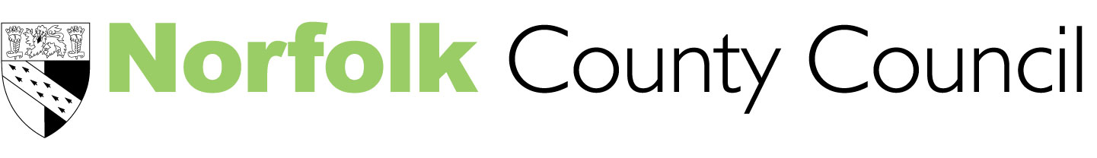

VAT manual

Please do not contact HM Revenue and Customs direct in respect of
County Councils tax matters.

Purpose of the manual
The aim of this manual is to provide basic guidance on VAT legislation and its application within the County Council.
It covers the main areas that affect the County Council and how these should be addressed.
Any queries should be directed to:
- Tax Accountant, telephone 01603 223177; or
- Schools Finance Support Officer (initial contact point for school VAT queries)

Please do not contact HM Revenue and Customs direct in respect of issues relating to County Council tax matters.

VAT manual
Contents
Section one - introduction
  - What is VAT?
  - VAT categories
  - Calculating VAT
  - Record keeping
  - Transactions within the County Council and with other organisations

Section two – expenditure
  - Expenditure - goods and services received (input VAT)
  - Incorrect invoices, incomplete invoices, till receipts and VAT only invoices
  - “Composite” or non-standard rates of VAT

Section three – income
Income - goods and services provided (output VAT)
3.2 Rental income – premises (excluding sporting facilities)

Section four – schools section
4.1 Transactions between Council departments and schools
4.2 School unofficial funds
4.3 Foundation schools / VA schools/ academies
4.4 VAT only invoices
4.5 School meals
4.6 Educational excursions and visits
4.7 Sale of goods to children and young people – general
4.8 Sale of school uniform and sweatshirts
4.9 School photographs
4.10 School drama / concert productions
4.11 Rental income – sporting facilities
4.12 Joint use / dual use agreements
4.13 Extended schools

APPENDICES

Section 2: expenditure 2A Expenditure, Nil VAT purchases: zero – 0 (ZER), exempt – E (EXE) or outside the scope – T (TSC)?
Section 3: income 3A VAT rates for sales / income - summary
3B List of VAT categories (when through delegated budget)
3C VAT and invoices to academies
3D Food – standard or zero rated?
3E VAT liability of hot takeway food - overview

Section 4: schools section 4A VAT on takeaway school meals sold to staff and visitors

1. Introduction


1.1 What is VAT?
Value Added Tax (VAT) is a tax on the supply of goods and services. The tax is administered in the UK by Her Majesty’s Revenue and Customs (HMRC). VAT incurred on purchases is known as “input tax” and is usually recovered from HMRC. VAT charged on sales is known as “output tax” and is paid to HMRC.
The County Councils VAT registration number is GB 106 9951 52. This registration covers all official activities of the Council.

1.2 VAT categories
All transactions must be assigned to one of the following VAT categories:

Non-business
Outside the scope of VAT
- no VAT
(TSC)

Business
Within the scope of VAT

Taxable
Exempt
- no VAT
(EXE)
Zero rate
- 0%
(ZER)
Reduced rate
- 5%
(HAF)
Standard rate
- 20%
(STD)

Purchases: The County Council can reclaim virtually all of the VAT added by suppliers onto their invoices. Supplier invoices are normally the best guide when coding expenditure. Appendix 2A gives guidance for supplier invoices with no VAT.
Sales: The majority of services provided by local authorities are outside the scope of VAT i.e. VAT is not chargeable on services which are provided under a “special legal regime” and are not in competition with private traders.
Other services and sales should be standard rated unless they clearly fall into another category. Appendix 3A and Appendix 3B give guidance as to which category is likely to be applicable.

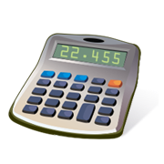
1.3 Calculating VAT

1.3.1 Standard rate VAT
VAT to be added to net price
To calculate the VAT on the price of goods or services, which are standard rated for VAT and do not yet include VAT, multiply the price by the VAT percentage.
Price net of VAT | £500.00
VAT @ 20% | £100.00
Total price | £600.00

VAT within income received or within the total price paid
To calculate standard rate VAT on the price of goods and services where the price already includes VAT, either:
- multiply by 20 and divide by 120 or, more simply
- divide by six

This is the “VAT fraction”, 20/120 or 1/6 for 20% VAT rate
Price including 20% VAT | £200.00
VAT £200.00 | £33.33
6
Price excluding VAT | £166.67

1.4 Record keeping
Business records must normally be retained securely and in good order for 6 complete financial years plus the current year. These include:
  - Orders and delivery notes
  - Relevant business correspondence
  - Purchase invoices from suppliers
  - Credit notes
  - Purchasing card statements
  - Cash records and till rolls
  - Invoices raised
  - Bank statements and paying in slips
  - Annual accounts

Records may be retained electronically.
Example: Invoice dated 12th November 2015
Keep Current year 12th November 2015 to March 2016
Keep Year 1 1st April 2015 to 31st March 2017
Keep Year 2 1st April 2016 to 31st March 2018
Keep Year 3 1st April 2017 to 31st March 2019
Keep Year 4 1st April 2018 to 31st March 2020
Keep Year 5 1st April 2019 to 31st March 2021
Keep Year 6 1st April 2020 to 31st March 2022
Destroy Year 7 1st April 2022
For detailed guidance, please find below link to the County Council retention schedule:
http://inet.norfolk.gov.uk/view/inet167614

1.5 Transactions within the County Council and with other organisations

1.5.1 Activities covered by the County Council VAT registration
Transactions between different sections of the County Council are “outside the scope” of VAT. This includes transactions with and between:

- Norfolk County Council schools, and
- Nplaw, and
- entities owned by the County Council and under its VAT registration, even if separately branded e.g. Hethel Engineering Centre, Scottow Enterprise Park

1.5.2 Entities not covered by the County Council VAT registration
Sales to organisations which do not come under the County Council’s VAT registration should have VAT applied as applicable (see Appendix 3A, Appendix 3B and Appendix 3C for specific guidance). This includes sales to:

- Academies
- Norse Group companies
- Independence Matters CIC
- Charities
- A school’s unofficial funds

Expenditure from third parties should be coded as per the invoice received.

2. Expenditure


2.1 Expenditure – goods and services received (input VAT)

2.1.1 Introduction
VAT can only be properly recovered if there is adequate documentation.
VAT registered traders who supply the County Council with goods and services are required to provide an original tax invoice. Statements or photocopies of VAT invoices or receipts are not normally acceptable. If necessary, ask the supplier for a duplicate invoice. For further clarification, see 2.2 Incorrect invoices, incomplete invoices, till receipts and VAT only invoices.
Where goods or services are supplied by traders who are not registered for VAT, no VAT will have been charged, therefore, no VAT can be recovered. Expenditure in these cases should be given an “outside the scope” VAT indicator (see 1.2 VAT categories).
If there are two or more rates of VAT on the invoice (e.g. standard and exempt or zero VAT), then an equivalent number of entries into the accounts payable system will be required, each with the appropriate VAT indicator (see 1.2 VAT categories). The total VAT input to the accounting system should always equal the total VAT shown on the invoice.

2.1.2 Pro-forma invoices
Sometimes the supplier will issue a ‘pro-forma’ invoice. This will either exclude VAT or, more commonly, state ‘this is not a tax invoice’. VAT cannot be recovered on these documents (with payment coded as outside the scope as above).
On receipt of the tax invoice, the original transaction on the pro-forma invoice should be cancelled, and the new invoice input using the appropriate VAT category.

2.1.3 Imports and foreign VAT
VAT on goods imported from outside of the European Union (EU) cannot be recovered and the whole invoice should be coded to “T” as outside the scope.
Zero-rating of VAT may be secured on goods received from within the EU by giving the supplier the County Councils VAT number in advance (GB 106 9951 52). The Council then accounts for the acquisition tax here in the UK so the Councils Tax Accountant must be informed of any such transaction.
Furthermore, the Council is required to declare the total of the goods received from the EU.
From 1 January 2015, the rules around EU VAT on supplies of services changed. This is now dependent on the location of the customer. Advice should be sought prior to any services being ordered.
The County Councils Tax Accountant should be informed of any EU acquisitions and imports as adjustments to the Councils VAT return may need to be made.

2.2 Incorrect invoices, incomplete invoices, till receipts and VAT only invoices

2.2.1 Retail purchases under £250
For minor purchases of less than £250 from a retailer, a receipt will be acceptable providing that it includes all the details required on a simplified tax invoice which must include:
  - Date of issue
  - Name, address and VAT number of the retailer
  - Description of the goods or services
  - Amount payable including VAT
  - The VAT rate applicable to the items at each different VAT rate

The only items of expenditure which do not require a VAT invoice/receipt to support VAT recovery are:
- Telephone calls
- Purchases through coin-operated machines
- Off-street car park charges.

This however only applies where the value of the supply is less than £25.

2.2.2 Incorrect VAT invoice
Except when taking agreed prompt payment discounts, the price on the invoice before VAT is charged should never be altered. The amount of VAT must never be changed.
If the supplier has clearly made a mistake, they should be contacted and asked to cancel and re-issue the invoice. If they refuse or do not re-issue, the total VAT input to the accounting system should always equal the total VAT shown on the invoice.
In addition, please inform the Councils Tax Accountant if the invoice is not amended.

2.2.3 Incomplete invoices and till receipts
Till receipts sometimes contain all the information required by a less detailed VAT invoice and VAT can be recovered. Some tills use a symbol such as an asterisk * to identify standard rated goods on till receipts. This is acceptable for VAT purposes if they contain the address and VAT registration number of the supplier (which can sometimes be found on the reverse side of the receipt).
Many receipts do not include all the information required (most commonly the VAT rate) in which case the Authority does not have the basic right to recover VAT.
However, where a receipt or invoice does not include the required information, HMRC will permit VAT recovery if we can demonstrate that:

a) A full VAT invoice was asked for
b) The retailer is an established VAT registered UK business; and
c) The goods are clearly VATable.

Notes to make on incomplete VAT invoice/receipt
In order to reclaim VAT, retain the till receipt and any other evidence of payment (e.g. purchasing card slip) and make a note stating:

- That the retailer was asked for a VAT receipt.
- The retailer is an established/well known UK business.
- How the goods purchased will be used for council purposes (if not obvious).
- Any other relevant information about the goods / supplier

Source:
HMRC Statement of Practice March 2007 ‘VAT Strategy: Input Tax deduction without a valid VAT invoice”.
HMRC guidance: VIT31200 - How to treat input tax: alternative evidence for claiming input tax

2.2.4 Pitfalls: small retailers, purchasing cards / internet
Do not recover VAT, even under the above rules, if:
- The vendor may be too small to be registered for VAT
- Internet purchases if the vendor is possibly outside of the UK; or
- You only have a pro-forma invoice stating “this is not a VAT invoice”.

The total gross amount of the invoice should be coded “outside the scope”.
Finally …
The VAT inspector would not expect files of invoices to be filled only with incomplete invoices, so please ask staff to obtain VAT receipts wherever possible.

2.3 “Composite” or non-standard rates of VAT
There are only three rates of VAT: 20%, 5% and 0%. However, some suppliers supply a mixture of zero and standard rated goods and they have agreements with their VAT inspectors to charge composite rates.
For example, a publisher may send an invoice for a combined book / CD package showing a price net of VAT of £1,100.00 plus VAT at 9% of £99.00 giving a total payable of £1,199.00.
To code this properly, it needs to be broken down into two transactions – the standard rated element (the CDs) and the zero rated element (the books).
- Calculate the value required to give £99 to give the standard rated amount:
 | 20%
Price net of VAT:
£99.00 x 5 | £495.00

- Calculate the zero rated element:

 | 20%
Price net of VAT:
£1,100.00 - £495.00 | £605.00

- Code the invoice as per the results:

Standard rated | £495.00
Zero rated | £605.00
VAT @ 20% | £99.00
Total price | £1,199.00

3. Income

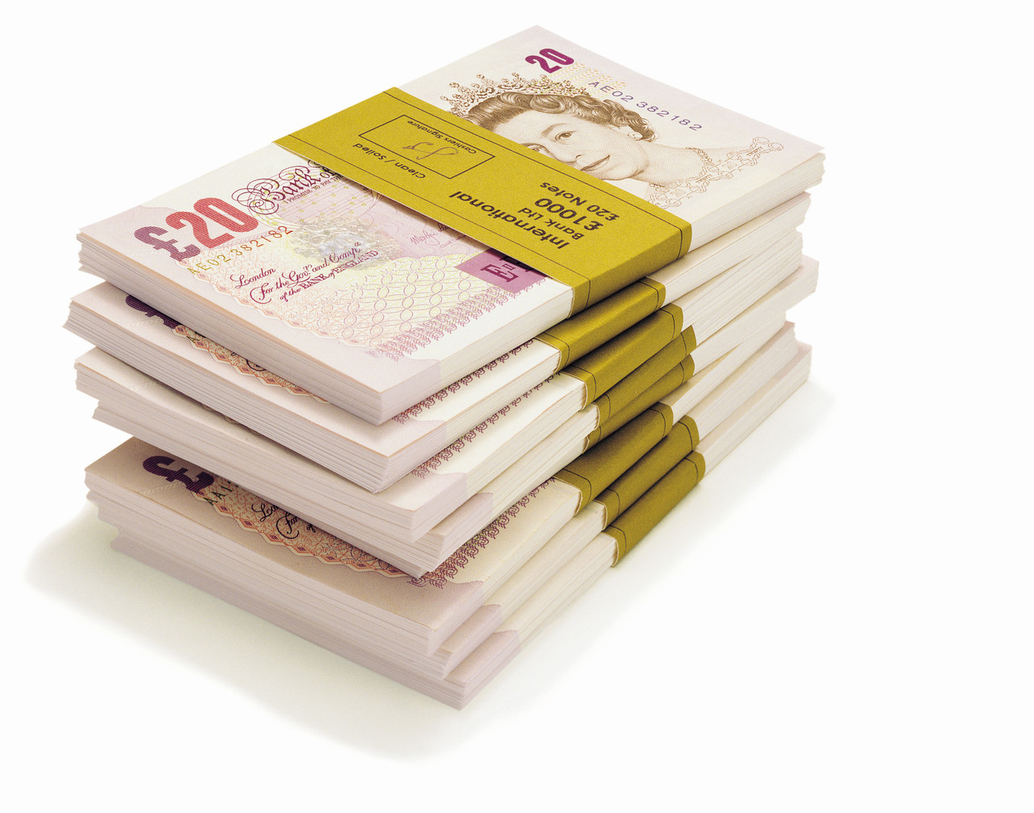
3.1 Income - goods and services provided (output tax)

3.1.1 Introduction
Income from services and sales which are the result of the Council’s statutory duties are outside the scope of VAT. This is because they are provided under a “special legal regime” and are not in competition with private traders.

Income from services and sales which are not part of the Council’s statutory duties may be subject to VAT, and should be standard rated unless they clearly fall into another category. Appendix 3A, Appendix 3B and Appendix 3C give guidance as to which category is likely to be applicable.

3.1.2 VAT invoices
Where the Council provides goods and services which are liable to VAT they are required to provide a tax invoice to the customer.
A VAT invoice must include the following details:
  - An identifying sequential number e.g. an invoice number
  - The date of issue and the date of supply or tax point if different
  - Name and address of Norfolk County Council/school
  - VAT registration number (GB 106 9951 52)
  - Name and address of the customer
  - Description sufficient to identify the goods or services supplied
  - The unit price/rate (if applicable) of the goods or services
  - Quantity of goods or services, rate of tax and the amount payable
  - Total amount payable excluding VAT
  - Rate of cash discount (if offered)
  - The total amount of VAT charged

3.1.3 Cash and cheque income
Official VAT receipts should be issued on request for any cash or cheques received in respect of vatable supplies. This includes income from sales such as photocopying and sale of assets as well as income from private telephone calls.

3.1.4 When to account for VAT on income
The actual date (tax point) when VAT should be accounted for on goods and services is the earlier of the date of the invoice or the date income is received.

3.1.5 Exports and VAT
VAT on goods moved within the EU may be zero-rated provided certain pre conditions are met, otherwise normal VAT rules apply. Main conditions are that the County Council must obtain the customers VAT registration number (including the 2-letter EC country prefix code) and show this on the invoice raised and obtain satisfactory evidence that the goods have been removed from the country.
Goods sold to someone in another EU country, who isn’t VAT registered, are subject to normal VAT rules.
The Council is required to declare the total of goods sent out of the UK to the EU. Please inform the Councils Tax Accountant of any such transaction providing a copy of the invoice raised and the evidence of removal.
Goods exported outside of the EU may also be zero rated providing that evidence that the goods have been removed from the country is retained and all other laws are complied with.
From 1 January 2015, the rules around EU VAT on supplies of services changed. This is now dependent on the location of the customer. This largely affects sales of digital services which includes any electronically supplied service to another EU country i.e. supplies of images or text, such as photos, e-books and web hosting services. Advice should be sought prior to any services being supplied.
Due to the additional VAT reporting requirements in respect of EU dispatches and exports, the County Council’s Tax Accountant must be informed of any export activity and should be consulted prior to the goods being shipped, services being delivered or invoices raised.

3.2 Rental income – premises (excluding sporting facilities)

3.2.1 Letting of non-sports facilities

Subject to some exceptions as listed below, if the predominant nature of a let is simply the occupation of premises then the supply is exempt from VAT.

The following flowchart shows when to charge VAT on lettings
Is the let subsidised at 100% or to another part of Norfolk County Council
No VAT (income is outside the scope of VAT)
Charge VAT at standard rate

Supply is exempt from VAT
Is the let for sporting purposes?

See 4.11 Rental income – sporting facilities

Is use of equipment (note 1) or of a kitchen the main purpose of the let?

Charge VAT at standard rate
Is catering (note 2) or event management a significant part of the let?

Charge VAT at standard rate.
No

Yes

Yes

Notes:

- “Equipment” does not include the tables, chairs, whiteboards etc which might be found in a normal hall or class base
- Where simple catering (e.g. teas and coffee) is included in the price, it can be exempt, but if charged separately it is standard rated. Catering is a significant part of the let regardless of whether the catering is supplied by you or by another person
- Itemised charges over and above the basic letting (e.g. cleaning charges) are standard rated, but costs included in the charge are all exempt if the letting charge is exempt.

Has the property been “opted to tax”
Is the let primarily of a car park or for holiday accommodation?
Yes

Yes

Yes

Yes

Yes

Charge VAT at standard rate.
No

No

No

No

No

3.2.2 Lettings – general guidance
Let of grounds and car park
The let of a playground, for example, for display of radio-controlled model cars, is exempt. However, admission charges to an event are standard rated.
Car parking:
Car parking income is standard rated if recorded in the official funds. If received into the school fund, the income counts towards the VAT registration threshold.
Car boot sales:
Charges for letting school premises for use as a car boot sale are exempt from VAT. If the sale is run directly by the school, charges to traders are also exempt from VAT. Car parking charges to non-traders, if made, would be standard rated.
Holiday Accommodation
Supplies of:
- Seasonal and holiday pitches (for example, caravan pitches); or
- School buildings hired for accommodation purposes in vacation periods
are standard rated.
Cancellation charges:
A cancellation charge (compensation for loss of letting) is outside the scope of VAT.

3.2.3 Extended Schools lettings – outside the scope of VAT
Where a maintained school charges an operator of an extended school facility for the use of the school on the basis of a recharge of costs (rather than to make a profit), the charge is outside the scope of VAT.
Note: this may have little impact on the charges, as previously they may have been exempt from VAT as part of a lease agreement, but it helps the Council if the correct outside the scope VAT code is used.
Extended school operators may include the governors, voluntary committees and private operators providing activities such as breakfast and after school clubs.

4. Schools section
Schools, via the County Council, can reclaim from HMRC virtually all of the VAT added by suppliers on to their invoices when these are paid for from delegated budgets. VAT cannot be reclaimed on expenditure from the school’s unofficial funds.

4.1 Transactions between Council departments and schools
In the eyes of HMRC, when spending money from their delegated budgets, schools are part of the County Council for VAT purposes. As a result, transactions between:

- different sections of the County Council and
- transactions between any part of the County Council and the County Council schools

are “outside the scope” of VAT.

Services made under the County Council’s VAT registration to other entities including:

- a school’s unofficial funds
- Academy schools
- Private schools
- Charities

are subject to normal VAT rules and VAT may be chargeable, depending on the nature of the service.
For VAT purposes, the NORSE group of companies is not part of NCC.

4.2 School unofficial funds

4.2.1 Introduction
This section refers to any funds administered by the school or its governors separately from the school’s delegated budget. Such funds are generally referred to as unofficial, private or school funds.
Expenditure made directly from private funds cannot be treated as part of the Councils VAT registration. However, it is possible for money to be donated from the unofficial fund to the delegated budget in such a way that VAT can be recovered on the related expenditure (see below).

4.2.2 VAT registration of unofficial funds
Most unofficial funds do not need to be VAT registered. However, unofficial funds must register for VAT where the level of their potentially taxable income exceeds, or is expected to exceed £82,000 (year to 31 March 2016).
Taxable turnover includes any potentially standard or zero rated supplies and could include:
- Car parking income
- Tuck shop sales
- Sales of uniforms and other clothing
- Sales of items donated to jumble sales
- Ticket sales to school plays, concerts etc
- Commission on school photograph sales
- Sales of equipment to staff and pupils not closely related to their education.

4.2.3 Donations made to the delegated budget from unofficial funds
VAT can only be recovered on the purchase of items for the school if the following conditions are all fulfilled: -
- The money used to make the purchase is paid into the schools delegated budget PRIOR to the invoice being passed for payment (to demonstrate beyond doubt that the purchase has not been made by the unofficial fund).
- The items purchased are of a kind which the local authority would ordinarily purchase from its resources.
- The school makes the purchase through the schools delegated budget, places the order, receives the goods or services, receives a VAT invoice addressed to it and makes the payment.
- The school assumes ownership of the goods and uses them for its own non business purposes.
- Sufficient records are kept to identify the transaction it the records of both unofficial fund and the schools delegated budget, and
- Sufficient records are kept to identify the purchase its purpose.

4.2.4 Donations from other sources / sponsorship
The conditions above can apply if donations are received from sources other than the school’s unofficial fund. However, the concession does not apply if the goods/services purchased are actually used by the donor (for example a voluntary group).
If the donor requires something in return for the donation, then VAT can be claimed by the school on the related purchase. However a VAT invoice (based on the value of the items or money received) should be issued to the donor/sponsor and VAT accounted for accordingly.

4.3 Foundation Schools / VA schools / academies

4.3.1 Overview
The governing body of a maintained school is seen as acting as an agent of the County Council when spending funds channelled to it via the Council. This means that VAT will normally be recoverable on purchases funded via their delegated budgets.
Normally funding for capital work in community schools (including Foundation Schools) is via the Council and VAT is therefore recoverable.
However, VAT cannot be reclaimed in respect of certain expenditure by:
- Voluntary aided schools, or
- Foundation schools where the finance is provided by a party other than the local authority
Charges made to the school by the local authority in respect of these projects (e.g. for project management) should be standard rated.
The governing body of the school is not regarded as an agent of the local authority in respect of:
i) Income generated by the school itself, which forms part of the school’s private, funds
ii) Loans (with approval from the Secretary of State), which a governing body has taken out even if these loans are to be repaid using funds obtained from the County Council.
Any VAT incurred on purchases funded from these sources is not recoverable via the County Council.
For detailed HMRC guidance in respect of VA schools please call the County Councils Tax Accountant on 01603 223177 or use the following link:
http://www.eficts.norfolk.gov.uk/finance/vat/VA_Schools_VAT_Guidance.doc
Particular attention should be made on checking the ownership of grant funding and following the flowchart for determining VAT recovery (this can be found on page 10).

4.3.2 Academies
Academies are not included within the County Council’s VAT registration i.e. where applicable, VAT should be charged on sales to academies, including on the secondment of staff (unless teaching students, in which case the charge is VAT exempt). See Appendix 3C for further clarification.

4.4 VAT only invoices
There are certain circumstances where a supplier will need to issue a VAT only invoice. STAR accounts is able to assist with this process:

- Calculate the gross amount from VAT:

 | VAT rate A (20%) |  | VAT rate S (17.5%)
VAT amount | £15.00 |  | £15.00
Gross amount of VAT: |  | Gross amount of VAT:
(£15.00/20) X 120 | £90.00 | (£15.00/17.5) X 117.5 | £100.71

- Enter the transaction using the gross amount calculated as above with the required VAT rate:
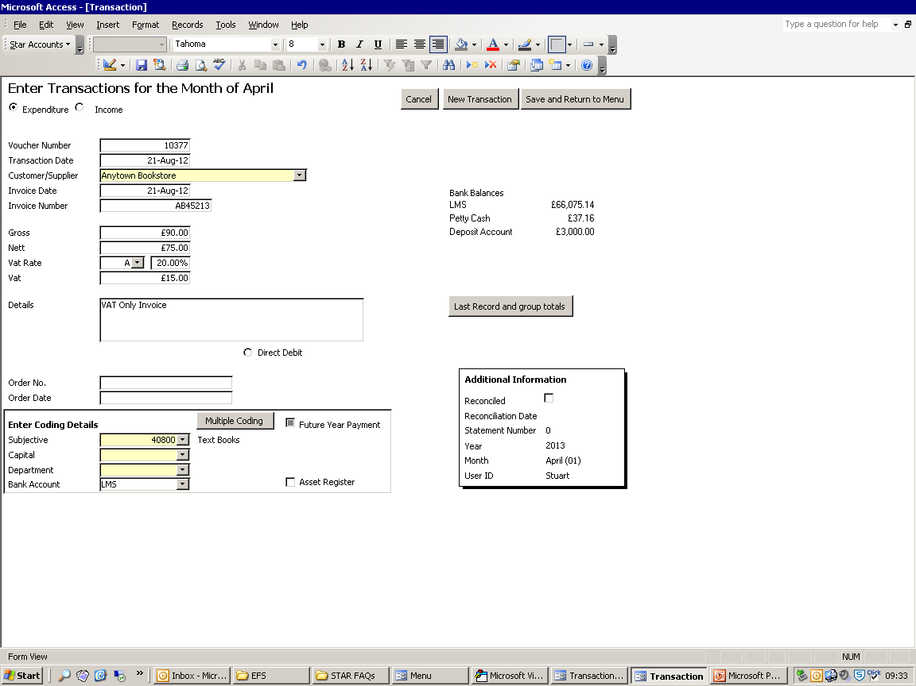
Make a note of the ‘net’ amount.

Click ‘Multiple Coding’ and enter the ‘net’ amount as a negative amount and the VAT rate as ‘T’ (outside the scope)

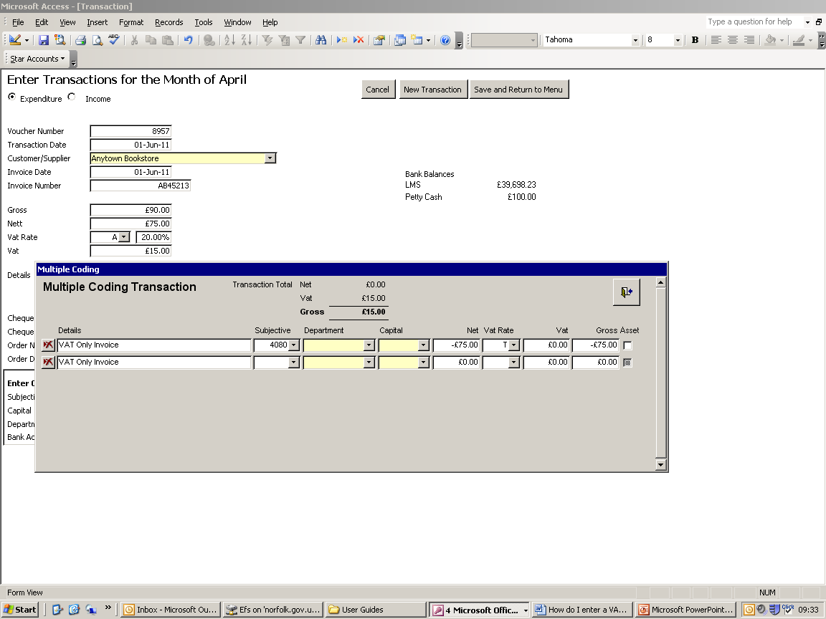

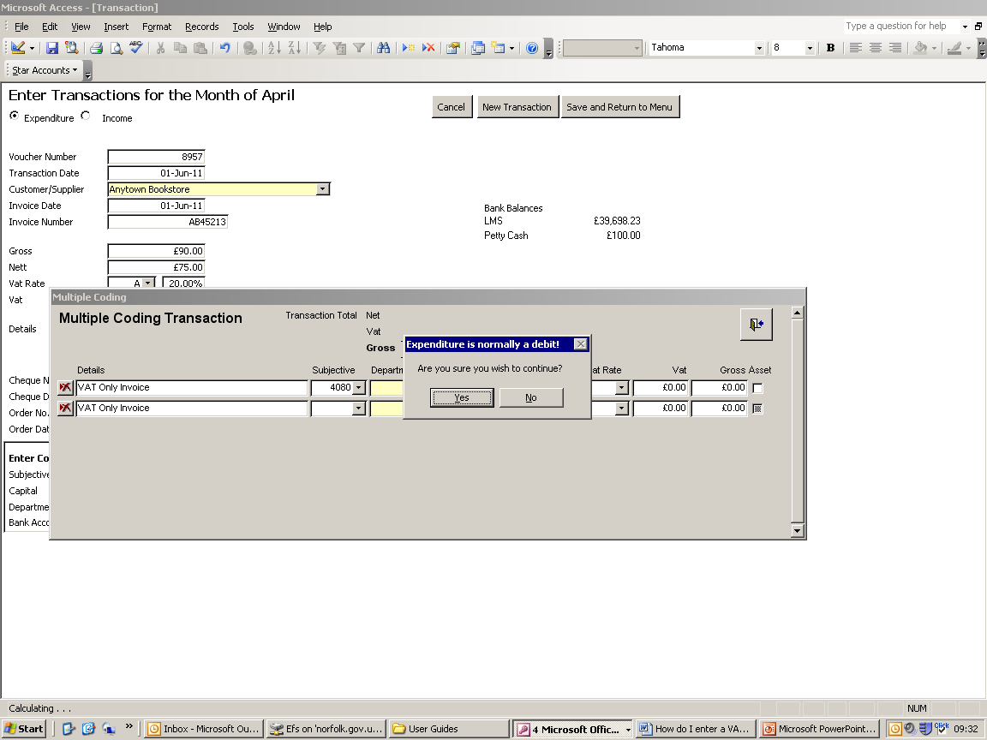
Click ‘Yes’ to this message.

The transaction summary should have a ‘net’ amount of £0.00, and a VAT amount that agrees to the invoice received.

This will enter the transaction as below:
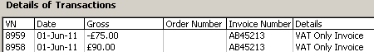

Please Note: If you are using cheque printing you will then need to process the cheque run to assign a cheque number to the transactions…………….”

4.5 School meals

4.5.1 Introduction
Schools should charge VAT on all taxable sales made through their delegated budgets. Any income from sales of goods originally purchased from delegated budgets should be paid into the delegated budget.

4.5.2 Charging VAT
Whoever supplies the meals to the school the rules for charging VAT to staff and pupils are the same:
- Supplies
The school can recover all VAT charged by suppliers (e.g. NCS, other external catering providers). Sales between Norfolk County Council schools are all outside the scope of VAT.

- Sales to staff and visitors – vatable catering supplies
VAT must be charged by the school for all hot meals or snacks sold to staff and visitors wherever they are eaten, and sandwiches (or other cold snacks) if eaten in the dining hall. Further clarification regarding hot takeaway food can be found in Appendix 3E.

- Sales to staff and visitors – cold takeaway food
Cold snacks purchased by staff which are eaten elsewhere e.g. the staff room may be zero if they fall within that category - see Appendix 3D and Appendix 4A.

- Sales to students
These are outside the scope of VAT.

- Duty meals
The school can recover VAT on the costs of duty meals. There is no VAT chargeable on free meals as there is no income, but any income from duty meals sold is subject to VAT.

4.5.3 Accounting for VAT and VAT estimation
VAT must be accounted for on staff and visitor catering income when entering the transaction on the school’s accounting system (e.g. Star Accounts) or when forwarding income to County Hall.
Where the income relating to staff or visitors cannot be clearly identified from e.g. till rolls, the school should make an estimate based on a sample observation, and account for VAT accordingly. Any estimation used should be confirmed annually, and supporting records and documents retained for six years.

4.5.4 Vending machines and tuck shops
As long as sales are “at or below cost”, the VAT rules are as above. One exception would be sales to pupils after school hours which would come under the rules shown above for sales to staff and visitors unless clearly operating as part of an extended schools programme, in which case the rules for cold takeaway food would apply.

4.5.5 Purchases of food and drink
Schools may reclaim VAT on brought in catering supplies. This includes food and drink which is incidental to the supply of education (i.e. for classroom use) and for “entertainment” such as parents evenings and governor’s meetings.

4.5.6 Foods – taxable or zero-rated?
“Taxable Foods” include ice cream, ice lollies and similar frozen products;
chocolates, sweets and similar confectionery; chocolate biscuits and similar
products; soft drinks; potato crisps, pop corn and similar savoury products;
salted and roasted nuts. This list is not exhaustive – however, the VAT treatment of a product by the school’s VAT registered suppliers will be a good guide.
Appendix 4A lists examples of food typically sold by schools, and shows whether they are standard or zero rated when sold as takeaway food to staff and visitors.
Appendix 3D covers examples of food which may be purchased outside the daytime school environment and shows whether they are standard or zero rated.

4.5.7 Catering – VAT definitions
“At or below cost”: Cost is the full cost, including overheads, of providing the catering to pupils. This includes overheads such as premises costs, administration and finance, staff wages and the purchase of food itself.
“Catering”: Catering is not defined, but includes supplies which are:
- in the normal meaning of catering
- for on-premises consumption (premises being canteen areas, including associated outside seating areas, but not the whole school or
- hot take away food.

4.6 Educational excursions and visits

4.6.1 Expenditure and income
HMRC generally accepts that school trips are by their nature related to the curriculum, and schools can recover VAT on all expenditure made through official funds where a VAT invoice has been received.
However, trips organised under the Tour Operators Margin Scheme may result in VAT costs which cannot be recovered (see below).
Charges to students are outside the scope of VAT, irrespective of whether the income has been collected direct into official funds or whether it has been collected into the school fund and subsequently donated into official funds.

4.6.2 Tour Operators Margin Scheme (TOMS)
Tour operators organising school trips under TOMS are not able to provide VAT invoices *. As a result schools are not able to recover VAT where TOMS applies.
Trips most likely to be affected are organised though an agent and contain significant costs relating to UK attraction admission fees and/or UK accommodation.
To minimise the potential impact:
- In-house package: If each element of a trip is organised directly by a school, VAT can be fully recovered (subject to obtaining a VAT invoice etc)
- UK adventure activities: Most activities organised through organisations such as YHA and PGL are not covered by TOMS and will not be affected. However, this might not always be the case and should be confirmed prior to booking.
- Activities organised through “Park Resorts” have been subject to TOMS, so always confirm before booking.
- Use of travel agent or intermediary: In order to establish the net cost of a trip, always check precisely what VAT will or will not be charged on a VAT invoice by the tour operator prior to booking.
* Since 1 January 2010

4.7 Sale of goods to children and young people - general

4.7.1 General rules
Within specific rules, the school can purchase goods for resale to children and young people. This allows the school to purchase certain items, recover VAT thereon, and resell the items “outside the scope” of VAT.
The goods, which qualify for this treatment, are those, which are incidental to education of the children and young people to whom they are sold. The basic conditions of the scheme are:
- The sale can only be made in the class by the school to its own children and young people
- The goods must be sold at or below cost
- The goods are incidental to the provision of education forming part of the normal school curriculum and are required for regular classroom use
- The goods are not clothing e.g. sweatshirts, ties or PE kit. (some clothing can be zero rated – see 4.8 Sale of school uniform and sweatshirts).
- The goods have been purchased under an official school order and not directly from the school’s unofficial fund.

4.7.2 Examples of sales which are “outside the scope” of VAT
To qualify under this scheme, the items purchased must be essential for the delivery of education, not just a useful adjunct to home study. Items will generally qualify if they are either:
- Necessarily brought to school on at least a weekly basis, examples include:
- Calculators
- Mathematical equipment
- Smaller musical instruments
- Sports equipment (not clothing)
- Larger musical instruments e.g. drum kits, double bass, pianos where the student is also paying for regular tuition on that instrument.

4.7.3 Examples of sales which are standard rated (not VAT-free)
- Sales of computers (e.g. laptops) to students should be standard rated. Specific software (e.g. music composition) may be closely related to a specific subject and outside the scope of VAT, but only if the software is accessible to all students on the relevant course.
- Book bags and water bottles - Although drinkable water has to be available in schools, bottles are not a requirement, and there is similarly no requirement to provide bags. Therefore, sales of these items should be standard rated.

4.8 Sale of school uniform and sweatshirts

4.8.1 Clothing (including school uniform)
When items of school-related clothing are purchased, VAT can be recovered on the suppliers invoice. If these items of clothing are subsequently sold to children and young people, they are subject to the normal rules of VAT supply, and VAT should be charged where appropriate.
General rules
The best guide as to whether items should be zero or standard rated is likely to be the supplier invoice, although the following should be taken into account:
Garments are zero-rated if they are both designed for younger children, and not suitable for young people. Only clothing and footwear in sizes up to those suitable for under 14 year olds can be zero-rated. Garments are standard rated for VAT if they are labelled, or otherwise held for sale, for body sizes exceeding those of the average 13 year old. The sizes determined as the maximum for zero-rating are:
Body part measured | Boys |  | Girls
Height | 163cms | 64’’ | 161cms | 63’’
Chest | 84cms | 33’’ | 85cms | 33.5’’
Waist | 70cms | 27.5’’ | 69cms | 27’’
Hips | 85cms | 33.5’’ | 90cms | 35.5’’
Arm (shoulder to wrist) | 59cms | 23’’ | 57cms | 22.5’’
Inside leg | 77cms | 30’’ | 76cms | 30’’
In addition, garments are accepted to be designed for young children provided they are at or within the tabled measurements below:
 | Boys |  |  |  | Girls
Garment | Chest |  | Waist |  | Chest |  | Waist
Shirts | 104cms | 41’’ |  |  | 105cms | 41.5’’
Knitwear | 104cms | 41’’ |  |  | 105cms | 41.5’’
Jackets, waistcoats | 109cms | 43’’ |  |  | 110cms | 43.5’’
Top coats, outerwear | 114cms | 44.5’’ |  |  | 115cms | 45’’
Dresses |  |  |  |  | 98cms | 39.5’’
Skirts |  |  |  |  |  |  | 71cms | 28’’
Trousers, shorts |  |  | 72cms | 28.5’’ |  |  | 71cms | 28’’
Underwear, swimwear | 88cms | 34.5’’ | 72cms | 28.5’’ | 89cms | 35’’ | 71cms | 28’’
Nightwear | 105cms | 41.5’’ | 73cms | 29’’ | 106cms | 42’’ | 72cms | 28.5’’
Any garment which exceeds these sizes must be sold with standard-rated VAT unless it can be demonstrated to HMRC that these products are designed exclusively for the under 14s and that they are held out for sale to this age group. Please contact the County Council’s Tax Accountant if an issue arises.
Primary Schools
If the items of clothing are supplied as part of the official uniform of a school catering exclusively for young people less than 14 years of age, and the garments bear a prominent badge or piping in school colours identifying them as part of the official uniform of the school, and held out for sale as being for that school only, they are likely to be zero-rated irrespective of garment size if identified as for younger children on invoices and price lists.
Secondary Schools
The majority of clothing for sale to secondary school pupils is likely to be standard rated rather than zero rated. VAT can be recovered, but must be charged on re-sale to students.

4.9 School photographs

4.9.1 Commission received from photographer
Where a school collects the income on behalf of the photographer and hands it directly to the photographer:
- the school is providing a service to the photographer and
- the photographer is likely to pay the school some commission from the sale of the photographs.
If the school has an unofficial fund, the commission should be paid into the unofficial fund and VAT will not have to be accounted for on the income.
If the school does not have an unofficial fund, the school will have to account for VAT on the commission when it is paid into the delegated budget. This applies whether or not the photographer is VAT registered and a VAT receipt should be provided by the school if requested.

4.9.2 Purchase and sale of photographs direct by the school
Where the school collects the income from the parents for the sale of photographs, it should be paid into the unofficial fund. The photographer’s invoice should also be paid from the unofficial fund with no VAT recovery.
If the school does not have an unofficial fund then the money collected will have to be paid into the delegated budget. Any payment will also have to be made from the delegated budget. VAT will have to be accounted for on both transactions.
Schools should notify the photographer as to whether the income will be accounted for through the private fund or through the delegated budget before any photographs are taken, in order to ensure that there will be no loss of income to the school.

4.10 School drama / concert productions

4.10.1 Admission charges
Income from school production should normally be paid into the school/unofficial fund. Costs specifically associated with the production (e.g. props) should be paid out of school funds and VAT should not be reclaimed.
If the income is paid into the delegated budget VAT should be accounted for at the standard rated. The advantage of this option is that VAT can be recovered on costs associated with the production.

4.10.2 Programmes are zero-rated.

4.10.3 Donations
Donations are outside the scope of VAT provided that there is no benefit to the donor.
A one-line acknowledgement in the programme to the donor is acceptable, but anything larger constitutes an advertisement or sponsorship and VAT is accountable on the income at standard rate.

4.11 Rental income – sporting facilities

4.11.1 Letting of sports facilities

Is the let for non-sporting purposes or to another part of Norfolk County Council
See previous flowchart
Is the let of a general purpose hall without sports markings or equipment?
Do not charge VAT (exempt)
Does the user have exclusive use for more than 24 consecutive hours?
Do not charge VAT (exempt)
Is the let part of a long series (see next page)
Do not charge VAT (exempt)

Charge VAT at standard rate
No

No

No

No

Yes

Yes

Yes

Yes

Notes:

What are "sports facilities?"
Premises count as sports facilities if they are designed or adapted for playing any sports or taking part in physical recreation.

Activities regarded as sport or physical recreation (not exhaustive)
Aerobics Cycling Keep-Fit
Angling Dancing Motor Sports
Archery Darts Netball
Athletics Football Snooker
Basketball Gymnastics Swimming
Billiards Hockey Tennis
Cricket Karate Yoga

Activities not regarded as sport or physical recreation

Card Games Dominoes Chess
Is the let of a facility to be used for non-sporting purposes?
Do not charge VAT (exempt)
No

Yes

4.11.2 VAT exemption for series of sporting lets
The lettings of sports or physical recreation facilities may be exempt from VAT if the facilities are let out for a series of sessions provided that:
- the series consists of 10 or more sessions; and
- each session is for the same sport or activity; and
- each session is in the same premises: and
- the interval between each session is at least a day and not more than 14 days: and
- the series is to be paid for as a whole, and there is written evidence to that effect. Provision for a refund in the event of the unforeseen non-availability of the facility would not break this condition but provision for a refund in other circumstances would; and
- the facilities are let out to a school, club, association or an organisation representing affiliated clubs or constituent associations (such as a local league); and
- the person to whom the facilities are let has exclusive use of them during the sessions.
If ALL of these conditions are NOT met then the supply is standard rated.
If an exempt sports let is extended during its life, the additional let will be subject to VAT at standard rate unless the additional let is itself for a series of ten or more.
It is not permissible to extend a standard-rated sports let during its life and change the VAT category to exempt.

4.11.3 Services supplied with hire of sports facilities
Provision of changing room facilities, floodlighting and similar services with a letting of sports facilities are incidental to the main supply of sports facilities and will have the same VAT liability.
Optional extra facilities or equipment, such as floodlighting for special events, the right of access to bar facilities, management services or the services of cloakroom attendants or life guards, are a separate standard-rated supply of services (even if the main let is exempt)

4.12 Joint use / dual use agreements

4.12.1 Contributions to revenue costs from other local authorities
Income from recharges to other local authorities of costs under a dual use agreement should be treated as outside the scope of VAT.
The joint charge should be based on net-of-VAT expenditure (usually items such as heat, light and other utilities).

4.12.2 Agreements with bodies other than local authorities
Income from bodies other than local authorities should follow the general lettings guidance in this document – see 3.2.1 Letting of non-sports facilities and 4.11.1 Letting of sports facilities

4.12.3 Contributions to capital costs
The VAT treatment of contributions to capital costs will depend on a number of factors, please call the County Council’s Tax Accountant.

4.13 Extended schools

4.13.1 Breakfast and after school clubs (no VAT)
Where a school provides for pupils at their schools to attend before (breakfast) and after school clubs, these supplies may be treated as closely related to education and therefore outside the scope of VAT.
This applies even where the activities do not appear to be linked to the curriculum, for example, snooker and football, as they are considered to be “social education”.

4.13.2 Holiday clubs and supervised play facilities
The provision of holiday clubs and supervised play areas for a charge by schools is outside the scope of VAT

4.13.3 Playgroups run by the school
As long as the playgroup is registered with OFSTED and run as part of the school then income is outside the scope of VAT and VAT on costs can be recovered.
This extends to the supply of meals and drinks for the children, as well as other sundry items provided as part of the children’s care such as picture books, crayons and toys. It does not however, extend to supplies such as children’s parties or day trips where the supply is advertised as a separate and identifiable package (this is a provision of entertainment rather than care) or to supplies of meals and drinks to staff and visitors.

4.13.4 Extended Schools lettings – external operators
Where a maintained school charges an operator of an extended school facility for the use of the school on the basis of a recharge of costs (rather than to make a profit), the charge is outside the scope of VAT (see 3.2.3 Extended Schools lettings)

Appendix 2A
Expenditure

Nil VAT purchases:
zero - 0 (ZER),
exempt - E (EXE) or
outside the scope -T (TSC)?

When coding invoices with no VAT, they could be one of three categories.

If it is not clear, the first port of call should be the supplier, as it is their responsibility to allocate the correct VAT code. If this is not possible, or you are creating a sales invoice, the following lists should help:

Zero-rating applies to specific groups of items including:
- Books and other forms of printed matter
- Some domestic and charitable buildings works *
- Young children’s clothing and footwear *
- Disabled person’s aids
- Most foods but there are exemptions, see Appendix 3D Food – standard or zero rated?
(this does not include food supplied in the course of catering)
- Talking books for the blind
- Passenger transport (in any vehicle, provided together with a driver, designed or adapted to carry not less than 10 passengers)

* Unless invoice received is standard-rated

Exempt supplies tend to relate to:
- Education by private suppliers
- Financial services
- Postage stamps (but see Appendix 3A for treatment of income)
- Health and welfare
- Leases and land transactions
- Professional associations, trade bodies and learned societies
- Insurance

Outside the scope - if still in doubt, this is the one to use. In particular, likely to apply to:
- Supplies from other authorities
- Smaller suppliers not registered for VAT
- Grants to other organisations
- Purchases from abroad.
Appendix 3A
VAT rates for sales / income - summary
(For a more comprehensive list of VAT categories, see appendix 1C)

TSC
Outside the scope / non-business – no VAT.

Examples:
- The majority of services provided by local authorities under a “special legal regime”, where not in competition with private traders
- Sales to pupils of calculators and musical instruments
- Donations
- Extended school activities.

STD  Standard rate - 20%  All transactions are standard rate unless they fall into another category  Examples:  - Secondary school uniforms/clothing  - Sales to staff (see also zero-rated - cold food)  - Supply / secondment of staff to bodies outside NCC, including charities  - Income from private use of telephones  - Event admission charges  - Sponsorship and advertising (but see outside the scope - donations)  - Postal costs where charged separately * | ZER  Zero rate - VATable, but at 0%  Examples:  - Books  - Children’s clothing (not secondary schools)  - Cold foods sold to staff unless eaten where purchased e.g. canteen
EXE  Exempt – no VAT  Examples:  - Non-sports lettings of school premises  - Adult education fees. | HAF (Heat and fuel)  Lower rate - 5%  Unlikely to apply to school sales.  May include:  - Domestic fuel

* Where a single charge is made covering items with different VAT categories, the “main supply” should be identified, and the VAT rate applying to that item should be applied to the whole charge. Examples include:
- letting of a hall (exempt) which includes use of kitchen for making tea (otherwise standard rated)
- sale of a book (zero rated) by post including an allowance for postage costs (otherwise standard rated)
Appendix 3B
List of VAT categories (when through delegated budget)

Type of income | Business or non-business | Liability | Reference / comment
Car parking and road safety
Car parking fees - off street | Business | STD
Excess charges - off street and other circs | Business | STD
Removal of parked cars - off street (overstay/dangerous parking) | Business | STD
Cycle training | Business | STD
Education - catering
Meals supplied to pupils/students at or below cost (by LA) | Non business | TSC | See Appendix 4A
Meals supplied to non students – hot food, food eaten in catering area and any food classed as standard rated | Business | STD | See Appendix 4A
Meals supplied to non students – cold takeaway food which is not classed as standard rated | Business | ZER | See Appendix 4A
Meals provided to non local authority establishments | Business | STD | See Appendix 4A
Vending machine sales - non school | Business | STD | See Appendix 4A
Vending machine sales on school premises to pupils at or below cost | Non business | TSC | See Appendix 4A
Education – uniforms and clothing
Adults' clothing and sportswear | Business | STD
Children’s clothing and sportswear | Business | ZER/STD | See supplier invoices for guidance
School uniform – primary school | Business | ZER
School uniform – secondary school | Business | STD
Education – course and trips
Educational course fees (e.g. adult education) | Business | EXE
Examination fees - supply is to pupil | Business | EXE
Recreational courses | Non business | TSC
School trips (pupils) | Non business | TSC | Must be curriculum related
Training courses (vocational) | Business | EXE
Training courses (other) | Business | STD

STD – standard rate | ZER – zero rate | TSC – outside the scope | EXE – exempt
Appendix 3B

Type of income |  |  | Business or non-business | Liability |  | Reference / comment
Education – sales:
Sale of goods and services at or below cost to pupils in LA schools (when “closely related” to education) – (see manual, includes musical instruments, calculators) |  |  | Non business | TSC
Sale of goods and services where not at or below cost or where not “closely related” to education e.g. clothing, book bags, water bottles |  |  | Business | STD
Sale of books |  |  | Business | ZER
Sale of sports equipment |  |  | Business | STD
Sale of students' work (if sold at no more than cost of materials) |  |  | Non business | TSC
Education – school photographs:
School photographs commission received - paid into LM account |  |  | Business | STD
School photographs commission received - paid into school fund |  |  | Not applicable | TSC
School photographs direct income received - paid into LM account |  |  | Business | STD
Commission on direct income – paid into school fund |  |  | Not applicable | TSC |  | Photographer costs to be paid out of school fund to match the income
Leisure – fees and charges:
Admission to swimming baths |  |  | Business | STD
Admission to sports centres |  |  | Business | STD
Admission to sporting events |  |  | Business | STD
Coaching fees |  |  | Business | EXE
Educational course fees |  |  | Business | EXE
Hairdryer receipts |  |  | Business | STD
Hire of sports facilities - non sporting |  |  | Business | EXE
Hire of sports facilities/pitches - sporting (series of lets) |  |  | Business | EXE
Hire of sports facilities/pitches - sporting (not series of lets) |  |  | Business | STD
Memberships - sports centres |  |  | Business | STD
Hire of sports equipment |  |  | Business | STD
Locker charges |  |  | Business | STD
Occasional sports licences (e.g. licence fee paid to hold race in County Council owned park) |  |  | Non business | TSC
Recreational course fees |  |  | Business | EXE
STD – standard rate | ZER – zero rate | TSC – outside the scope |  |  | EXE – exempt
Appendix 3B

Type of income |  |  |  | Business or non-business | Liability |  |  | Reference / comment
Leisure – sales:
Adults clothing and sportswear |  |  |  | Business | STD
Children's clothing and sportswear (iaw PN 714) |  |  |  | Business | ZER
Confectionery and drinks |  |  |  | Business | STD
Publications |  |  |  | Business | ZER
Sports equipment |  |  |  | Business | STD
Sale of folded maps |  |  |  | Business | ZER
Sale of framed pictures |  |  |  | Business | STD
Sale of maps via internet |  |  |  | Business | ZER
Sale of pictures via internet |  |  |  | Business | STD
Sale of old stock - books (printed) |  |  |  | Business | ZER
Sale of old stock - records, tapes, dvds, cds |  |  |  | Business | STD
Talking books |  |  |  | Business | STD
Libraries – misc.:
Disposals of equipment (where chargeable) |  |  |  | Business | STD
Photocopies |  |  |  | Business | STD
Misc. receipts – fees and charges:
Admission fees to lectures |  |  |  | Business | EXE
Catering facilities |  |  |  | Business | STD
Compensation |  |  |  | Non business | TSC
Damage cost |  |  |  | Non business | TSC
Donations |  |  |  | Non business | TSC
Filming rights - site rental e.g. depots/school halls |  |  |  | Business | EXE
Lease cars - employee contributions |  |  |  | Business | STD
Hire of equipment |  |  |  | Business | STD
Hire of space on notice board |  |  |  | Business | STD
Photocopying charges |  |  |  | Business | STD
Private telephone calls |  |  |  | Business | STD
Telephone box income |  |  |  | Business | STD
Misc. receipts – sales:
Drinks machine takings |  |  |  | Business | STD
Sale of agenda/minutes |  |  |  | Non business | TSC
Sale of badges |  |  |  | Business | STD
Sale of books/leaflets |  |  |  | Business | ZER
Sale of beverages |  |  |  | Business | STD
Sale of equipment |  |  |  | Business | STD
Sale of photographs |  |  |  | Business | STD
Sale of postcards |  |  |  | Business | STD
Sale of posters |  |  |  | Business | STD
Sale of stationery |  |  |  | Business | STD
Sale of sweets |  |  |  | Business | STD
Sale of vehicles, equipment etc. |  |  |  | Business | STD
STD – standard rate | ZER – zero rate |  | TSC – outside the scope |  |  |  | EXE – exempt
Appendix 3C
VAT and invoices to academies

A number of secondary schools are in the process of becoming, or have become, academies.

This change from local authority control to independent academies will have an impact on VAT. When the schools were part of the local authority, no VAT was charged on services provided to them. However, as they are now independent of the local authority, they should be treated as would any other external organisation when it comes to invoicing for services provided and VAT should be charged, where and if relevant.

Below is a list of services that academies may decide to buy back from the County Council and what the VAT treatment should be.

This is not an exhaustive list, it does try to cover the majority of the services provided by the County Council to academies, please contact the Councils Tax Accountant on 01603 223177 if you feel anything else should be included.

Service provided | VAT treatment
Admissions Service incl. appeals | Standard
Cleaning and caretaking | Standard
Children’s university service | Standard
Copyright service | Standard
Communications and media service | Standard
HR/payroll service | Standard
Finance service | Standard
ICT services | Standard
Safety/ premises services | Standard
Library advisory service (books are zero-rated) | Standard
Energy and water efficiency advisory services | Standard
Education advisory services | Standard
Provision of non-teaching staff | Standard
Consultancy | Standard
Legal services | Standard
Clerking services | Standard
Free school meals service | Standard
Property risk management service | Standard
County music services | Exempt
Education social work service | Exempt
Early intervention service | Exempt
Training | Exempt
Education safeguarding service | Exempt
Ethnic minority traveller achievement service | Exempt
Appendix 3C

Service provided | VAT treatment
Governor development scheme | Exempt
Integrated disability service | Exempt
Minibus driver training and assessment | Exempt
Outdoor Education Centre service and Duke of Edinburgh awards | Exempt
Specialist teachers | Exempt
Face to face welfare services | Exempt
Educational psychology services | Exempt  (if practitioner psychologist)
SEN teacher | Exempt
Provision of teaching staff | Exempt
Provision of training | Exempt
High level special education needs | Outside the Scope
Home to school transport | Outside the Scope

 | Appendix 3D  Food – standard or zero-rated? | 

This is not an exhaustive list, it does try to cover the majority of items that are either standard-rated or zero-rated by a school, please contact the County Council’s Tax Accountant on 01603 223177 if you feel anything else should be included.

Standard-rated |  | Zero-rated
Catering:
All hot food (whether eat-in and takeaway ) |  | Cold takeaway food where zero rated below
All hot and cold food eaten on caterer’s premises (e.g. in café)
Cold takeaway food where standard rated below
Confectionery:
Chocolate |  | Cakes (inc. chocolate covered)
Cereal bars |  | Flapjacks
Chewing/bubble gum |  | Chocolate crispcakes
Jelly confectionery |  | Caramel shortbread
Dry fruit confectionery |  | Toffee apples
Crystallised fruits |  | Marshmallow teacakes
Marshmallows |  | Baking ingredients inc. cooking chocolate
Biscuits:
Chocolate covered biscuits (wholly or partly covered) |  | Plain biscuits
 |  | Bourbon creams
 |  | Gingerbread men (even with chocolate eyes)
 |  | Caramel covered biscuits
 |  | Jaffa cakes
Savouries:
Potato crisps |  | Breadsticks
Pringles |  | Tortilla chips
Prawn crackers |  | Bagel chips
Flavoured rice cakes |  | Twiglets
Roasted / salted nuts |  | Doritos
Beverages:
Hot drinks |  | Milk drinks
Fruit juices and cordials |  | Milkshakes
Bottled drinking water |  | Cooking ingredients, tea bags, coffee powder, cocoa, hot chocolate powder etc
Flavoured soya, coconut milk
Sports drinks
Alcoholic drinks
Carbonated drinks
Other soft drinks (e.g. tea based)
Appendix 3E
VAT liability of hot takeaway food – overview

The sale of food which (or any part of which) has been heated for the purposes of enabling it to be consumed hot, and is hot at the time that it is provided to the customer is standard-rated.

In order to ascertain if the sale is standard-rated, a number of objective tests have been added to help ensure that hot takeaway food is taxed consistently. Under the new rules, the sale of food is standard-rated if:

Is the food (or any part of it) hot at the time that it is provided to the customer?
Does the food satisfy one or more of the following tests?

Test 1It has been heated for the purposes of enabling it to be consumed hot (i.e. the current test).
Test 2It has been heated to order.
Test 3It has been kept hot after being heated.
Test 4It is provided to a customer in packaging that retains heat (whether or not the packaging was primarily designed for that purpose) or in any other packaging that is specifically designed for hot food.
Test 5It is advertised or marketed in a way that indicates that it is supplied hot.

Standard
-rated
No
Yes
Yes
No

Standard
-rated
Zero
-rated

Appendix 4A  VAT on takeaway school meals sold to staff and visitors | 

This is not an exhaustive list, it does try to cover the majority of items that could be sold by a school to staff and visitors, please contact the County Council’s Tax Accountant on 01603 223177 if you feel anything else should be included.

Food/Drink | Items | Hot or Cold | VAT (standard/zero)
Drink | Britvic can | Cold | Standard
Drink | Calypso (various) | Cold | Standard
Drink | Milk | Cold | Zero
Drink | Oranka | Cold | Standard
Drink | Slush | Cold | Standard
Drink | Tropicana | Cold | Standard
Drink | Water (bottle) | Cold | Standard
Food | Bacon muffin | Hot | Standard
Food | Bacon roll | Hot | Standard
Food | Baguettes (cold filling) | Cold | Zero
Food | Baguettes (hot filling) | Hot | Standard
Food | Baked beans | Hot | Standard
Food | Beef burger | Hot | Standard
Food | Biscuits (chocolate) | Cold | Standard
Food | Biscuits (no chocolate) | Cold | Zero
Food | Bread | Cold | Zero
Food | Bread roll (incl. butter if required) | Cold | Zero
Food | Butter | Cold | Zero
Food | Cakes | Cold | Zero
Food | Cheese on toast | Hot | Standard
Food | Chips | Hot | Standard
Food | Curry | Hot | Standard
Food | Egg (hard boiled) | Cold | Zero
Food | Filled Roll | Cold | Zero
Food | Fruit | Cold | Zero
Food | Fruit (dried) | Cold | Standard
Food | Fruit bags | Cold | Zero
Food | Fruit platters | Cold | Zero
Food | Fruitshoot | Cold | Standard
Food | Garlic bread | Hot | Standard
Food | Hot Dog | Hot | Standard

Note: All food sold to staff and visitors when eaten in the canteen/catering area is standard-rated (this includes outdoor tables)

Food/Drink | Items | Hot or Cold | VAT (Standard/Zero)
Food | Jacket potatoes | Hot | Standard
Food | Main meal | Hot | Standard
Food | Pasta | Hot | Standard
Food | Pasta salad | Cold | Zero
Food | Pizza | Hot | Standard
Food | Potatoes | Hot | Standard
Food | Roast meal | Hot | Standard
Food | Rolls | Cold | Zero
Food | Salad | Cold | Zero
Food | Salad P  potatoes | Cold | Zero
Food | Sandwiches | Cold | Zero
Food | Sauce | Cold | Zero
Food | Sausage | Hot | Standard
Food | Sausage roll (see Appendix 3C) | Hot | Standard
Food | Scones | Cold | Zero
Food | Soup | Hot | Standard
Food | Spaghetti | Hot | Standard
Food | Sweet (pudding hot) | Hot | Standard
Food | Toast (hot topping) | Hot | Standard
Food | Toasted sandwich | Hot | Standard
Food | Vegetables | Hot | Standard
Food | Wraps | Cold | Zero
Food | Yoghurt | Cold | Zero

Note: All food sold to staff and visitors when eaten in the canteen/catering area is standard-rated (this includes outdoor tables)

