Sir Philip Reckitt Educational Trust

C/o Mrs J Pickering, 99 Yarmouth Road, Ellingham, Bungay, NR35 2PH
Tel/Fax: 01508-518115 E-Mail: spretrust@googlemail.com

www site: http://www.spret.org
Registered Charity Number 529777

January 2016

Dear Headteacher,

IS YOUR SCHOOL PLANNING AN EDUCATIONAL VISIT?
HAVE YOU APPLIED FOR A TRAVEL GRANT?

The Sir Philip Reckitt Educational Trust had another successful year in 2015 and during the year the Trustees received a record number of applications. The majority of those who applied received an award and many of these were students currently attending schools in Norfolk.

Just as a reminder to those who are interested, the aim of the Trust is to encourage individuals resident or in education in the geographic boundary of Norfolk to travel, preferably abroad, to further their interest or education.

Application forms for grants to travel this year can be obtained by either ringing Julie Pickering on 01508 - 518115, via e-mail, by writing to the address above or by accessing our ‘SPRET’ Website. Applicants must clearly outline on the application form the nature of the project for which a grant is sought. There is no age limit, but applications received after 1st March will not normally be considered unless received at least six weeks prior to departure.

All applications submitted for consideration must have the backing of the Headteacher of the school and this supporting letter should be forwarded via post, fax or e-mail with the application form or be forwarded direct by the referee.

The Trustees require a written report from those who receive grants, at the conclusion of the travel period, and it is considered reasonable to expect this to be forwarded within three months of their arrival back home. The Trustees would underline the obligation falling upon those supporting applications in this respect, as they do wish to avoid the unnecessary expense and inconvenience in ‘chasing’ these reports.

Priority will be given to completed applications received before 1st March. Applicants will be advised by the end of April if their application has been successful and the amount of their award.

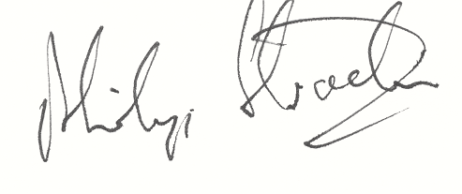
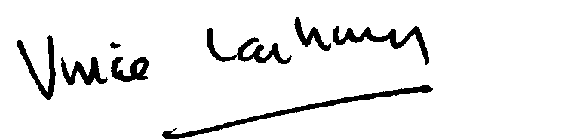
Yours sincerely,
P. W. Strachan V.G. Lachowycz G.M. Witham
Trustee Trustee Trustee

