
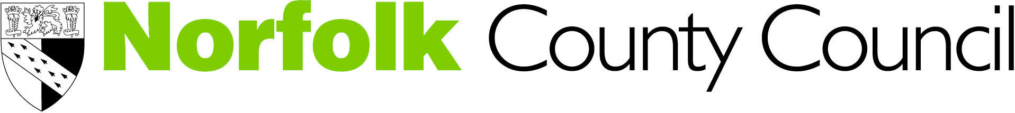
The effects of separation and divorce on children and young people

Working together to improve the emotional and mental wellbeing of young people

Date: 16th March 2016 Location: Norwich
Date: 17th March 2016 Location: Dereham

Time: 9.30am to 4.30pm

Number of places: 30

Aims and objectives
To increase the awareness of the potential emotional impact that loss, separation and divorce has on children and young people’s mental health (C&YP) and how it presents itself.

Outcomes
- Understand the impact loss, separation and divorce can have
- Demonstrate increased skills, knowledge and self-confidence when providing first line support for C&YP
- Develop an understanding of loss, separation or divorce in the context of child development
- Describe the links between grief and divorce and separation
- Reflect upon the changing lives of children based on research and evidence
- Describe effective interventions at different ages and stages
- Know when, where and how to refer on or get further help from targeted or specialist services
- Develop awareness of relevant cultural issues
- Cascade knowledge to peers within own setting

Target group
Staff working in Universal (non-specialist mental health settings) who have some understanding of, or responsibility to support children and young people with mental health issues. Ideally participants will have attended a previous foundation course, i.e. Emotional Health Awareness Foundation Training offered by CAMHS. This course is now available on line. For further information and to access this on line course via the Learning Hub please click here

Participants will be required to cascade knowledge gained with colleagues in their setting. A tool to help with this will be provided.

Training provider:
Associate Development Solutions Ltd is an organisation made up of people with extensive experience of the mental health of children and young people; working in child and adolescent mental health services, universal services and in training and education. Our aim is to support raising the profile of the mental health of children and young people and to provide a training experience that is informative and useful.

We want people to be as involved as possible. To facilitate this, we will include small group exercises using case studies, a game, and explore how we can share skills. The day will also include DVD clips, presentations on the theory and an exploration of the care pathways in Norfolk.

Course length: One day

Cost
The course will cost £40.00. Refreshments will be provided but participants will need to bring their own lunch or purchase food at the venue or nearby.

Allocation of Places
Places will be allocated on a first come first served basis

Booking
To request a place, please fully complete and return the attached booking form by
29-02-2016 to HRSS Learning & Development, County Hall Annexe, Martineau Lane, Norwich, NR1 2UE: or email to hrld@norfolk.gov.uk

Please ensure a full invoice address is entered on the application or alternatively if you are a Norfolk County Council employee please ensure your departments cost centre code is entered.

Cancellations and non-attendance
A course will only run with a minimum number. In the event that a course is under-subscribed applicants will be notified and where possible offered an alternative date/venue. No refund will be given for non-attendance: however, we are happy to accept a suitable delegate in your place. Any changes of delegate must be notified to HRSS Learning & Development, County Hall Annexe, Martineau Lane, Norwich, NR1 2UE: or email to hrld@norfolk.gov.uk prior to the course date.

Confirmation and course programme
If you are allocated a place we will email confirmation to you by return and joining instructions will be emailed to you by 03-03-2016. The course programme and location map will also be emailed to you at this time.

To be added to the distribution list for courses, please email camhs@norfolk.gov.uk

