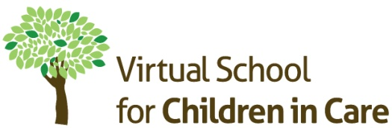

Multi-Agency Network Meetings
We would like to invite Designated Teachers, Social Workers and Independent Reviewing Officers to join our first multi-agency network events which will focus on PEPs, setting SMART targets and Pupil Premium Plus. Presentations and discussion will consider the statutory guidance and national and local best practice.
It will be an opportunity to hear about initial findings from a recently commissioned project focusing on raising attainment for looked after children.
Delegates will also have the opportunity to review and inform the good practice PEP guidance and shape the agenda for future network meetings.
This event is offered at no cost to delegates although there will be a cancellation charge for delegates who book a place but do not attend. All events will begin at 9.30 with refreshments available from 9.00 and will end at 12.00 followed by a networking lunch.
Date | Time slot | Venue | Address
Wednesday, 27th April 2016 | 9.30 – 12.00 | Kings Lynn PDC | Kilham’s Way, Kings Lynn, Norfolk  PE30 2HU
Friday, 6th May 2016 | 9.30 to 12.00 | Norwich PDC | 144 Woodside Rd  Norwich NR7 9QL
Thursday, 19th May 2016 | 9.30 to 12.00 | Great Yarmouth Race Course | Jellicoe Road, Gt Yarmouth NR30 4AU
To reserve your place on the training:  
 Please telephone Linda Golder, Business Support Officer, Virtual School for Children in Care on 01603 303323 or  complete details below and email to linda.golder@norfolk.gov.uk

Name: | School:
Contact no: | Email:
Date/session time preference:

