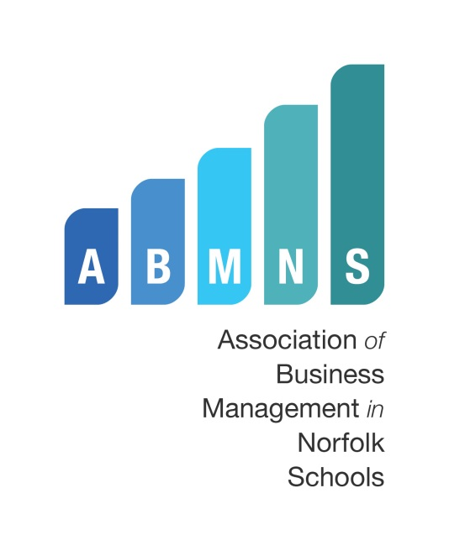

‘CHANGE’
2016 ANNUAL CONFERENCE
15th JUNE AT JOHN INNES CENTRE
BOOKING FORM
Please reserve me a place at the above conference
Name:
School/Organisation:
ABMNS Membership:  (Please tick to select) | I am a member of ABMNS. The cost is £20
ABMNS Membership:  (Please tick to select) | I am NOT a member of ABMNS. The cost is £35
Payments  Please provide invoice detail. An invoice will be issued on receipt of completed booking form. | Name:
 | Address:
 | Email:
If you are NOT a member of ABMNS or your details have changed since joining, please complete the following section in BLOCK CAPITALS
Address:
Phone Number:
Email Address:
Any Dietary, access or other special requirements?
In association with NASBM
Sponsored by Dulux Trade
The completed form should be returned to:
Wendy Ormes, ABMNS Committee Member


Little Plumstead CE VA Primary School
Hospital Road
Little Plumstead, Norwich NR13 5EW
Email: office@littleplumstead.norfolk.sch.uk
(please quote “ABMNS booking” in subject box

