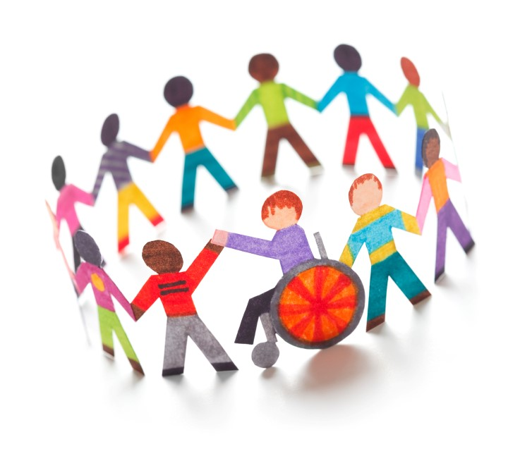
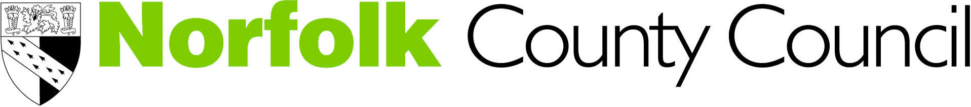

Norfolk County Council

Education, Health Care Plans Personal Budget Policy

Children and Young people aged 0-25 with Special Educational Needs and their families

September 2016

www.norfolk.gov.uk/send
www.norfolksendpartnershipiass.org.uk

Contents

1. Introduction - 3 -

2. Person centred planning and co-production - 3 -

3. What is a Personal Budget? - 3 -

4. How a Personal Budget is delivered - 4 -

5. Personal budgets across education, health and social care - 5 -

5.1 Health Personal Budgets - 5 -
5.1.1 Children’s Health (Age: Birth to 19 years) - 5 -
5.1.2 Adult’s Health (age 18 plus) - 5 -

5.2 Social Care - 6 -
5.2.1 Children’s Services – Social Care (Age: Birth to 18 years) - 6 -
5.2.2 Young people in transition from Children’s social care to adult services - 6 -
5.2.3 Adult Services Social Care (Age: 18 to 25 plus) - 7 -

5.3 Special Educational Needs (Education) - 7 -
5.3.1 Schools and colleges budget share - 7 -
5.3.2 Element 3 Local Authority High Needs Block funding - 7 -

6. Integrating and pooling personal budgets - 8 -

7. Direct Payments - 10 -

7.1 Direct payments for health or social care provision in an EHCP - 10 -

7.2 Direct payments for SEN provision in an EHCP - 10 -
7.2.1 Persons to whom direct payments can be made - 10 -
7.2.2 Reviewing a direct payment - 11 -
7.2.3 Stopping making a direct payment - 12 -
7.2.4 How funding will be made available for a direct payment - 12 -

8. What is in scope? - 13 -

8.1 Funding sources and scope for personal budgets - 14 -
8.2 Services in scope funded by the sources - 18 -

9. What happens in practice? - 19 -

10. Support to parents/young people for personal budgets - 19 -

- Introduction

The Children and Families Act 2014 sets out the legal arrangements for the provision of help and support for children and young people with special educational needs and disabilities (SEND). The Act includes particular duties relating to personal budgets; this policy therefore sets out Norfolk’s arrangements in relation to:

- The Children and Families Act, 2014 (section 49)
- The Statutory Guidance and Code of Practice for special educational needs and disability 0-25 years, 2014 (9.95- 9.124)
- The Special Educational Needs (Personal Budgets) Regulations 2014.

A Local Authority is under a duty to consider a Personal Budget when requested by a parent or young person who have the right to request a personal budget

- Following the completion of an Education, Health and Care (EHC) needs assessment and where the Local Authority has confirmed that it will produce an Education Health Care Plan (EHCP)
- As part of a statutory review of an existing EHCP

- Person centred planning and co-production

Norfolk sees personal budgets as a key part of person centred planning and co-production for children and young people with SEND. The EHC planning process will be an opportunity for all involved people and agencies (parents, young people, educational establishments, the local authority and health commissioners and providers) to have positive and collaborative discussions about how the provision across education, health, social care and from other sources such as parental contribution or the voluntary sector can be brought together to meet the needs of children and young people with SEND. This approach is in its early stages in Norfolk and will require a culture change of how agencies work together with young people and their families in developing holistic and integrated plans. Personal budgets do not introduce any new money into the funding systems across education, health or social care but they do provide an opportunity to explore the range of funding streams that contribute towards meeting the child’s needs and how best they can be deployed to deliver personalised provision that enables the child to achieve the outcomes of their EHCP.

- What is a Personal Budget?

Personal budgets are an allocation of funding made for children or young people with an Education Health and Care Plan for provision detailed in an EHCP that gives families choice and control over how provision is delivered. A personal budget therefore is not ordinarily used to pay for assessments of children’s particular needs within the EHC needs assessment or in readiness for an annual review. Instead, the personal budget could be used following those assessments to deliver the provision as described in the child’s EHCP based upon their assessed needs.

There are lots of ways in which the provision to meet the needs and achieve the outcomes of children with EHCPs can be delivered. A personal budget therefore is not the sum total of all of the provision identified and described to meet a child’s SEN. A personal budget is a sum of money identified to deliver specific provision described in an EHCP where the parents or young person are involved in arranging and securing that provision.

Any personal budget agreed as part of an EHCP will be described in Section J (Personal Budgets) of the EHCP. Section J does not need to list all the costs associated with supporting a child or young person but will provide a detailed explanation of how the personal budget will be used to deliver agreed provision and the needs and outcomes it will meet. It will also explain how the money will be used, spent and managed including arrangements in relation to any direct payments. Personal budgets can only be used for outcomes identified in the EHCP. A personal budget cannot be used to cover the cost for fees of a named educational placement.

It’s useful to think of a personal budget for an EHCP like a ven diagram. It can be arranged by a single agency across education, health or social care, or by more than one by those agencies agreeing to pool funding. When exploring personal budgets therefore it is important that it is identified which agency is responsible for delivering the provision and how the personal budget would be secured as this is different according to each agency. The ven diagram below shows this in more detail:

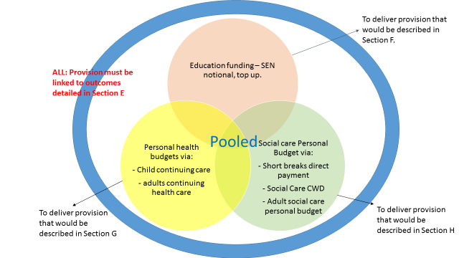

The arrangements for each agencies arrangements for personal budgets is set out below as well as the scope for pooling funding for a personal budget.

- How a Personal Budgets is delivered

A personal budget can be set up in the following four ways:

- Direct payments

This is where individuals i.e. parents and, once over compulsory school leaving age, young people receive the cash to contract, purchase and manage services. Here, the funds are paid into a bank account and managed by the parent/carer or young person themselves. More information on direct payments is detailed in Section 6 of this policy.

- An arrangement (sometimes called a Notional Budget)

In this scenario, no money needs to change hands. Here, the family direct the provision but the agency, service, the school or the college holds the funds and arranges support based on assessed needs to meet the outcomes specified in the EHCP.

- Budget held by a third party

Here, a third party (meaning someone other than the agency, parent/carer or young person) is paid the funds and manages the personal budget on behalf of the parents or young person. There are no additional funds to pay the third party provider to do this – it comes out of the basis of the assessed need and agreed allocation for provision;

- A combination of the above

- Personal budget across health, social care and education

Since an EHCP details provision made from the local authority (for education and social care) or health, a personal budget could be set up under one or more of the following processes:

  - Health Personal Budgets

These are oversee and agreed by Clinical Commissioning Groups (CCGs) who decide whether a child is eligible for ‘Continuing Care’ funding or an adult through ‘NHS Continuing Health Care for adults’ and whether they may receive a personal health budget. Where this is the case, that provision can be set out and described in Section G of the EHCP and delivered by a personal health budget detailed in Section J. Only children and young people with complex, long-term and/or a life-limiting condition/s will be eligible for continuing care and a personal health budget as described below.
    - Children’s Health (Age: Birth to 19 years)

Personal health budgets (PHBs) are being introduced for children and young people from October 2014. In the first instance, the approach is being offered for those who qualify for Continuing Care. Continuing care will be required when a child or young person has significant needs arising from disability, accident or illness that cannot be met by existing universal or specialist services alone. A personal health budget can be used to provide such a package of care.

Eligibility and decision making

- For children up to 18 who qualify for Continuing Care
- Decisions will be made by the relevant clinical commissioning group following a health care assessment from an appropriate medical practitioner

    - Adult’s Health (age 18 plus)

Personal budgets are available for adults who are eligible for NHS continuing health care. The five Norfolk Clinical Commissioning Groups are working in partnership with Norfolk County Council adult services department to expand and establish arrangements for the assessment and provision of Personal Health Budgets (PHB) for those eligible for NHS continuing healthcare. Once established the aim is to roll out PHBs to all care groups beyond continuing health care.

The introduction of PHBs will allow people to have more choice, flexibility and control over the health services and care they receive. At the heart of a PHB is a support plan, an agreement between the NHS and the individual that sets out the person’s healthcare and wellbeing needs, the amount of money available to meet those needs and how this money will be spent.

Norfolk county council adult services are leading this PHB work with the five Norfolk based CCGs through a joined up PHB team (health and social care) who will undertake all support planning for a PHB direct payment. The ultimate aim is to develop the skills and knowledge required to carry out personalised support planning within these joined up health and social care teams (called Integrated Care Teams).

Eligibility and decision making

- For children over 18 who qualify for Continuing Healthcare
- Decisions will be made by the relevant clinical commissioning group following a health care assessment from an appropriate medical practitioner

  - Social Care

Social care personal budgets are overseen and agreed by local authorities across children’s and adults social care services and are made available if it is clear that a young person or child needs significant additional and individual support at home and when out and about in the local and wider community. This would be determined following a social work assessment from either children or adult services. Where this is the case, that provision can be set out and described in Section H of the EHCP and delivered by a personal health budget detailed in Section J.

    - Children’s Services – Social Care (Age: Birth to 18 years)

Direct payments are available for parent carers to employ a personal assistant to work with their disabled child and/or to enable participation of community based activities for the purposes of short breaks.

Eligibility and decision making

Eligibility would be determined following a social care assessment under Section 17 of the Children’s Act and includes children up to age 18 with:

- Severe and profound learning disabilities
- Severe or profound physical disabilities
- Significant or profound sensory disabilities
- Multiple disabilities which together severely impact quality of life
- Complex or long term health needs
- Severe or profound social and communication difficulties related to disability

Decision making would be based on the outcomes of the assessment and the identified needs of the child. Parents and young people have the option of requesting a direct payment for meeting the short breaks needs of their disabled child but it is not a requirement. No new money is being introduced into the social care system to fund personal budgets detailed in EHCPs and they will come from existing resources.

    - Young people in transition from Children’s social care to adult services

Norfolk County Council Adults Services and Norfolk CCGs will be working with Children’s Services (health and social care) to support them to develop pathways which will enable children in transition to have personal budgets. The principles of offering a personal budget for children or a personal health budget for adults (as a direct payment) is very similar.

The national framework for NHS continuing health care for adults requests that children in transition are assessed at age 16 or earlier if possible, by a multidisciplinary team to agree their ongoing needs and service requirements as they move to adulthood.

    - Adult Services Social Care (Age: 18 to 25 plus)

A personal budget for social care is the total amount of money which adult services has identified to meet a person’s eligible social care needs, following a social care assessment.

Eligibility and decision making

If a person is eligible for adult care services they will be offered a personal budget to meet eligible needs. The personal budget is recorded within a ‘personal plan’ which describes the outcomes, the activities or services identified meet these, along with the associated cost. The outcomes are identified from the personal assessment of need, discussed and agreed with the person and how it is intended it will be met. Planning of the support to meet the outcomes can done jointly between the person and the adult services worker or independently.

Once the care package is in place, the needs, outcomes and personal budget are reviewed in line with the adult services review procedure.

To find out more about personal budgets for adults, you should contact your allocated care manager.

  - Special Educational Needs (Education)

This is a sum of money that could made available by a school, nursery, college and/or the local authority across the age range 0-25 where an EHCP has been agreed. There is no set eligibility criteria and each case will be considered on the particular circumstances. Where this is the case, the provision can be set out and described in Section F of the EHCP and delivered by a personal health budget detailed in Section J.

Schools and colleges budget share

Schools and colleges are being encouraged to personalise the support they provide from their direct SEN funding and can choose to contribute the funding they receive directly from the Education Funding Agency for SEN towards a personal budget.

Element 3 Local Authority High Needs Block funding

The local authority’s higher needs block funding is used to commission a variety of provision and services for children with special educational needs across the age range 0-25. Much of the money available is already committed to services and provision or delegated/issued to schools, colleges and early years settings directly. The potential for a personal budget will therefore depend on the individual circumstances of the child or young person and also on the type of educational establishment they attend. This is because the local authority’s high needs budget will vary based on how we commission services locally and what schools, colleges and early years settings provide as part of their local offer.

Decision making and eligibility

There is no eligibility criteria for a personal budget for SEN (Section F) provision and all decisions would be taken dependent upon the needs of the child and the outcomes and provision identified from the EHC needs assessment.

The local authority will consider the following factors when considering requests for personal budgets once it has confirmed that it will make an EHCP following a needs assessment:

- That the service for which the personal budget has been requested is to deliver SEN provision in order to meet needs and achieve the SMART outcomes and that is underpinned by documented professional evidence.
- Whether the service is already commissioned by the local authority and to separate funding for a personal budget would have an adverse impact on services provided by the local authority for other EHC plan holders
- The total cost of the provision described in Section F of the EHCP and whether the funding for the personal budget is already committed within delegated funding arrangements to schools or colleges and to separate funding for a personal budget would place provision to other children/young people at risk
- Whether agreeing provision through a personal budget would be an efficient use of the local authority’s resources

No new money is being introduced into the education system to fund personal budgets therefore any personal budgets must come from redirecting funding from existing resources. In Norfolk, the arrangements made for delegating funding to schools and colleges for places and higher needs SEN provision and the additional top up provided to fund the special educational provision for children and young people with EHCPs means that the vast majority of money is spent on staffing and other provision or support costs. The way that schools and colleges meet the needs of children and young people with SEN is set out in the local offer. The potential for a personal budget varies depending on individual circumstances, however, for the vast majority of children and young people in a school or college the opportunity for a personal budget will be limited without the agreement of individual schools and colleges.

- Integrating and pooling personal budgets

The way in which social care, health and SEN will work together to ensure a joined up approach to personal budgets is in development and is a complex process. There are separate legal frameworks for personal budgets and direct payments for each of the Education, Health and Social Care agencies. However, it may be possible for personal budgets to be pooled across education, health and social care where doing so would bring benefits to the child by integrating provision described across the various sections of the EHCP. This is a developing picture as agencies work together across the age ranges from birth to age 25 to see how this might operate in future.

This will require a culture change in the way that those agencies offer and commission services for children.
An example of such an integrated budget is described below.

Example of an integrated EHCP personal budget

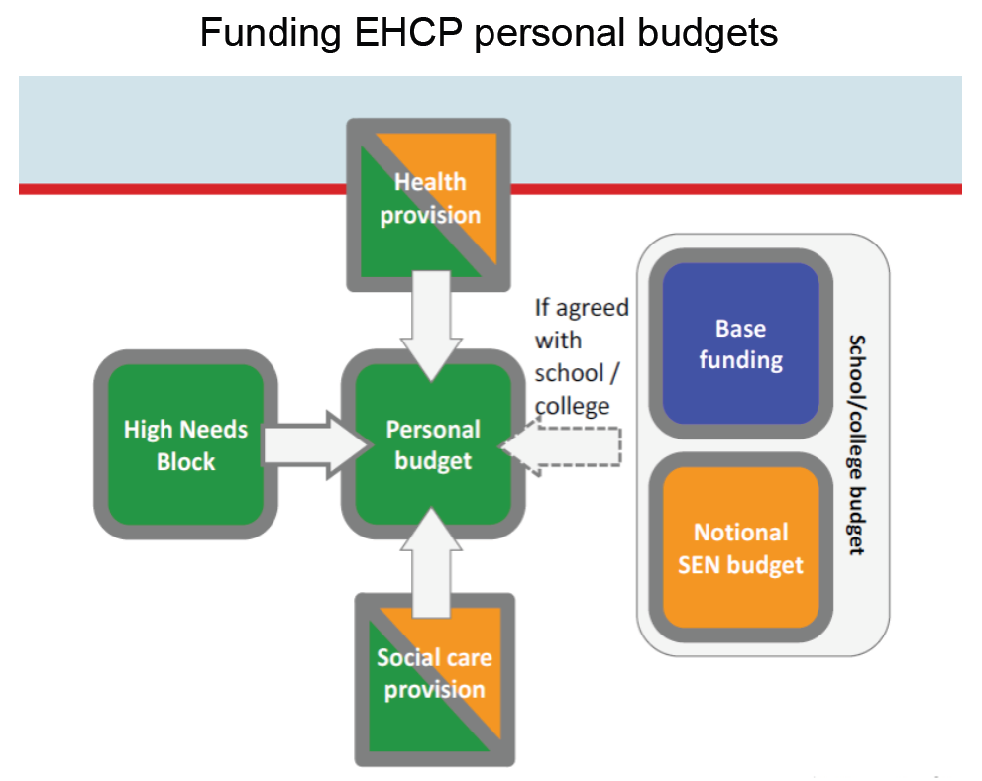

A child attends a local special school and has a range of complex physical and medical needs, sensory impairment and severe learning difficulties.

The family receive a personal budget from health under Continuing Care which they use for nursing care within the home. The family also receives a personal budget from local authority social care to fund a personal assistant to support the child to access short breaks and social activities. The child receives home to school transport which includes a personal travel assistant to tend to the care needs whilst travelling and the school is funded directly by the local authority and provides a trained teaching assistant to provide care and learning support to the child whilst in school.

The child therefore has 4 different individuals all delivering support to meet their complex learning difficulties and disabilities and broadly carrying out similar roles at different types of the day.

The family wish to access a personal budget via the EHCP in order to employ one holistic support assistant who will deliver all of this provision to meet the child’s needs and achieve outcomes across the education, health and care elements of the EHCP. The EHCP via its approach to joining up support across all elements of the EHC system provides the vehicle to do this. The cost of employing the support assistant is estimated together between the local authority and the family to provide an indicative sum. The family agree to pool their social care and health budget and the school agrees for the local authority to release the funding from the child’s top up funding to contribute to the personal budget. The family chooses to receive the funding for a direct payment and the school agrees that the assistant can deliver provision from within their premises. The arrangements are finalised at the transfer review of the child’s statement to an EHCP.

Such an arrangement would require all responsible commissioning bodies (the local authority for education and social care provision) and CCGs or NHS England (in the case of health provision) to agree to the pooling of the personal budget and each would need to assured that any regulatory requirements are met.

Direct Payments

Direct payments for health or social care provision in an EHCP

Direct payments for health or social care provision are subject to separate regulatory frameworks which are:

- The National Health Service (Direct Payments) Regulations 2013
- The Care & Support (Direct Payments) Regulations 2014

Before agreeing to a personal budget being provided under direct payments, health and social care services will need to ensure that their own regulatory frameworks are met. Professionals from health and social care will make arrangements for this if agreeing to make a direct payment for health or social care provision as described in Sections 4.1 and 4.2 of this policy. The local authority will only be able to detail a personal budget under direct payments for health or social care provision in an EHCP once those arrangements have been made and the relevant regulatory conditions are in place.

Direct payments for SEN provision in an EHCP

Persons to whom direct payments can be made

The local authority is able to make direct payments to:

- The child’s parent
- The young person
- A person nominated in writing by the child’s parent or the young person to receive direct payments on their behalf

And if the person

- appears to the local authority to be capable of managing direct payments without assistance or with such assistance as maybe available to them;
- where the recipient is an individual [and] is over compulsory school age;
- does not lack capacity within the meaning of the Mental Capacity 2005 Act to consent to the making of direct payments to them or to secure the agreed provision with any direct payment; (this means the person must have the mental capacity to manage a budget)

In addition, the regulatory framework specifies that some people may not receive direct payments:

(a) A person who is subject to a drug rehabilitation requirement
(b) A person who is subject to an alcohol treatment requirement,
(c) A person who is released on license
(d) A person who is required to submit to treatment for their drug or alcohol dependency by virtue of a community rehabilitation order
(e) A person who is subject to a drug treatment and testing order
(f) a person who is subject to a youth rehabilitation order imposed in accordance with paragraph 22 (drug treatment requirement) of Schedule 1 to the Criminal Justice and Immigration Act 2008(16) which requires the person to submit to treatment pursuant to a drug treatment requirement;
(g) a person who is subject to a youth rehabilitation order imposed in accordance with paragraph 23 (drug testing requirement) of Schedule 1 to the Criminal Justice and Immigration Act 2008 which includes a drug testing requirement;
(h) a person who is subject to a youth rehabilitation order imposed in accordance with paragraph 24 (intoxicating substance treatment requirement) of Schedule 1 to the Criminal Justice and Immigration Act 2008 which requires the person to submit to treatment pursuant to an intoxicating substance treatment requirement.

The local authority may not make direct payments for the purpose of funding a place at a school or post-16 institution.

A number of conditions will apply to the delivery of a direct payment and the local authority and recipient of the personal budget must enter into a written agreement which will cover those conditions. This is to enable the local authority to ensure that the regulations are met, that the use of the direct payment is appropriate, lawful, in the best interests of the child or young person and that public money can be accounted for. The recipient of the direct payment will be required to set up a bank account that is only accessible by them and used only for the purposes of direct payment (this bank account can be used for direct payments across education, health or social care).

    - Reviewing a direct payment

The local authority will monitor and review a direct payment. Reviews will take place

- At least once within the first 3 months of the direct payment being made
- When undertaking a review or reassessment of an EHCP

As part of the review, the local authority will consider a range of factors including, whether:

- The provision should continue to be arranged via a direct payment
- The direct payments have been used effectively and that the regulatory requirements and term and conditions are being met
- The amount of the direct payment continues to be enough to secure the provision

A recipient may also make a request for the local authority to review the direct payment and the local authority must consider this request. This will usually be where a recipient feels that the sum of the direct payment is no longer sufficient to deliver the provision it is being used for. When undertaking a review of a direct payment at a recipient’s request this will be carried out under the same arrangements for any other review of the direct payment, usually via a review or reassessment of the child’s EHCP.

Following the review the local authority may:

- Substitute the recipient of the direct payment for another person
- Increase, maintain or reduce the amount of direct payment
- Require the recipient not to secure a service from a particular person
- Require the recipient to provide such information as the local authority deems necessary
- Stop making direct payments

Any changes to the arrangements for direct payments will be communicated in writing and if reducing a direct payment, the local authority will provide reasonable notice and set out the reasons for doing so. The local authority must reconsider its decision when requested to do so by the recipient. Following reconsideration the local authority will again provide written notice of its decision; the local authority is not required to undertake more than one reconsideration following its initial decision.

    - Stopping making a direct payment

The local authority may stop making direct payments in the following circumstances:

- at the request of a recipient made in writing or, in the case of a young person, where no notice has been received but where the local authority has taken reasonable steps to confirm that the young person agrees to direct payments
- the recipient is a person to whom a direct payment cannot be made as per the regulations
- that following a review, the local authority views that the recipient is not using the direct payment to secure the agreed provision or that the agreed provision can no longer be secured by means of a direct payment
- the local authority becomes aware that the direct payment is adversely impacting on services arranged for other children or young people with an EHCP or is not an efficient use of public finances
- Where the recipient has not complied with the terms and conditions of the direct payment agreement

In all cases, the local authority will provide notice in writing to the recipient and must reconsider its decision when requested to do by the recipient. Following reconsideration the local authority will again provide written notice of its decision; the local authority is not required to undertake more than one reconsideration following its initial decision.

    - How funding will be made available for a direct payment

If a personal budget is agreed through a direct payment arrangement, each agency (where applicable) will place money into a nominated bank for the recipient to receive the budget from direct payments. Any agreed costs from health would be paid by the agreed process to fund the plan. The money will be given to parents/young people on an agreed basis. The eventual aim will be for pooled budgets between health and the local authority.

A parent and/or the young person will be expected to sign a Direct Payment Agreement before the payment is made. This will outline the parameters of use of the payments and how it should be managed. It will also outline other aspects, such as any employed people having to have an enhanced Disclosure Barring Service (criminal record) check.

If a parent/young person would want to use a direct payment to pay for support staff in school/ college this discussion should occur at an early stage as possible, as part of the person centred planning, since these staff can only be used in schools/colleges via a direct payment with the permission of the school head teacher or college principal. Any staff employed in schools/ colleges would have to follow that institution's code of conduct, for instance in speaking to others and dress code.

Requests for personal budgets using the extra resources normally supplied to support a student by a college/school budget (termed elements 1 and 2 funding) must occur at as an early stage as possible. It is likely that this would only be agreed by the school/college in certain circumstances where a creative solution to provision is required.

Although there will normally be a set amount of money paid on an agreed cycle there may be one off payments, for instance around specific equipment needs, that could be paid via the direct payment mechanism. A value for money judgement will be made in these circumstances. The equipment would need to meet professional specifications and maintenance of the equipment would be required. If used in a school, agreement of the setting would need to occur.

8. What is in scope?

The following table details current services and funding sources that are in scope for personal budgets within EHCPs. The table also identifies the lead agency and the section of the EHCP to which it relates. In some cases, this may be spread across more than one section and this is where pooled budgets would be beneficial to explore further in the development of the draft EHCP.

8.1 Funding sources for personal budgets

Educational establishment | Core and SEND Funding | Scope for personal budgets | Agreement needed by | Age range
Early Years settings | Core funding:  LA provides funding to settings for up to 15 hours per week statutory entitlement | N/A |  | Up to 5
Early Years settings | SEND funding:  Providers can apply for short term discretionary top up funding from the local authority to provide additional funding to meet the needs of high needs children in their settings. Requests are considered by the local authority and is part of the graduated approach before an EHC needs assessment is requested. | Parents can make a request for a personal budget, subject to the agreement of the Head teacher/manager. | Parent  Local authority  Early Years setting | Up to 5
Mainstream school | Core funding:  Funding is allocated directly to schools either by central government (academies, free schools) or the local authority (LA maintained schools) for basic teaching costs. | N/A | N/A
Mainstream school | SEND Funding:  Element 2 notional SEN funding: Additional funding is allocated directly to schools by central government of the local authority for SEN support costs (known as notional or Element 2.  Higher needs block top up funding (also known as Element 3 or cluster funding): the local authority delegates SEND funding for pupils with high needs directly to groups of schools in cluster arrangements. Those groups of schools then use the funding to commission services and provision for children on a local level. The local authority retains a small sum in reserve known as “Exceptional Circumstances” funding to provide additional financial support to schools (i.e. when a child with very high needs moves into the school’s catchment area that they were previously unaware of). | Requests can be made for a personal budget which may incorporate Element 2 or Element 3 funding.  All arrangements would require the agreement of the Head Teacher or Principal. | Parent  School Head Teacher or Principal  School Head teacher or Principal  Local Authority | 5-19
Specialist resource bases at mainstream schools  AND  Special academies and LA maintained special schools | Core / SEND funding  The local authority provides a fixed amount of funding per planned pupil place as well as top up. The local authority also supplements for Speech and Language therapy and educational psychology support. | Parents should be fully consulted on how this funding is used by schools and can make a request for a personal budget in circumstances where this would not detrimentally affect school wide services provided to other pupils. | Parent  School Head teacher or Principal  Local Authority | 5-16  5-19
Independent special schools | Core / SEND funding  The local authority commissions places and provides an agreed level of top up funding to meet the requirements of the EHCP | Parents should be fully consulted on how this funding is used by schools and can make a request for a personal budget in circumstances where this would not detrimentally affect school wide services provided to other pupils. | Parent  School Head teacher or Principal  Local Authority | 5-19
Further education colleges and other post-16 training providers | Core funding  The Education Funding agency provides funding for students on a national formula which recognises that some learners will have additional needs | Requests can be made for a personal budget which may incorporate core funding and/or top funding. | Young person  College Principal or equivalent | 16-25
 | SEND funding  The local authority provides top up funding to meet the needs of children with significant difficulties over and above that which can be provided from providers own core funding. Access to this funding does not necessarily require the pupil to have an EHCP. |  | Young person  College Principal or equivalent  Local authority | 16-25
Independent specialist colleges | Core / SEND funding  The local authority commissions places and provides an agreed level of top up funding to meet the requirements of the EHCP | Parents should be fully consulted on how this funding is used by schools and can make a request for a personal budget in circumstances where this would not detrimentally affect school wide services provided to other pupils. | Young person  College Principal or equivalent  Local Authority | 16-25
All | Home to school travel  The local authority arranges appropriate school travel for eligible pupils which may include the provision of a passenger transport assistant.  County commissioned services (i.e. SaLT) where single or joint agencies commission county or area wide services | Parents can request a personal travel budget where this would not detrimentally affect other pupils or local authority budgets  These services are continually reviewed to ensure they operate effectively and represent best value for money through development of the local offer. Personal budgets will only be agreed where provision is over and above what is provided by jointly commissioned services. | Parent / young person  Local authority | 0-25  Varies
Children whose parents have chosen to home educate | Families assume financial responsibility for the educational provision for their child once they elect to home educate.  In certain circumstances, the local authority retains a duty to arrange the SEN provision detailed in the child’s EHCP or can use discretion to do so. This would be funded via the local authorities higher needs block. | Where a local authority agrees that home education is the right provision, a personal budget will be the method used to fund SEN provision. | Parent  Local authority | 5-16
All types of providers to age 18 | Children’s social care funding | Personal budgets can be requested where a child is eligible for a service from the CWD social care service | Parent / young person  Local authority | Up to 18
All types of providers post age 18 | Adult’s social care funding | Personal budgets can be requested where a young person qualifies for an adult social care service | Young person  Local authority | 18+
All types of providers to age 18 | NHS funding | Personal health budgets can be requested for children who are eligible for Continuing Care | Parent / young person  CCGs | Up to 18
All types of providers post age 18 | NHS funding | Personal health budgets can be requested for children who are eligible for Continuing Care | Young person  CCGs | 18+

8.2 Services in scope funded by the sources

Provision | EHCP Section | Funding source from above
Continuing care | G | NHS children’s funding
Continuing healthcare | G | NHS adult funding
Short breaks / personal assistance | H | Social care children’s funding
Adult care | H | Social care adults funding
Speech and Language Therapy | F | Schools/colleges/early years and local authority
Occupational therapy | F, G or H | Schools/colleges/early years and local authority  CCGs and social care
Physiotherapy | F and/or G | Schools/colleges/early years and local authority  CCGs and social care
Personal travel budget | F or H | Local authority
Communication augmentative equipment (i.e. laptop, tablets) | F | Schools/colleges/early years and local authority
Learning support | F | Schools/colleges/early years and local authority
Support to access a supported internship / work experience support | F | Schools/colleges/early years and local authority

- What happens in practice?

When the local authority receives a request for an EHC needs assessment, an EHCP Coordinator will make contact with the parents/young person in the early stages for initial information gathering. As part of this, they will introduce personal budgets explain what they are, what they can be used for and their scope based on the content of this policy. They will ask whether the child/young person already receives a personal budget from either social care or health and what these are currently used for and whether they are provided through a direct payment.

The person centred planning meeting in the assessment/plan writing phase will outline the needs of the child/young person, outcomes wanted from the EHCP, and provision to meet these. Professional reports will also outline the provision required. Personal budgets will be further discussed at the meeting and possible options for their use explored with the input of the family and all possible contributing agencies (i.e. social care, health, school/college, local authority) including scope to integrate and pool budgets. The school or college will give an early indication of agreement for staff or services that may be delivered through a direct payment on their premises and a firmer indication will be made by the family/young person about whether they wish to pursue a personal budget including a direct payment. Some families may already be accessing personal budgets in terms of heath or care, and these will continue throughout the statutory process, and be incorporated, as part of the person centred planning meeting and drawing up of the EHCP.

On development of the EHCP where one is agreed, the personal budget will be costed and considered against the criteria described in Section 4 of this policy and the family notified of the decision. The local authority may need to enter into further discussion with schools/colleges, social care or health to confirm their contribution to a personal budget. The EHCP coordinator will also confirm with the family provisionally how they wish for the personal budget to be managed and, if via a third party, which agency or person the parent/young person wishes to nominate. Where the personal budget is agreed via a direct payment, the recipient will be asked to sign the Direct Payment agreement. The personal budget will be described in Section J of the EHCP in readiness for the first draft to be issued to the parent/young person and, following consultation, finalised.

Support to parents/young people for personal budgets

The Independent Supporter service in Norfolk will be able to provide advice and information to families on personal budgets more broadly. The organisations delivering independent supporters in Norfolk and their contact details can be found on the local offer. These organisations however will not be able to provide support or help a parent/young person to manage a personal budget.

Norfolk is currently exploring with a local organisation who provides direct support and guidance about personal budgets and who help to families to manage direct payments for our social care short breaks provision. We are arranging for this type of support to be made available for parents and young people with EHCP personal budgets. If you receive a short breaks direct payment, you may already be receiving support from this organisation and discussions can be held to join this up any EHCP arrangements. More information about this support will follow soon.

Subject to certain conditions and exemptions.
as defined by section 209 of the Criminal Justice Act 2003(6), imposed by a community order within the meaning of section 177 of that Act(7) or by a suspended sentence order within the meaning of section 189 of that Act(8)
as defined by section 212 of the Criminal Justice Act 2003(9), imposed by a community order within the meaning of section 177 of that Act or by a suspended sentence order within the meaning of section 189 of that Act
under Part 2 of the Criminal Justice Act 1991(10), Chapter 6 of Part 12 of the Criminal Justice Act 2003(11) or Chapter 2 of Part 2 of the Crime (Sentences) Act 1997(12) subject to a licence condition requiring the offender to undertake offending behaviour work to address drug-related or alcohol related behaviour
within the meaning of section 41 of the Powers of Criminal Courts (Sentencing) Act 2000(13) or a community punishment and rehabilitation order within the meaning of section 51 of that Act(14)
imposed under section 52 of the Powers of Criminal Courts (Sentencing) Act 2000(15)
For provision only over and above block services jointly commissioned between health and local authority
In line with Norfolk County Council’s home to school and Post 16 transport policy

