

Autumn Term 2016

Scheme for Financing Schools

Proposed Changes 2017/18

Due to continued pressure within the High Needs Block and, in part, due to the changes proposed as part of the National Funding Formula, it is necessary to outline budget proposals to all Norfolk state funded schools. These proposed changes include a transfer of funding between the Schools Block and the High Needs Block and do impact on all school budgets.

Last year there was an overspend of, approximately, £4.5 million that was offset using reserves. This year (FY 2016/17) the forecast is for an overspend of around £6.0 million and next year (FY 2017/18) in excess of £8.0 million.

There has been a 10% shift of pupils (Statements / Education Health & Care
Plans) from mainstream schools to the specialist sector over the past 5 years
and, in Norfolk, a higher percentage of those in high cost independent / non-
maintained rather than state funded special schools.

The reserves, used previously, have been exhausted and we must now consider a combination of actions to reset the budget in a sustainable way; we propose to:
• transfer funding from the Schools Block to the High Needs Block
• reduce the SEND Cluster budget
• reduce funding for the recommissioning of Specialist Resource Bases and ongoing commissioning of LA and 3rd party services (described as ‘LA Hosted and Commissioned Services)
• create an ‘Inclusion Incentive Fund’
• review the banding / matrix scheme within complex needs schools
• allocate the anticipated inflationary growth from DfE, for next year, towards revenue funding for our planned new specialist provision (250 places)
We must make it clear that there are risks associated with the proposal, however, we
believe that in the current context such actions are required and the combination of
actions provide the best possible way to mitigate the associated risks.

Every school will have a budget reduction and this will present challenges to schools;
needing to re-assess their approach to inclusion, ensuring that a range of approaches
are used to meet pupil needs and reconsidering how a range of resources can be
deployed.

If schools cannot include all children appropriately then this would cause further
pressure within the High Needs Block if even more pupils move out of mainstream
schools.
With the introduction of a National Funding Formula, from April 2018, this
means that the need to resolve this issue is more pressing than usual; this is
the last opportunity to determine locally the balance of funding between the
Schools Block and the High Needs Block, to reflect current pupil need and to
anticipate pupil need in the future.

We know that other local authority areas are also dealing with similar issues
and considering a range of solutions. We know that Suffolk have recently
proposed a £3million transfer between their Schools Block and High Needs
Block and in Cumbria and Surrey, whilst having not published figures at this
stage, the local authorities have signalled a transfer along these lines also, as they
experience the same pressures that we face:
• increase in complex needs within the pupil population,
• rise in exclusions and/or the use of pupil referral units via managed move arrangements
• increases in post 16 funding linked to the change in age range for Education Health & Care Plans (age range 0-25).

This consultation, therefore, seeks views from school regarding the impact of the proposal and views on the likelihood of this meeting the needs of pupils within mainstream and special schools now and in the medium/long term.

Chris Snudden, Assistant Director Education Services

THE PERIOD FOR CONSULTATION BASED ON THIS DOCUMENT WILL BE:

7 NOVEMBER TO 25 NOVEMBER 2016

YOUR RESPONSE IS IMPORTANT

Reply at:

www.schools.norfolk.gov.uk under ‘Finance’ and then ‘Fair Funding’ after 7 November 2016, or click on the link below:

http://www.smartsurvey.co.uk/s/FairFunding2016Survey/

The purpose of this paper is to provide information and to seek your comments, agreement and suggestions on changes originating within Norfolk. It is an important part of our commitment to work with schools and to respond to our collective need to support all children and young people with their education.

Fair Funding Review Proposals Overview

The Department of Education announced in late July 2016, that it would be delaying the National Funding Formula implementation until April 2018, financial year 2018-19.

The are two significant national changes to schools funding for the financial year 2017/18;

- The post 16 funding factor has been removed. Schools that receive an amount per pupil under the post 16 factor will receive protection on their budgets under the minimum funding guarantee.

- The use of new bandings for the index of deprivation affecting children. (IDACI)
We did not anticipate the need for a consultation for the financial year 2017/18. However, due to the ongoing movement of pupils moving out of mainstream schools and into specialist provision, during the current financial year and previous years, there is a need to mitigate the year on year growth of commitments to the Highs Needs Block.

This document sets out the proposals for mitigating the pressures on the High Needs Block. To view the technical papers and complete the survey, please visit the website below;

www.schools.norfolk.gov.uk. Select ‘Finance’ (on the ‘School Administration’ menu), then ‘Fair Funding.

You can access the survey with the following link: http://www.smartsurvey.co.uk/s/MYNGF/

Decision Making & Briefings

Due to the tight timescales involved the online consultation survey will run from 7 November – 25 November, the results of the survey will be analysed and the results with recommendations presented to Norfolk Schools Forum on 14 December 2016. Following consultation with Norfolk Schools Forum final recommendations will be presented to Childrens Services Committee in January 2017 for a decision.

Again, due to the tight timescales involved, colleagues from within the Education Inclusion Service will be contacting school clusters to arrange, where possible, to attend these meetings to outline these proposals. We hope that this will ensure that as many views are gathered as possible.

Process of Formulating Proposals

The Education Act 2002 made it a legislative requirement for each Local Authority to set up a Schools Forum. This body must be consulted about certain school funding issues. A list of current members of the Forum can be found at Annex A at the end of this paper.

School Responses

The Children’s Services Committee, when making its decision in January 2017, will take all views into account when considering the proposals and, therefore, it is important that all schools respond. It would be helpful if you give us one single response from your school, using the electronic response sheet. We welcome any alternative suggestions to the proposals, but when responding please remember that the final decision will need to take into account the impact on all schools in Norfolk.

Consultation Responses

To respond to the consultation go to www.schools.norfolk.gov.uk under ‘Finance’ and then ‘Fair Funding’ after 7 November 2016.

Requests for Further Information
For more information contact: Marilyn Edgeley (01603 223546) (marilyn.edgeley@norfolk.gov.uk)

Fair Funding Proposals

High Needs Block Forecast Overspend Mitigation

- Context

The High Needs Block pressure (year on year forecast overspend) has been reported regularly in recent years to Schools Forum and Children’s Services Committee; with one off in year savings / reserves having been used to balance the budget. However, reserves have been exhausted and a sustainable re-setting of the budget is required. Also, the current forecast overspend is of a greater level than in previous years and our ability to mitigate the risk within year and going into the next financial year is significantly limited.

- Financial Year 2016/17 – Forecast Overspend of at least £5.910 million
- Financial Year 2017/18 – Forecast Overspend of at least £8.48 million

The forecast overspend is linked directly to an increase in placements within special schools and alternative provision:

Budget Element | Budget | Forecast | Variance | Extra Places | Average Placement Costs
Special Schools | £25.537 m | £26.706 m | -£1.169 m | 45 | £25,977
Short Stay School for Norfolk | £5.090 m | £5.819 m | -£0.729 m | 20 (+ transport costs) | £15,350 (placement cost only)
Post 16 FE High Needs | £2.440 m | £3.159 m | -£0.719 m | 55 | £17,363
Non Maintained Special Schools | £13.362 m | £16.655 m | -£3.293 m | 73 | £45,000
 |  |  |  | 193
Note: income, from mainstream schools AWPA following each permanent exclusion, was £250k during FY2015/16 and is forecast as £350k during FY2016/17

The table below illustrates pupil movement over the past 5 years from mainstream schools to special schools and alternative provision; via a combination of placement transfer following Statement / EHCP Annual Review or permanent exclusion:

Year | Statement / EHCP | Mainstream |  | Special
 | No. | % |  | % |  | %
2012 | 4851 | 3631 | 74.9 | 1220 | 25.1 | 100
2013 | 4754 | 3481 | 73.2 | 1273 | 26.8 | 100
2014 | 4452 | 3145 | 70.6 | 1307 | 29.4 | 100
2015 | 4378 | 2902 | 66.3 | 1476 | 33.7 | 100
2016 | 4385 | 2826 | 64.4 | 1559 | 35.6 | 100
This 10% shift of pupils, of those with Statements / Education Health & Care Plans from mainstream schools to the specialist sector, does underline the core reason for our High Needs Block overspend; more pupils in specialist placements and, in Norfolk, a higher percentage of those in high cost independent / non-maintained rather than maintained special schools.

In addition to the need to resolve the funding pressure, in the current and next financial year, the fact that next year is likely to be the final year of the current funding system, prior to the introduction of a National Funding Formula from April 2018, means that the need to resolve this issue is more pressing than usual. The key issue is that this is the last opportunity to determine locally the balance of funding between the Schools Block and the High Needs Block, to reflect current pupil need and to anticipate pupil need over the next 3 to 5 years.

We know that other local authority areas are also considering similar actions; Suffolk have recently proposed a £3million transfer between the Schools Block and High Needs Block and Cumbria and Surrey, whilst having not published figures at this stage, have signalled a transfer also.

There is no doubt that action is required now to mitigate the significant risks of the forecast overspend within the current and next financial year. However, changes on the scale proposed in this paper would ordinarily be implemented alongside transition arrangements and usually take place over a three year period. Therefore, further work is required to assess where it may be possible to consider transition elements and whether or not the national funding formula outcome will provide support to us in these approaches or, simply, will act as a further ‘complicating factor’.

The description of the unknown outcomes of the current national consultations (white paper and national funding formula) as complicating factors is accurate. However, the more pressing complicating factor is we also need to take account of the impact of further need to place children into specialist provision. There are two very real drivers for further commitment to the High Needs Block:

- Permanent Exclusions

The rate of permanent exclusions has risen significantly over the past three years,
  - Permanent Exclusions 2013/14 = 170 (Primary 52, Secondary 118)
  - Permanent Exclusions 2014/15 = 195 (Primary 65, Secondary 126, Special 4)
  - Permanent Exclusions 2015/16 = 296 (Primary 83, Secondary 197, Special 2, Other 14)

At autumn half-term in 2015 there had been 52 permanent exclusions across Norfolk, at the autumn half-term stage currently there have been 65 permanent exclusions. If this profile continues then we will have in excess of 350 exclusions at the end of this academic year; each placement for a permanently excluded pupil at the Short Stay School for Norfolk costs £15,350 (this does not include off site transport costs)

- Complex Needs / Learning Disability

We are currently considering in excess of 100 placement requests; moving from mainstream schools to specialist provision. The complex needs schools are almost at full capacity and cannot agree to any more than a fraction of these placement requests; placement options do exist to some degree in the independent / non-maintained sector but placements here would of course commit the greatest possible further pressure to the budget.

Our current strategic planning for increased specialist placements is as follows:
- Wherry Free School (Norwich) for Autistic Spectrum Disorder : September 2017 for 40 places initially and building up to 90+
- Chapel Green (Old Buckenham) for Complex Needs : September 2017 with current cohort (60) and with new growth from spring term 2018 up to 100+
- West Norfolk Specialist Academy (Kings Lynn) for Social Emotional & Mental Health Difficulties : First admissions of 24 places September 2017, steady growth over a 6 year period up to 90+
However, the current national funding allocation for High Needs Block does not incorporate growth linked to new provision / capital developments; despite the fact that Free Schools / Academies are agreed by the DfE. Therefore, we continue to monitor the progress of the National Funding Formula consultation to gauge whether the new model may provide Norfolk with increased funding in future that reflects new provision developments.

- Evidence

- Comparisons with other local authorities

We know that other local authority areas are also dealing with similar issues and considering a range of solutions. We know that Suffolk have recently proposed a £3million transfer between their Schools Block and High Needs Block and in Cumbria and Surrey, whilst having not published figures at this stage, the local authorities have signalled a transfer along these lines also.

Information published by these local areas point to the same pressures that we are facing in Norfolk; increase in complex needs within the pupil population, rise in exclusions and/or the use of pupil referral units via managed move arrangements and increases in post 16 funding linked to the change in age range for Education Health & Care Plans (age range 0-25).

It is notoriously difficult to attempt comparisons on per pupil spend between local authorities, even those who are considered to be statistical neighbours (LA areas with size, pupil population and geography characteristics of a similar nature), as all national data sets rely on individual LA’s submitting data on a like for like basis. This does not mean that LA’s submit information in an inaccurate or inconsistent way, it is simply a case that national data sets do not take account of the different way in which local areas distribute funding; I.e the level of funding that is delegated within the schools block for SEND compared to the High Needs Block or the nuances related to funding that may or may not be de-delegated, such as for behaviour support.

Having said that, we have carried out a review of other LA funding models to provide a level of comparison; the information below must, therefore, be considered alongside the commentary and ‘health warning’ above:
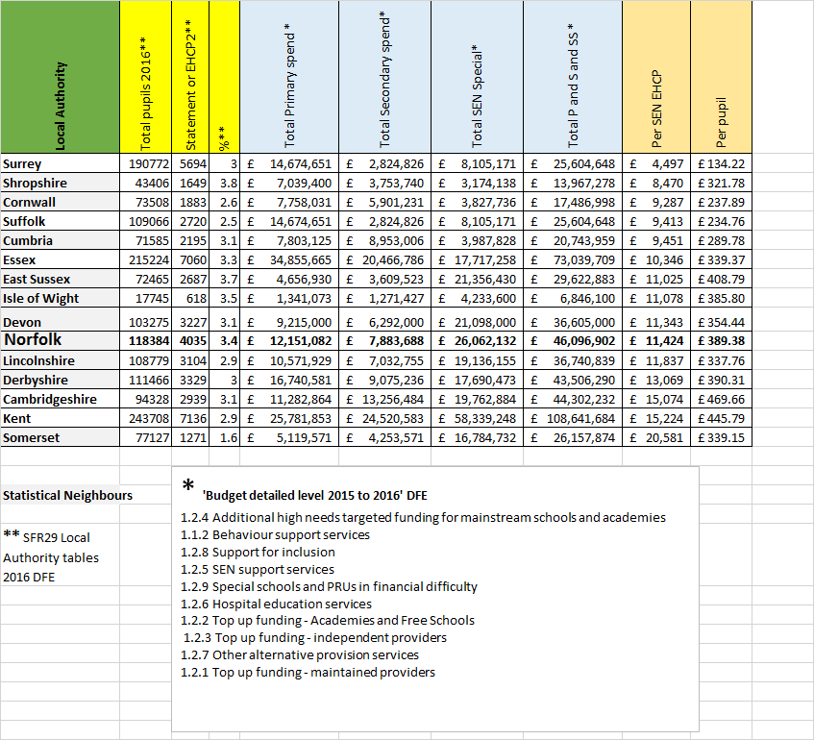

In addition to funding, per pupil, for SEND we have also looked at a new set of LA data within the public domain. The extract below illustrates the type of provision used in Norfolk for SEND compared with LA’s within the Eastern Region. This illustrates our higher rate of placements within specialist provision, both maintained and non-maintained / independent.

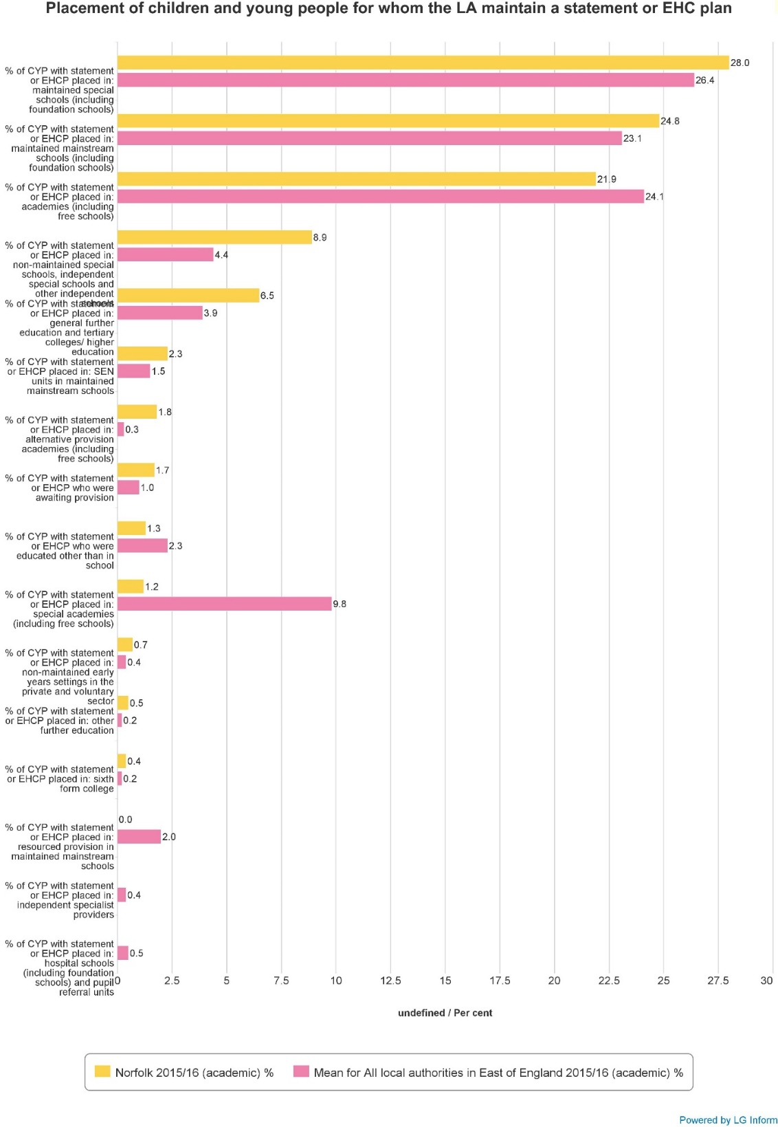
- Our previous and current strategies to meet needs and balance the budget

Due to the ongoing, and increased, budget pressure within the High Needs Block we need to accelerate our ongoing review of specialist placements and associated placement decision making process. However, in addition, we also need to consider more direct actions to achieve a balanced budget in the current and next financial year.
Our ongoing work includes,
- Revised decision making approach within the ‘Inclusion Commissioning’ strand of the Education Inclusion Service. This is ensuring consistency of decision making for agreeing new Education Health & Care Plans and ensuring that requests for specialist placements include an assessment of the reasonable adjustments that could occur to enable mainstream inclusion where this is appropriate.
- Commissioning Trust SEN Norfolk (Norfolk complex needs schools and other maintained / academy special schools) to work with the local authority on a range of activity to support our strategies; identifying children who could be supported within mainstream school, further developing the S2S outreach service, promoting and assisting placement within schools that balance the need to be close to home whilst providing the most appropriate placement.
- Implementing the outcomes of the development work (previously described as the ‘Inclusion Barometer’) to establish an Inclusion Framework for mainstream schools; supporting the local authority role for support, challenge and intervention work and facilitating self-evaluation through a co-produced, voluntary, framework.
- Benchmarking Norfolk levels of SEN Support / Education Health & Care Plans, and associated funding and placements, with other LA areas
- Working with Headteacher / Governor Associations and County Councillors to address issues related to the high level of permanent exclusions; recommendations are likely to support the need to a new managed move / re-integration model and commissioning of specialist preventative support for schools to purchase as part of their current and anticipated (within the government White Paper, Education Excellence Everywhere) for Alternative Provision
- Commissioning new special school provision, including significant capital developments, and a re-commissioning of our ‘Select Provider List’ (now known as a dynamic purchase system) for independent and non-maintained sector specialist providers
- Proposal

Within Section 4. there are examples of other proposals that have been considered, and discussed at Schools Forum (including, Learning Disabilities Sub Group), but that have been assessed as presenting too high a level of risk to be progressed further; predominately these risks relate to options where all budget risk would be located in one sector (eg mainstream schools), where the opportunity for unintended consequences is unknown to too great an extent and/or where actions need to be taken after the outcome of the government National Funding Formula consultation.

This is not to say that the proposal described below is not without risks, we must make it clear that there are risks associated with the proposal, however, we believe that in the current context such actions are required and the combination of actions provide the best possible way to mitigate the associated risks.

This consultation, therefore, seeks views from schools regarding the impact of the proposal and views on the likelihood of this meeting the needs of pupils within mainstream and special schools now and in the medium/long term.

For context, in the current financial year (2016/17) we have already taken actions to offset the forecast overspend of £5.91 million through a combination of one-off savings and roll-forward of remaining deficit, as follows:

- Early Years 2 year old reserve - £2.000m
- Invest to Save reserve - £1.000m
- Schools Block De-delegation / Rates Recoupment - £0.800m
- High Needs Block – deficit roll forward to FY17/18 £2.110m

This means that our forecast overspend, already, for financial year 2017/18 is £8.4 million; including the £2.110m roll forward above.

It is this total forecast overspend of £8.4 million that we propose to offset through a combination of,
- transfer of funding from Schools Block to High Needs Block
- reduced SEND Cluster budget
- reduced funding for the recommissioning of Specialist Resource Bases and ongoing commissioning of LA and 3rd party services (described as ‘LA Hosted and Commissioned Services)
- creation of an ‘Inclusion Incentive Fund’
- review of the banding / matrix scheme within complex needs schools
- allocation of the anticipated inflationary growth from DfE towards revenue funding for our planned specialist provision capital developments:
Budget Description | Current Budget | Proposed Cut | Decision Maker | Justification | Risk | Overspend – running total
 |  |  |  |  |  | £8,480,000
Schools Block SEN Notional Funding –  Reduction of the Basic Per Pupil Entitlement funding | Total Schools Block £459,000,000  SEN Notional  £36,000,000 | £3,600,000  10.0%  See Appendices 1 & 2  Please note there are 2 technical papers to this proposal, one with IDACI deprivation funding remaining equal, one reflecting national changes. | Schools Forum | 10% of pupils have transferred from mainstream to special schools (including alternative provision) over the past 5 years. This moves the budget to where the pupils / need is now located. | There is no risk to the Minimum Funding Guarantee (any transfer between blocks of up to a maximum of £5million is possible). However, every school will have a budget reduction and this will present challenges to schools; needing to re-assess their approach to inclusion, ensuring that a range of approaches are used to meet pupil needs and reconsidering how a range of resources can be deployed.  If schools cannot include all children appropriately then this would cause further pressure within the High Needs Block if even more pupils move out of mainstream schools. | £4,880,000
Budget Description | Current Budget | Proposed Cut | Decision Maker | Justification | Risk | Overspend – running total
SEND Cluster | £9,424,000 | £5,000,000  See Appendix 3  53.1% | Children’s Services Committee | 10% of pupils have transferred from mainstream to special schools (including alternative provision) over the past 5 years. This moves the budget to where the pupils / need is now located.  Current cluster balances are in excess of £1million (SEND element only) and contingency planning on this scale raises questions regarding the fair distribution of the budget, i.e. many clusters claim that they do not have sufficient funding to meet needs. | Every cluster will have a budget reduction and this will present challenges to schools; needing to re-assess their approach to inclusion, ensuring that a range of approaches are used to meet pupil needs and reconsidering how a range of resources can be deployed.  If schools cannot include all children appropriately then this would cause further pressure within the High Needs Block if even more pupils move out of mainstream schools.  A reduced cluster budget could, further, call into question the ability of the current proxy indicator delegation model to target need effectively; a move from delegation and to a referral/bidding scheme may be required to mitigate these risks, therefore. | +£120,000
Budget Description | Current Budget | Proposed Cut | Decision Maker | Justification | Risk | Overspend – running total
Specialist Resource Bases (SRB) | £3,970,000 | £ 880,000  22.0% | Children’s Services Committee | Initial outcome of SRB review has highlighted high vacancy rates within high school behaviour SRBs and the potential to move to a traded model for dyslexia and/or cognition and learning.  Addressing these issues could fulfil our requirements to ensure value for money. | The SRB review has also highlighted the need to invest further in ASD SRB’s and this de-commissioning proposal without the associated re-commissioning for ASD could lead to a further pressure for higher level specialist provision and associated additional pressure on the High Needs Block. | + £ 1,000,000
Budget Description | Current Budget | Proposed Cut | Decision Maker | Justification | Risk | Overspend – running total
High Needs Block inflationary growth | n/a | n/a | Children’s Services Committee | We are currently anticipating that annual inflationary growth, for the High Needs Block, would be in the region of £1.3 million.  This will be part of the overall HNB budget, however, we will plan for this to be used to off-set additional revenue funding associated with additional specialist capacity that has been commissioned and is due to start from September 2017  - Wherry Free School (Norwich) for Autistic Spectrum Disorder  - Chapel Green (Old Buckenham) for Complex Needs  - West Norfolk Specialist Academy (Kings Lynn) for Social Emotional & Mental Health Difficulties | We are continuing with our plans for additional specialist provision in Norfolk without assurance that revenue funding growth will be sufficient to cover this. Therefore, we must also ensure that, where appropriate, we consider pupil transfers to local specialist provision and that these achieve savings as well as meeting needs. | + £2,300,000
Budget Description | Current Budget | Proposed Cut | Decision Maker | Justification | Risk | Overspend – running total
Alternative Provision (AP) recommissioning | n/a | n/a | Children’s Services Committee | We are currently anticipating that the government’s white paper (Education Excellence Everywhere) will signal a change in responsibility for AP between the Local Authority and individual schools.  The LA will still, likely, have a duty to ensure that there is a sufficiency of specialist provision across the county for schools to purchase from, in addition to the LA duty for pupils who are permanently excluded. However, this will mean that when we review our current commissioning of various AP providers that we also reduce the funding available for this activity. It would be sensible to anticipate funding in the region of £1.0 million available for other High Needs Block activity through these changes. | Individual schools would be responsible for purchasing AP and could experience further budget pressure to do so.  Therefore, it is possible that as part of the national funding formula consultation that the DfE determine there is a need to top-slice the High Needs Block and pass this funding to individual schools. Conversely, savings for the High Needs Block would not be realised. | + £3,300,000
Budget Description | Current Budget | Proposed Cut | Decision Maker | Justification | Risk | Overspend – running total
LA Hosted & Commissioned Services | £5,300,000 | £ 329,000  6.2%  And/or  £1,600,000  30.2% | Children’s Services Committee | Ceasing funding in HNB that is not a direct / statutory duty of the Local Authority (for example, specialist equipment duty transferred to schools as part of Equality Act 2010).  And/or  As above plus…Reviewing, for possible reduction, of all historic budgets within the overall High Needs Block that are not a statutory duty and in line with current inclusion strategy priorities (i.e. activity that does not directly support inclusion within mainstream schools or provide for placements within special schools). | Individual schools would be responsible for purchasing specialist equipment and arranging associated staff training e.g. moving and handling  And/or  As above plus…support for services for vulnerable groups, outside of the main SEND cohort, would experience reductions in budget and associated risks to service delivery eg CAMHS, Looked After Children, Youth Offending Team | + £3,629,000  And/or  + £4,900,000

Notes:

- A & B, in the table above, would offset the forecast overspend (FY2017/18) of £8,480,000
- C, D, E & F, in the table above, would provide capacity to meet projected need for planned pupil movement from mainstream schools to specialist provision
- The balance of SEND Cluster funding (remaining after the cut in B. above) of £ 4,424,000 would be retained by the LA and allocated to Clusters via a new system based on ‘bids’ (similar to the model used for the previous SEND Capacity & Development Fund)
- The forecast High Needs Block ‘balance’ after these proposed cuts of between £3.629m and £4.900m would be used to meet forecast complex needs and permanent exclusion placement costs.
- Alternative Options Considered

As already acknowledged in other sections of this consultation paper there are significant risks associated with the proposals, outlined in Section 3, and that we are making these proposals due to the need to achieve a balanced budget and also as we believe they provide the best opportunity to mitigate the risks.

However, to enable schools to consider the proposal fully we also want to provide information regarding the alternative options that were outlined by the LA to colleagues within the Schools Forum (including, Learning Disabilities Sub Group). We believe that these alternative options provide too high a level of risk to be progressed further; predominately these risks relate to options where all budget risk would be located in one sector (eg mainstream schools), where the opportunity for unintended consequences is unknown to too great an extent and/or where actions need to be taken after the outcome of the government National Funding Formula consultation is known.

 | Budget Description | Current Budget | Proposed Cut | Decision Maker | Justification | Risk | Overspend – running total
 |  |  |  |  |  |  | £8,480,000
1. | Schools Block – SEN Notional Funding – Reduction of the Basic Per Pupil Entitlement funding | £36,000,000 | £8,480,000  23.6% | Schools Forum | 10% of pupils have transferred from mainstream to special schools (including alternative provision) over the past 5 years. This moves the budget to where the pupils / need is now located. | Risk to the Minimum Funding Guarantee (any transfer between blocks in excess of £5million would impact on MFG).  Every school will have a budget reduction and this will present challenges to schools; needing to re-assess their approach to inclusion, ensuring that a range of approaches are used to meet pupil needs and reconsidering how a range of resources can be deployed.  If schools cannot include all children appropriately then this would cause further pressure within the High Needs Block if even more pupils move out of mainstream schools. | £0,000,000
2. | SEND Cluster | £9,424,000 | £8,480,000  89.9% | Children’s Services Committee | 10% of pupils have transferred from mainstream to special schools (including alternative provision) over the past 5 years. This moves the budget to where the pupils / need is now located. | The remaining cluster budget of approx. £1.1million would not be sufficient to distribute via a formula and would not enable an effective ‘top-up’ budget fund to be established at a county-wide level.  If schools cannot include all children appropriately then this would cause further pressure within the High Needs Block if even more pupils move out of mainstream schools. | £0,000,000
Alternative Provision (including medical needs) |  | The government’s National Funding Formula, outline changes to the responsibility for the commissioning of alternative provision; moving responsibility for the individual support / placement from the LA to individual schools. We can anticipate a reduction in duties for LA’s for such provision, however, at this stage we do not know if there would be a movement of funding from the High Needs Block to the Education Funding Agency to assist school funding allocations.  This policy change could, therefore, create a reduction in the HNB forecast overspend (shifting risk to individual schools) or vice versa.
Complex Needs School Audit / Matrix |  | We are currently assessing the average funding for special schools within statistical neighbour Las; we need to determine if Norfolk maintained complex needs schools are funded, significantly, differently to other LA areas. We need to consider sharing the risk of budget reduction, that we are proposing within mainstream schools, to complex needs schools also, for example moving to a cash limited funding model and/or capping annual audit / matrix inflation
Cluster Balances |  | As at 31 March 2016 the balances held in cluster funding totalled £1.550m. Of this total £1.042m related to SEN funding with the remaining balance related to general cluster funding. However, only £54,390 of the balances did not meet the approved criteria for holding a balance. The use of balances to offset the in year overspend is not possible within the current rules.
Salami Slicing |  | We need to also consider the relative risk of the proposals above with a straight forward cut of approximately 10% across all SEND School Block and High Needs Block related budgets.

This is easier said than done, without even considering the rationale for this action and the potential for a whole range of unintended consequences. Experience within Children’s Services, over the past 8 years with a cycle of council wide budget reduction, has signalled caution for this approach; it is at first consideration a relatively enticing option where the risk and the impact of budget reduction is spread across a whole range of services and provision (everyone taking their share of the difficulty).

The difficulties with this approach within the High Needs Block, however, are linked also to the fact that many aspects of the budget are linked to contracts with providers and/or linked to fair funding derived regulations; to change the basis of these contracts and local regulations would require consultation at the very least and could not be implemented until April 2018 at the earliest.

- Impact on current budgets

Appendix 1 to 3 show the impact of the main proposal, i.e. a transfer of £3.6million between the Schools Block and High Needs Block + a reduction in the SEND Cluster budget of £5.0million (linked to Section 3. above).

Please note there are 2 appendices to illustrate the reduction in the schools block, one retaining IDACI funding at current levels and one reflecting the national revision of the IDACI deprivation banding levels back to 2015/16 levels of deprivation funding. See item 6 below.

- Deprivation IDACI Funding.

Summary
The Education Funding Agency has announced that the Income Deprivation Affecting Children Index (IDACI) bandings will be changing for 2017/18.

This is the first change to the banding methodology since Norfolk opted to use IDACI as a deprivation measure in the 2013/14 financial year.

In modelling, the new bandings show a £2.4m increase in IDACI allocations for the 2017/18 financial year based on current financial year data. This change in methodology reverses a previous reduction in IDACI allocations that occurred in the 2016/17 financial year when the IDACI dataset was refreshed.

Background
As part of the Government’s Funding Reform in 2013, IDACI (Income Deprivation Affecting Children Index) was offered as one of two deprivation measures that local authorities were allowed to use within their mainstream schools’ funding formula. The other measure was Free School Meals. Norfolk has used a combination of these deprivation measures in the local formula since 2013.

The IDACI deprivation measure is a subset of the Indices of Multiple Deprivation (IMD), an area-based measure which scores postcodes between 0 and 1, representing the proportion of families with children aged under 16 in that area which are income deprived. Pupil records are matched to IDACI scores from the Autumn Census.

The IDACI dataset is updated at five year intervals. The original IDACI dataset used for the 2013/14 to 2015/16 financial years was collated in 2010, but was updated in 2015 by the Department for Communities and Local Government for use within the 2016/17 financial year budget allocations.

The 2015 dataset refresh showed a significantly different distribution to the previous 2010 dataset, creating unexpected turbulence in budgets at both a national and local level. For Norfolk, the new dataset resulted in an IDACI reduction of approximately £2m, with schools protected by Minimum Funding Guarantee against losses. The difference in funding was re-allocated to schools via the underlying Basic Per-Pupil Entitlement weightings.

For the 2017/18 financial year, in response to the deprivation funding changes that were caused by the dataset, the Education Funding Agency has updated the banding methodology used nationally for IDACI to return the bands to approximately similar sizes as in 2015/16. As a result, Norfolk modelling of IDACI for 2017/18 is showing a £2.42m increase (based on current data). The final IDACI dataset for the 2017/18 financial year will be received in December 2016.

IDACI Banding Methodologies
The current IDACI bands are labelled ‘0’ to ‘6’. Only pupils within bands ‘1’ to ‘6’ are classed as being deprived and eligible for deprivation funding, where band ‘1’ is the least deprived and band ‘6’ the most deprived. The IDACI area deprivation scores of between 0 and 1 are allocated by the EFA to the different band levels as shown in the table below.

IDACI Score | IDACI Band
<0.2 | 0
0.2 to <0.25 | 1
0.25 to <0.3 | 2
0.3 to <0.4 | 3
0.4 to <0.5 | 4
0.5 to <0.6 | 5
0.6 to 1 | 6

Norfolk funds each pupil in those bands in the local formula as follows:

IDACI Band | Primary (£) | Secondary (£)
0 | 0 | 0
1 | 413.53 | 560.09
2 | 533.24 | 687.67
3 | 857.18 | 1,031.91
4 | 889.91 | 1,066.79
5 | 1,254.37 | 1,453.70
6 | 1,254.37 | 1,453.70

The new 2017/18 banding system is based on the same principle but the boundaries between bandings have been moved and they have been relabelled from ‘A’ to ‘G’, with band ‘A’ being the most deprived, and band ‘G’ the least deprived, as follows:

IDACI Score | New IDACI Band (2017/18)
<0.2 | G
0.2 to <0.25 | F
0.25 to <0.3 | E
0.3 to <0.35 | D
0.35 to <0.4 | C
0.4 to <0.5 | B
0.5 to 1 | A

Funding Modelling
The total IDACI allocations for the different years, including the new IDACI banding methodology for 2017/18 (based on estimated data) are as shown in the table below:

IDACI Band  (and new equivalent) | 2015/16 (£) | 2016/17 (£) | 2017/18 (estimated £)
0 (G) | 0 | 0 | 0
1 (F) | 3,705,430 | 4,005,012 | 4,007,398
2 (E) | 2,073,655 | 3,834,634 | 3,833,628
3 (D) | 9,888,353 | 9,317,759 | 5,275,283
4 (C) | 6,277,061 | 5,784,060 | 4,218,171
5 (B) | 4,293,582 | 1,890,261 | 8,018,081
6 (A) | 1,441,941 | 901,150 | 2,800,338
TOTAL | 27,680,022 | 25,732,876 | 28,152,899

The reduction in IDACI allocations for 2016/17 was offset by an increase in Basic Per-Pupil Entitlement values, agreed by Forum in January 2016. This increase was approximately £19 per-pupil on average as part of the overall budget allocation calibration to the total funds available. Individual schools were MFG protected against losses from deprivation where the loss was more than the Basic Per-Pupil Entitlement increase received.

The new IDACI banding methodology will increase the IDACI allocation by approximately £2.42m if the band values remain at the original rates. As the main proposal of this paper is seeking to reduce Schools Block allocations, to fund. This IDACI increase would require a reduction of approximately £24 per-pupil on average from the Basic Per-Pupil Entitlements when the final allocations are calibrated to funds available for 2017/18. The effect of this is included within the Schools Block reduction modelling.

As an alternative, the 2017/18 IDACI funding could be restricted to the current funded total of £25.7m based on the new bandings. Reducing the IDACI band values by an equal percentage, approximately -9.4%, would give the funded values shown in the table below, and would keep IDACI within the current funded total.

IDACI Band | Primary (£) | Secondary (£)
G | 0 | 0
F | 377.98 | 511.94
E | 487.40 | 628.56
D | 783.50 | 943.21
C | 813.41 | 975.09
B | 1146.54 | 1328.74
A | 1146.54 | 1328.74

The effect of this has been included within the Schools Block reduction modelling.

Proposal
Reduce 2017/18 Basic Per-Pupil Entitlement values to fund an estimated IDACI increase of £2.42m based on the EFA’s new IDACI bandings.

Proposal
Restricting the total IDACI allocation based on the EFA’s new bandings methodology to the current IDACI deprivation total of £25.7m.

7. Your views

Please provide your views and comments on each proposal via the online survey:

http://www.smartsurvey.co.uk/s/FairFunding2016Survey/

Annex A

MEMBERS OF NORFOLK’S SCHOOLS FORUM

Primary School Headteachers
Jo Pedlow, Toftwood Infant School (Chair) - head@toftwood.norfolk.sch.uk
Deborah Leahy, Buxton Primary School – head@buxton.norfolk.sch.uk
Ashley Best-White, White Woman Lane Junior School – head@whitewomanlane.norfolk.sch.uk
Vacancy

Primary School Governors
Mike Grimble, Avenue Junior School – mike.grimble@ngn.org.uk
Alex Robinson, Millfield Primary School – alex.robinson@ngn.org.uk

Secondary School Headteachers
Andrew John, Sprowston High School - head@sprowstonhigh.org

Secondary School Governors
Martin Dutton, NGN, Wells Schools Federation - martin.dutton@ngn.org.uk

Special School Representative
Fyfe Johnston, The Clare School – head@clare.norfolk.sch.uk

Academies Representatives
Alan Evans, College of West Anglia Academy Trust
Alan.Evans@kingslynnacademy.co.uk

Carol Dallas, Broadland High School - caroldallas@broadlandhigh.org
Linda Bennett, Notre Dame High School - LBennett@ndhs.org.uk

Academies Governor Representative
Peter Rout, Wymondham College, St. Mary's Junior at Long Stratton – peter.rout@ngn.org.uk

Nursery School Representative
Holly Bowman, Emneth Nursery School – head@emneth-nur.norfolk.sch.uk

Early Years Representative
Jill Wilson - jillmikewilson@gmail.com

Short Stay Schools for Norfolk Representative

Des Reynolds, The Locksley School - office@locksley.norfolk.sch.uk

Non-School Members
Martin Colbourne, City College Norwich - 16 – 19 Representative
Bob Groome, representing secondary phase teachers on the Joint Consultative Committee Teachers Panel

David Hicks, Diocese of Norwich

Adrian La Chapelle, representing The Roman Catholic Church Diocese

Vicky Warnes, representing primary phase teachers on the Joint Consultative Committee Teachers Panel

Norfolk Governor’s Network holds elections annually for vacancies that arise on the Forum. The vacancies are covered by substitutes in the interim. Should you have any further queries about this please contact the Chair of Norfolk Governor’s Network alex.robinson@ngn.or.uk

